NEW YORK STATE DEPARTMENT OF TRANSPORTATION (on behalf of the)
NEW YORK METROPOLITAN TRANSPORTATION COUNCIL

REQUEST FOR PROPOSALS (RFP MODIFICATION #2)

NYMTC UPWP WEB APPLICATION PROJECT
Contract No. C000797

December 7, 2020

To All Potentially Interested Parties:
Enclosed is a copy of the Non-Architect/Engineering Request for Proposals (RFP) referenced above. If you are interested in developing a proposal in response to this solicitation, please complete and return the attached RFP Response Form to the designated contact persons.
Interested firms are advised that under New York State’s Procurement Lobbying Law Compliance, communications regarding this solicitation can be made only to the following designated contact persons: Seitu Allen (seitu.allen@dot.ny.gov) of NYMTC, and Al Hasenkopf (alfred.hasenkopf@dot.ny.gov) of NYSDOT Contract Management.
The New York State Department of Transportation (NYSDOT) and the New York Metropolitan Transportation Council (NYMTC) encourage submission of written questions to the designated contact persons per the RFP’s schedule. Questions regarding all consultant-provided services and deliverables shall be governed by the resulting contract, which shall include an added scope of services (per Schedule A of the contract), an added budget (per Schedule B of the contract), the RFP and the selected Consultant’s proposal.
Pre-Proposal Webinars: To assist firms in preparing proposals in response to this solicitation, a pre-proposal conference will be held via webinar at 10:30 AM on December 21, 2020. All interested parties are required to advance register for this event: please provide names, firm affiliation and e-mail addresses to the designated contact persons. Participation will be remote only via recorded WebEx. If you plan to attend, Rules of Etiquette will be announced at the start of the event. This recorded webinar will feature an overview of the RFP and provide an opportunity for unofficial oral questions and answers. Questions can be submitted in advance to the designated contact persons.
A second, supplemental pre-proposal webinar for RFP C000797 will be held at 10:30 AM on December 29, 2020, for those who missed the December 21st pre-proposal webinar or for any interested party to participate and ask questions regarding the C000797 RFP. This second PPW event is optional; attendance is not mandatory.
Only written answers to submitted questions are official, which shall be released per the RFP’s schedule and publicly posted onto NYSDOT’s and NYMTC’s websites under this solicitation. To keep you informed, e-mail notices shall be sent to the e-mail addresses of all parties who officially register their interest in this solicitation. Questions that address possible conflicting information in this RFP will be resolved via formal Modification to this RFP and posted on NYSDOT’s and NYMTC’s websites, with all firms expressing interest being notified via e-mail. NYMTC and NYSDOT are not obligated to respond to any questions submitted after the deadline for question submission has passed. However, NYMTC and NYSDOT will only consider late questions to which the answers to are in the State’s best interest.
To be deemed responsive, all firms offering proposals are required to acknowledge receipt of the RFP and all RFP Modifications in writing (by completing and submitting RFP Attachment 11, Form AOR, in your proposal).
NYMTC estimates that work for the successful bidder/offeror will commence between June and July 2021. The base term of Contract No. C000797 shall be five years (or 60 months) including at least three years of maintenance. The payment method for the resulting contract will be a lump sum milestone-type contract. For planning purposes, it is anticipated that the level of complexity for this project is moderately complex, and it may require up to the equivalent of one to one and a half (1 to 1.5) full-time equivalents of staff effort to complete.
NYSDOT/NYMTC will attempt to adhere to the following REVISED RFP schedule:
- NYS Contract Reporter: December 7, 2020
- RFP Release Date: December 7, 2020
- Pre-Proposal Webinar: December 21, 2020 at 10:30 AM
- Second Pre-Proposal Webinar December 29, 2020 at 10:30 AM
- Questions Due (Round One) January 8, 2021 by 2:00 PM
- Answers/RFP Mod #1 Due January 15, 2021 COB
- Questions Due (Round Two) January 27, 2021 by 2:00 PM
- Answers/RFP Mod #2 Due February 3, 2021 COB
- Proposals Due February 22, 2021 by 2:00PM Eastern Time
- Proposal Evaluation February 23, 2021 - March 26, 2021
- Demonstrations/Interviews March 15–19, 2021
- Recommendation & Designation Late March/Early April 2021
- Contract Finalizing April 2021

Inquiries and Information: All questions concerning this solicitation shall be directed only to the designated contact persons. The last date to submit questions for Round One of this solicitation is January 8, 2021; the last date to submit questions for Round Two this solicitation is January 27, 2021.
We look forward to the receipt of your proposal.
Sincerely,
Debra A. Nelson
Assistant Director
New York Metropolitan Transportation Council
Enclosures

RFP RESPONSE FORM

NYMTC UPWP WEB APPLICATION PROJECT
Contract #C000797

Please review the enclosed RFP and complete the following information. You can e-mail to the addresses shown below.

______________ WE DO INTEND TO SUBMIT A PROPOSAL
______________ WE DO NOT INTEND TO SUBMIT A PROPOSAL FOR THE FOLLOWING REASONS:
__________________________________________________________________

__________________________________________________________________

Name and Address of Organization (Include Zip Code):
_______________________________________________________________________

_______________________________________________________________________

_______________________________________________________________________

Signature: ____________________________________ Date: _____________________

Type or Print Name and Title: _______________________________________________

Telephone: _______________________________ Fax: ___________________________

E-Mail Address: __________________________________________________________

Please E-Mail a completed RFP Response Form to:

alfred.hasenkopf@dot.ny.gov
seitu.allen@dot.ny.gov

NEW YORK STATE DEPARTMENT OF TRANSPORTATION (on behalf of the)
NEW YORK METROPOLITAN TRANSPORTATION COUNCIL

REQUEST FOR PROPOSALS

NYMTC UPWP WEB APPLICATION PROJECT
CONTRACT No.: C000797

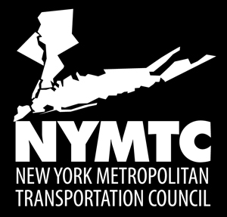

Request for Proposals Release Date: December 7, 2020
Proposal Due Date: February 22, 2021

Electronic Proposal Submission. Proposals shall be electronically submitted to NYSDOT Contract Management by 2:00 PM on February 22, 2021 as separate Part 1 and Part 2 proposal submissions (in native Word/Excel formats and in PDF format). NYMTC/NYSDOT Contract Management shall utilize a NYS managed file transfer protocol (mySend.ny.gov) for C000797 proposers to electronically submit their proposal files. Proposers shall send one email to Al Hasenkopf (mailto:alfred.hasenkopf@dot.ny.gov) and Seitu Allen (mailto:seitu.allen@dot.ny.gov) expressing their intent to submit their proposal electronically at that time. NYSDOT Contract Management will then send the proposer an invitation to mySend so the proposer can upload their RFP submission files to the mySend site. Acknowledgement of proposal receipt via e-mail shall be sent to the proposer to confirm NYSDOT’s successful receipt of electronically-submitted proposals. Proposers are advised to provide ample time to address any technological errors prior to proposal deadlines.

REQUEST FOR PROPOSALS
NEW YORK STATE DEPARTMENT OF TRANSPORTATION (on behalf of the)
NEW YORK METROPOLITAN TRANSPORTATION COUNCIL
NYMTC UPWP WEB APPLICATION PROJECT
Contract #C000797
Table of Contents
I. INTRODUCTION 1
A. Purpose 1
B. Contract Schedule 1
C. Background 1
II. PROJECT OBJECTIVES 2
III. SCOPE OF SERVICES 3
A. Project Task Requirements 3
B. Project Deliverable Submittal, Review and Acceptance Process Requirements 11
IV. PROPOSAL RESPONSE AND FORMATTING REQUIREMENTS 12
A. General Submission Requirements 12
B. Minimum RFP Responsiveness Requirements 13
C. Part I: Technical and Management Proposal Submittal 14
D. Part II: Cost and Administrative Proposal Submittal 17
V. PROPOSAL EVALUATION PROCESS 21
A. Pre-Screening of Proposals 21
B. Initial Best Value Determination 22
C. Proposal Shortlisting 23
D. Demonstration Evaluation 23
E. Best and Final Offer (Optional) and Proposal Withdrawal/Dismissal 25
F. Final Best Value Evaluation 25
G. Consultant Selection Recommendation and Tentative Contract Award 26
H. Evaluation Factors and Evaluation Weight Distribution 27
VI. ADMINISTRATIVE SPECIFICATIONS 29
A. State’s Rights 29
B. Consultant Responsibility when Proposing Former NYMTC or NYSDOT Employees 29
C. Information for the Selected Consultant: 30
VII. ATTACHMENTS 32
Attachment 1. Consultant Information and Certifications 33
Attachment 1A. Subconsultant Information 36
Attachment 2. Procurement Lobbying Law Compliance Information and Forms 37
Attachment 3. Draft Contract 41
Attachment 4. Consultant Employment Disclosure Legislation Forms 99
Attachment 5. Part II Cost Proposal (On-Line) 100
Attachment 6. Executive Order 177 Certification 101
Attachment 7. DBE Participation Information 102
Attachment 8. DBE Subconsultant Participation Solicitation Log 103
Attachment 9. Non-Collusive Bidding Certification 107
Attachment 10. Current UPWP Web App Screenshots 110
Attachment 11. Form OAR 127
Attachment 12. Vendor Assurance of No Conflict of Interest or Detrimental Effect 128
Attachment 13. Firm Experience 130
Attachment 14. Key Personnel Experience 133
Attachment 15. New York State Holidays 134
Attachment 16. Sample Data Dictionary for Current UPWP Application 135
Attachment 17. Sample Data from Current UPWP Application 135
Attachment 18. Product Demonstration Scenario Data 135

REQUEST FOR PROPOSALS
NEW YORK STATE DEPARTMENT OF TRANSPORTATION (on behalf of the)
NEW YORK METROPOLITAN TRANSPORTATION COUNCIL
NYMTC UPWP WEB APPLICATION PROJECT
Contract #C000797

INTRODUCTION

Purpose

The New York Metropolitan Transportation Council (NYMTC), through its host, the New York State Department of Transportation (NYSDOT), is releasing this Non-Architectural/Engineering Request for Proposals (RFP) to seek software and services from a responsive and responsible Consultant (or team of consultants) for development, testing, training, support and maintenance of the Unified Planning Work Program (UPWP) Web Application.

Contract Schedule

NYMTC estimates that work for the successful bidder/offeror will commence around July 2021. The base term of Contract No. C000797 shall be up to five years (or up to 60 months). The resulting contract will be a lump sum milestone-type contract. Please see the Attachment 3 Draft Contract for further details.

For planning purposes, it is anticipated that the level of complexity for this project is moderately complex, and it may require up to the equivalent of one to one-and-a-half (1 to 1.5) full-time equivalents of staff effort to complete.

Background

Unified Planning Work Program (UPWP)

Current federal transportation legislation, entitled the Fixing America's Surface Transportation Act or "FAST Act", authorizes funding for transportation improvements across the nation. To be eligible to use this funding, metropolitan regions must undertake the metropolitan transportation planning process specified in related federal planning regulations. Under these regulations, metropolitan regions, functioning through their metropolitan planning organizations (MPOs), work in cooperation with their states and operators of publicly owned transit services to annually or biennially develop and adopt a Unified Planning Work Program (UPWP) to carry out mandated planning activities.

A UPWP is an annual or biennial statement of work identifying the planning priorities and activities to be carried out within a metropolitan planning area. At a minimum, a UPWP includes a description of the planning work and resulting products, who will perform the work, time frames for completing the work, the estimated budget of the work, and the source(s) of funds used to support delivery of each UPWP task. MPOs are required to develop UPWPs to govern work programs for the expenditure of Federal Highway Administration (FHWA) and Federal Transit Administration (FTA) planning funds.

NYMTC

NYMTC is the officially designated MPO for New York City, Long Island, and the lower Hudson Valley portion of New York State. Comprised of regional governments, NYMTC is a council that provides a collaborative planning forum to address transportation-related issues, develop regional plans and make decisions on the use of federal transportation funds within its planning area, which encompasses an area of 2,440 square miles and a population of 12.4 million, approximately 64 percent of New York State’s population, based on the 2010 Census. The region has one of the most extensive transportation networks in the world with 477 route miles of commuter rail, 225 route miles of rail rapid transit, 22,870 centerline miles of roads, streets, and highways, as well as several commercial airports and maritime facilities for the movement of passengers and goods.

NYMTC members are elected officials and heads of transportation and environmental agencies. The council is comprised of nine voting members and seven advisory members. The voting member agencies includes the New York State Department of Transportation, the New York City Department of Transportation, the New York City Department of City Planning, the Metropolitan Transportation Authority, Nassau County, Suffolk County, Putnam County, Rockland County, and Westchester County. NYMTC’s advisory member agencies include the Federal Highway Administration, the Federal Transit Administration, the United States Environmental Protection Agency, the New York State Department of Environmental Conservation, the Port Authority of New York and New Jersey, the North Jersey Transportation Planning Authority, and New Jersey Transit. For more information about NYMTC, please visit: www.nymtc.org.

PROJECT OBJECTIVES

The main objective for this solicitation is to advertise for and select a qualified, responsive and responsible Consultant (or team of consultants) via a fair and equitable best value Request for Proposal process. The second objective is to meet the NYSDOT established 10% Disadvantaged Business Enterprises (DBE) participation goal for the resulting contract. While not indicative of an offeror’s individual merit (technical excellence, offeror’s ability, experience, etc.), NYSDOT encourages the participation of certified DBEs in its solicitations. The level of DBE participation will be relevant to the process of selecting proposals that will best achieve the overall goals of the Department. Please see RFP Section 4 for further details.

The selected Consultant shall deliver software and services to redesign, test and maintain NYMTC’s stand-alone web application for managing project information related to the UPWP. The resulting web application shall function on Windows and macOS based devices and shall support all major web browsers including Microsoft IE, Edge, Google Chrome, Firefox and Safari. The selected Consultant shall create a database design, data model, and program using, preferably, Microsoft SQL Server. The selected Consultant shall create a scalable web application using, preferably, .NET Framework. The resulting web application shall include interactive reports and tables, and customizable data entry forms. The resulting web application shall be as capable or better at performing all tasks performed by the current UPWP Tool and shall improve users’ experience and ability to perform analyses such as planning, budgeting, accounting, tracking and so on.

The current UPWP web application is being used for entering and querying project-related data, for project programming and grant funding management, and for generating and downloading various reports. NYMTC and its member agencies access and enter project information using assigned login credentials. NYMTC performs the administrative tasks (create users, account management, security, etc.) for the web application. Most project data are entered once a year, though project information is frequently revised. More specific purpose information regarding NYMTC’s UPWP is available via: https://www.nymtc.org/Required-Planning-Products/Unified-Planning-Work-Program-UPWP.

Description of NYMTC’s current UPWP web application

NYMTC’s current UPWP web application (‘Tool’) is relatively small and has no more than 50 total fields. It was created a decade ago using an older version of the Adobe ColdFusion platform and is currently hosted on a server physically located in NYMTC’s offices. The application can be visualized via various screenshots presented in Attachment 10. Attachment 16 and Attachment 17 present sample data tables from the current UPWP web application and a data dictionary for informational purposes.

Limitations of the current Tool:

  - The application’s security measures do not meet current security standards.
  - Passwords are stored in plain text and are visible to anyone who accesses the UPWP database.
  - User provisioning is poor.
  - There are no password strength requirements and there is no history to capture how data has changed over time.
  - The system cannot support multi-year projects. In its current format, a new project needs to be created for each budgeting year.
  - The database design is antiquated. There are no primary or foreign key relationships throughout the database and the referential integrity of the database cannot be guaranteed.
  - Project progress reporting has been developed as a separate module requiring a second login to access and draft reports.
  - Project tracking and expenditures tracking are not part of current application.

SCOPE OF SERVICES

Project Task Requirements

The project consists of performing and delivering all required tasks. If the Consultant decides to rearrange the task order or recommends alternative tasks, it shall still respond to, meet and/or exceed all requirements defined in this RFP, since all proposals shall be evaluated against assuring successful delivery of all required task work. Please note that NYMTC has an on-site IT Unit, which the selected Consultant shall be directed to work with during this project. At a minimum, staff from NYMTC’s IT Unit will:
- Assist the selected Consultant to deploy the application onto NYMTC’s server once accepted.
- Provide a DR environment for the selected Consultant to work from.
- Provide non-production environments and production environments on NYMTC’s web-server.
The project’s deliverable processing method is presented at the end of this section. Tasks and project requirements are presented below.

Task 1: Requirements Gathering

The selected Consultant shall conduct various techniques such as brainstorming, document analysis, focus group discussions, interface analysis, group meetings with users, prototyping, and reverse engineering to perform analysis and document requirements related to all aspects of the UPWP web-application development. This task shall collect requirements for adding project tracking, expenditure tracking, and customizable reporting functionality, which currently are not part of the existing UPWP application. While not limited to, the analysis shall identify users/stakeholders, functional, technical, data, and database requirements. The selected Consultant shall be required to meet with NYMTC staff and other UPWP app users to conduct requirements gathering activities. NYMTC will provide the selected consultant with access to the current UPWP web application. NYMTC will form a project steering committee, including application users, and this team will guide development of the entire project.

Deliverable: Business Requirement Document describing findings from the requirements gathering process and list of requirements to be incorporated into the UPWP web application. (Draft and Final)

Task 2: Database Design and Modeling: A Relational Database Model

The selected Consultant shall create a database design using an Entity Relationship Diagram (ERD) to effectively minimize data redundancy, restructure, and help with enforcement of referential integrity. The database design shall support version control and provide an audit trail to track changes made to the database.

Deliverable: A Tech-memo describing all the data tables and fields of the proposed UPWP application; database design version tracking; description of conceptual and physical design and relationship of all normalized tables. (Preliminary Draft, Final Draft, and Final)

Task 3: Development of the UPWP Web Application using Wireframing and Iterative Prototyping

The selected Consultant shall progress creation of a web application using iterative wire-framing and prototyping design processes so that users and stakeholders can see the interaction flow, design, and navigation at the completion of each iteration. NYMTC estimates a minimum of six iterations to incorporate input related to User Experience (UX) and User Interface (UI). Development and testing of each iteration shall be created on NYMTC’s server. NYMTC shall provide a testing environment on NYMTC’s server. If the NYMTC Project Manager determines additional iterations are needed/warranted, such iterations beyond the minimum of six can be authorized under Task 10.

Deliverable: Wire-frames, Prototypes (up to 6 iterations).

Task 4: Web Vulnerability Assessment

The selected Consultant shall perform scans and security checks for any web vulnerabilities and misconfigurations. Web vulnerability types include but are not limited to: Cross-Site Scripting, SQL injection, CSRF injection, and transport layer weaknesses. Other vulnerability types are possible, per the selected Consultant’s recommendation and expertise. See Appendix D (in RFP Attachment 3 ‘Draft Contract’) for security requirements.

Deliverable: Web vulnerability scan report (Draft and Final).

Task 5: Historical Data Migration

NYMTC’s legacy tool UPWP application has about fifteen years of data. Some of the data tables have evolved over the years with some loss of referential integrity. The selected Consultant shall migrate all historical data into the new database where applicable. The selected Consultant shall be responsible for cleaning and formatting all historical data to prepare it for migration into the new UPWP web application. In the historical data examination and modeling process, the selected consultant shall find and identify the data tables with loss of referential integrity, suggest solutions to remedy, and implement solutions approved by the project manager. The selected Consultant shall assist NYMTC staff and staff from NYMTC member agencies to enter UPWP data for inaugural use of new UPWP web application. The selected Consultant shall provide user support as required.

Deliverable: A database including successfully migrated historical data. Data referential integrity report (Draft and Final).

Task 6: Web Application Testing, Acceptance and Deployment

The selected Consultant shall set up a testing and production server environment on NYMTC’s server. The selected Consultant shall perform test script for NYMTC review. The selected Consultant shall prepare an acceptance procedure document for NYMTC review and approval (NYMTC will not accept the new UPWP application until all tests have been satisfactorily completed and documented). Once approved, the selected Consultant shall deploy the web application. The contract’s warranty period (Task 7) then commences, as well as the required maintenance period (Task 9). Please note that the selected Consultant shall spend up to one-person week (40 hours) on-site at NYMTC's central office to work with NYMTC’s IT Unit to help deploy the new UPWP Web Application onto NYMTC's server as part of RFP Task 6.

Deliverable: Documented test results. Successful deployment of the new UPWP web-based application onto the NYMTC server. Technical documentation including fully commented source code and System Design Report (Draft and Final).

Task 7: Warranty Period

After formal acceptance of NYMTC’s new web-based UPWP application, a 12-month warranty period shall commence AT NO COST TO nysdot/nymtc. To provide documentation of NYMTC’s acceptance, a formal letter shall be sent to the selected Consultant, who shall co-sign said letter, which shall formally present the acceptance date and the start and end dates for the 12-month warranty period, the start and end dates for the maintenance period, and the start and end dates for user support. During the warranty period, the selected Consultant shall assure that the new UPWP web application shall function bug-free and in accordance with the accepted design and documentation. Any bugs identified during the warranty period shall be successfully fixed by the selected Consultant at no additional cost to NYSDOT/NYMTC. Failure to successfully correct bugs during the warranty period may lead to breach of contract. Consultant shall provide NYMTC with additional reports and documentation to account for all bug fixes.

Deliverables: Warranty letter. Bug-free fully functioning UPWP web application. Bug fix documentation.

Task 8: Training and Support

Training: The selected Consultant shall develop new NYMTC UPWP Web Application training curriculum and documents, subject to NYMTC review and approval. The selected Consultant shall provide up to three (3) half-day trainings for users and up to one (1) half-day training for NYMTC’s IT support team via webinar and is expected to train up to 15 users per event. The selected Consultant shall be expected to revise any training documents to reflect material changes to the UI or UX resulting from maintenance activities.

The selected Consultant shall develop a web-based training curriculum that shall be provided to NYMTC users. The selected Consultant shall solicit feedback on training effectiveness and make revisions, as appropriate, prior to subsequent trainings.

Deliverables: Up to three (3) half-day trainings for the users; one (1) half day specialized training for NYMTC’s IT support team; training documents (Draft and Final).

Support: The selected Consultant shall provide effective support for all NYMTC UPWP web app users. The selected Consultant shall provide NYMTC admin with complete and clear NYMTC UPWP web app support manual/procedures. NYMTC users will be instructed to report a problem to NYMTC’s IT staff who will provide initial support; they, in turn, may refer the problem to the selected Consultant’s Support Team. The support provided by the selected Consultant’s team shall be clear English readily understandable by a broad spectrum of users.

Deliverables: Systems support plan (Draft and Final); Systems continuity and error management plan (Draft and Final); UPWP web app support manual/procedures (Draft and Final); NYMTC UPWP web app user support.

Technical Support and Help Desk Services
In the proposal, the Consultant shall describe all plans to meet, at a minimum, the following requirements and meet the service level described below:
- The Consultant shall provide Help Desk support during normal business hours, Mon-Fri 8:00am – 5:00pm Eastern Time, excluding designated NYS Holidays (Attachment 15).
- The Consultant shall provide email and phone support (via a toll-free phone number) Mon-Fri 8:00am – 5:00pm Eastern Time, excluding designated NYS Holidays.
- The Consultant shall provide access to the Consultant’s ticketing system.
- The Consultant will provide technical support for handling all future upgrades.
- All future upgrades made to the base Commercial Off-The-Shelf (COTS) solutions shall include any and all customizations made to meet the NYSDOT/NYMTC Requirements in this RFP. Customizations in this context shall include all software modifications to the application interfaces and standard reports.
- NYSDOT/NYMTC shall be afforded an adequate timeframe to test and approve all future updates.
- The Consultant shall not force or mandate any update/upgrades. Enough advanced notice shall be provided to NYSDOT/NYMTC and to New York State Office of Information Technology Services (ITS) of any proposed maintenance activities to allow for proper preparations to be made by NYSDOT/NYMTC. Unless otherwise instructed, maintenance packages shall be required to be first tested in a test/development environment prior to being implemented in the active production environment.
- The Consultant shall provide a minimum of one-year advanced notice before the Consultant, or other third party, designates a version of software as unsupported.
- The Consultant will provide resources to fix the new UPWP web application until completed to the satisfaction of NYMTC (and NYSDOT). The Consultant shall not close a defect fix unless that fix shall have been demonstrated to either:
  - Repair the functionality, performance, and usability of the application to its pre-defect level, or
  - Improve the functionality, performance, and usability of the application from its pre-defect level.

Service Level Objectives
The Consultant shall meet or exceed the Service Level Objective indicated below:

Defect Severity | Maximum Response Time | Maximum Resolution Time
Severity 1 | 2 clock hours | Same calendar day
Severity 2 | 4 clock hours | 2 calendar days
Severity 3 | 12 clock hours | 10 calendar days

Definitions of Severity Defects (Note: NYSDOT/NYMTC determine the level of severity of the defect based on the business impact):

Severity 1 Defect - A problem whose nature and/or severity prevent NYSDOT/NYMTC from continuing its business. A Level 1 Defect may have one or more of the following characteristics:
- The application suspends indefinitely and causes other NYSDOT/NYMTC applications to stop working
- The application crashes and causes other NYSDOT/NYMTC applications to crash
- A security incident has occurred or is suspected to have occurred

Severity 2 Defect - May have one or more of the following characteristics:
- The performance, functionality or usability of one or more parts of the application are severely degraded or not available
- Multiple users are impacted
- One or more business functions are unavailable or unusable by the end users
- Incorrect application of a business function, resulting in data integrity issues

Severity 3 Defect - A failure of a system or part thereof which has a minor impact on a NYSDOT/NYMTC business process and can be handled on a non-immediate basis. Examples may include user requests (e.g., a report is not formatted correctly) and peripheral problems (e.g., output fails to print properly).

To aid the Consultant in developing a proposal in response to this RFP, requirements to support the system are described below.

Requirement Description – Proposed System Support Plan
The selected Consultant shall provide, as part of Task 8, a Systems Support Plan addressing in detail each of the following aspects of system support or present an alternative support plan with sufficient justification:
- Include a definition of the roles of the Consultant with a list of the responsibilities of each role related to the processes and support of the proposed solution.
- Describe the proposed solution’s system alerts, monitoring and management tools (defining where these items are addressed with COTS or customized) that will be available to NYMTC/NYSDOT.
- Describe in detail what methods are available to contact the Consultant for system support i.e., web site, toll free phone number, etc.
- Provide detailed procedures and guidelines for escalation of problems which cannot be solved in a timely manner. Indicate if there are multiple levels of support and if so, the timeframes for the Consultant’s internal escalation process to the next level of support.
- Describe the issue tracking and resolution reporting documentation that will be provided.
- Detail the proposed communication strategy for issues status and resolution, system health and support performance.
- Include an organization chart of the Consultant’s support structure
- Certify that all future upgrades made to the base COTS solution will include any and all customizations made to meet NYSDOT/NYMTC requirements in this RFP. Customizations in this context shall include all software modifications to the application interfaces and standard reports.
- The selected Consultant shall provide documentation and support for implementation and post-implementation operations for updates and upgrades.

Examples of items considered to be software support include, but are not limited, to:
      - Handling incidents
      - Handling apparent software “bugs”
      - Assisting in the interpretation of system output (reports, error messages, etc.)
      - Answering “how-to” questions
      - Answering technical support questions

Requirement Description –System Continuity and Error Management
Background: NYS’s ITS has a NYS Disaster Recovery Plan. It is a living document that describes ITS’ approach and plans for technology disaster recovery at an alternative location. The plan is complimented by the ITS Continuity of Operations Plan (COOP), Agency COOPs and Individual System Contingency Plans for specific systems. The disaster recovery plan will cover essential and critical infrastructure elements, systems and networks, in accordance with key state priorities.

The selected Consultant shall describe the Consultant’s Systems Continuity and Error Management Plan that shall meet, at a minimum, the following requirements:
- The system shall be able to automatically back-up incomplete processed transactions if the system fails.
- The system shall handle database failovers in a clustered database server configuration.
- The system shall have fully documented restart capabilities for the application’s on-line and batch processing components.
- The system shall be capable of functioning in a load balanced and redundant configuration. End user session persistence, in the event of web/app server failover, would be desired.
- The solution shall provide recovery capability supporting retries for faults and error handling that includes displays of network and database errors for troubleshooting.
- The solution shall provide logging capabilities to trap user access and application events.

Task 9: Maintenance

Maintenance of NYMTC new web-based UPWP application shall commence after NYMTC accepts and formally approves start-up of the new UPWP web application. For the remainder of the resulting contract’s term, the selected Consultant shall assure NYMTC that the new web-based UPWP application shall function bug-free and in accordance with all accepted design and documentation, shall provide any modifications to keep the application current with revision of all underlying tools and technologies (upgraded software, operating systems, databases, etc.), shall provide updates to ensure proper operation with recent versions of leading web browsers, shall provide patches to respond to security concerns, and shall provide the timely correction of material bugs that interfere with day-to-day use of all software associated with the accepted web-based UPWP application. All maintenance services shall invoke as necessary repetition of Task 5 (and Task 3 as directed, and Task 6 as necessary). If the UPWP application provided by the selected Consultant shall become inoperable or crashes so that needed features and functions are unavailable, the selected Consultant shall provide a response plan within five (5) business hours and restore full service within two (2) business days.

The selected Consultant shall be responsible for Corrective Maintenance. This type of maintenance includes diagnosing and fixing defects including, but not limited to, those found by users. Correction of bugs during the 12-month warranty period shall be at no cost to NYMTC.

Preventative Maintenance (i.e., implementing new or changed user requirements which concern functional enhancements to the software) will be invoked per the selected Consultant’s standard maintenance procedures.

Adaptive Maintenance (i.e., modifying the system to cope with changes in the software environment), where possible, will be the responsibility of NYMTC. NYMTC may require additional support from the Consultant for adaptive maintenance. Such support shall be provided through a scheduled WebEx event wherein NYMTC will act as Server Administrator to support triage, troubleshooting and resolution.

NYMTC will perform back-up of data and application.

It is expected that the Consultant will provide software updates at least quarterly or per a schedule which best serves NYMTC and the State.

Deliverables: Fully functioning UPWP web-application. Maintenance of NYMTC’s new web-based UPWP application.

Task 10: Development of the UPWP Web Application using Wireframing and Iterative Prototyping (Additional Iterations; Contingent):

NYMTC’s Project Manager may authorize additional iterations, on an as needed basis, during the initial development process or following NYMTC’s formal acceptance of the UPWP Web Application. Attachment 5 provides both a fixed total amount for such authorizations and a method for determining the maximum allowable cost authorized for iterations after iteration 6. Other as-applicable earlier cited task work shall be as applicable should NYMTC order additional wireframes.

Deliverable: Additional Wire-frames and Prototypes.

Task 11: DBE Participation Program:

The Consultant agrees to maintain its DBE utilization plan per Exhibit D (RFP Attachment 7) over the full life of the contract. Attachment 7 references a DBE goal of 10%. The table presented in Attachment 7 shall be added to the contract under Task 11 as Exhibit D. The Consultant shall set up an account and report all required DBE utilization information per NYSDOT Consultant Instruction CI-13-02 ‘Implementation of the Equitable Business Opportunity (EBO) Software for Consultant Contracts’ (or CI-13-02’s successor). Additional help and user documentation can be found on NYSDOT’s EBO page via https://www.dot.ny.gov/dotapp/ebo.

Project Deliverable Submittal, Review and Acceptance Process Requirements

The selected Consultant shall abide by the following deliverable submittal, review and acceptance process for all deliverables.
Submittal Process:
The Consultant shall electronically submit an advance deliverable to the assigned NYMTC Project Manager (PM). An electronic copy is preferred.
Review Process:
- NYMTC’s PM consults with involved users/stakeholders to develop lists of reviewers and approvers.
- Electronic copies of the deliverable are distributed to reviewers and approvers.
- If requested, the Consultant shall schedule a meeting with designated reviewers and approvers to provide a high-level walkthrough of the document to facilitate review.
- The NYMTC PM may schedule a review meeting with reviewers and approvers. They are notified of the importance of reviewing the deliverable and that it is essential for them to have read and developed comments before the meeting.
- A Review Meeting may be held. At the meeting, the document may be reviewed page-by-page. Minor in-line changes shall be made using Microsoft Word’s ‘Track Changes’ feature. Comments shall be inserted into the document where appropriate. The originator of each comment shall be noted. (This may be done on a pilot basis, with the effectiveness of the process evaluated and a decision made regarding process refinement.)
- Unless informed otherwise, NYMTC staff will make every reasonable effort to provide the review comments to the Consultant within 10 business days from submittal. It should be noted that all submittals not received before noon shall be considered to have been submitted the following day.
- It is expected that NYMTC PM will receive from the Consultant the revised documents addressing all NYMTC comments within five business days, unless other arrangements between the NYMTC PM and the Consultant are made.
- NYMTC staff may review the revised submittal and return additional comments to the Consultant. NYMTC PM will make every effort to return such comments to the Consultant within five business days.
- The Consultant shall address all NYMTC review comments and resubmit within three business days.
- NYMTC staff may complete the “Final Review” within two business days. If there are outstanding issues that remain, resolution of such may involve higher levels of NYMTC management.
Acceptance Process:
- When the deliverable has been accepted, the Consultant shall be so notified by the NYMTC PM. The Consultant shall submit an invoice via email to the NYMTC PM.
- NYMTC PM will forward the invoice to the designated the NYMTC payment person along with a statement indicating that the deliverable fulfills contract requirements and has been accepted.
- The designated NYMTC payment person will then forward the invoice to NYSDOT Accounting for payment.
- Questions regarding all Consultant-provided services and deliverables shall be governed by the contract (which includes the RFP and the selected Consultant’s proposal).

PROPOSAL RESPONSE AND FORMATTING REQUIREMENTS

General Submission Requirements
Your proposal shall be electronically received by NYMTC and NYSDOT by 2:00 PM on February 22, 2021. NYSDOT and NYMTC will acknowledge receipt via e-mail reply.

Electronic Submission. Proposals shall be electronically submitted to NYSDOT Contract Management by 2:00 PM on February 22, 2021. NYMTC/NYSDOT Contract Management shall utilize a NYS managed file transfer protocol (mySend.ny.gov) for C000797 proposers to electronically submit their proposal files. Proposers shall send one email to Al Hasenkopf (alfred.hasenkopf@dot.ny.gov) and Seitu Allen (seitu.allen@dot.ny.gov) expressing their intent to submit their proposal electronically at that time. NYSDOT Contract Management will then send the proposer an invitation to mySend so the proposer can upload their RFP submission files to the mySend site. Acknowledgement of proposal receipt via e-mail shall be sent to the proposer to confirm NYSDOT’s successful receipt of electronically-submitted proposals. Proposers are advised to provide ample time to address any technological errors prior to proposal deadlines.

For the purposes of evaluation, each proposal shall be electronically submitted in two (2) separate parts: the Technical and Management proposal (Part 1); and the Cost and Administrative proposal (Part 2). Each part of the proposal shall be complete in order that the evaluation of both parts can be accomplished independently and concurrently.

The Technical and Management submittal shall be evaluated strictly on the basis of its merits. Cost information is not to be included in the Technical submittal. Any referenced information found via web link must include very specific navigational directions to reach the referenced information. General or non-specific web links are not acceptable.

Signatures. To be compliant during the COVID-19 pandemic, NYSDOT is accepting scanned signatures.

Notary Acknowledgement. To be compliant during the COVID-19 pandemic, NYSDOT is allowing a notary public to witness a document being signed using audio-video technology then to notarize the document. To remotely notarize a document, the following conditions shall be satisfied:
- The person seeking the Notary’s services, if not personally known to the Notary, shall present a valid photo ID to the Notary during the video conference, not merely transmit it prior to or after. The signatory may use an electronic signature, provided the document can be signed electronically under the Electronic Signatures and Records Act (Article 3 of the New York State Technology Law). If the signer uses an electronic signature, the notary shall witness the electronic signature being applied to the document.
- The video conference must allow for direct interaction between the person and the Notary (e.g., no pre-recorded videos of the person signing).
- The person shall affirmatively represent that he or she is physically situated in the State of New York. If the Notary and if the signatory are in different states, then the Notary should indicate on the document the state and the county where each person is located (use the ‘Out-Of-State’ notary section).
- The person shall transmit by fax or electronic means a legible copy of the signed document directly to the Notary on the same date it was signed.
- The Notary shall print and sign the document, in ink, and may not use an electronic signature to officiate the document. The Notary may notarize the transmitted copy of the document and transmit the same back to the person. An electronically transmitted document sent to the Notary or sent back to the signer can be sent in any electronic format (e.g., PDF, JPEG, TIFF), provided it is a legible copy.

Minimum RFP Responsiveness Requirements

Any interested firms who does not provide all of the following by the RFP deadline will be determined to be non-responsive and will be removed from further consideration (see RFP Section VI Part A Proposal Submission for details on RFP deadline and delivery locations):

- Complete Technical Proposal – See Table 1: Part I: Technical and Management Proposal Submittal.
- Complete Cost Proposal – See Table 2: Part II: Cost and Administrative Proposal Submittal.
- Submission of completed Consultant Information and Certifications (Attachment 1; featuring written acceptance of the RFP’s draft contract’s terms and conditions).
- Submission of completed Procurement Lobbying Forms (Attachment 2).
- Submission of completed Form OAR (Attachment 11).
- Meet or exceed the RFP’s 10% DBE participation goal by offering certified DBE subconsultants (via Attachment 7) else the prime consultant shall provide an acceptable evidence of a good faith effort by completing a DBE Subconsultant Participation Solicitation Log (Attachment 8) and submitting a letter of explanation. DBE primes automatically meet this goal yet are still required to seek DBE subcontract participation.
- Proposals are required to use 11-point font or larger, except where necessitated for readability of tables or special graphics. Twelve fonts are preferred.
- Proposers are requested to keep their proposals concise and relevant. Unrelated experience, company history or irrelevant projects shall not be included. Cost information is not to be included in your technical proposal and technical information is not to be included in your cost proposal, or your proposal could be deemed unresponsive.

NOTE: NYSDOT may protect confidential and proprietary information from disclosure to the extent permitted by the Freedom of Information Law (“FOIL”), Article 6 of the Public Officers Law, provided that NYSDOT agrees beforehand to shield the release of proposed information. If an offeror believes information included in their proposal is confidential and proprietary, they shall identify those page(s) of their proposal which contain such information as “confidential and proprietary”. Any information identified as “confidential” or “proprietary” shall be identified in your proposal to only identify what specific material to shield from public scrutiny. All offerors shall explain the material and substantive reason(s) why this information should be considered exempt from public disclosure under FOIL. The identification of pages and the reasons for exemption should be included in your Cover Letter. In addition, the proposer shall acknowledge in their Cover Letter that any proposed information labelled as confidential will be treated in accordance with Article 6 of the New York State Public Officers Law. NYSDOT reserves the right to only consider those FOIL exemption requests for which public release of such information would truly be injurious to a firm.

Your proposal shall be submitted per the RFP proposal formatting requirements listed below in Part I and Part II.

Part I: Technical and Management Proposal Submittal
A responsive Technical and Management proposal shall contain the following (per Table 1)

Table 1. Part I Technical and Management Proposal Submittal Checklist⁭
Part I Technical & Management Proposal Submission Requirements:
□ | Submit a complete electronic copy in MS Office 2016 Word and PDF formats.
⁭  □ | Proposal Cover: Labeled with the consultant’s full legal name, mailing address, and office telephone number. Label shall also say: RFP #C000797 NYMTC UPWP Web Application Technical and Management Proposal. Add submittal date (MONTH, DD, YEAR format).
□ | Table 1: Technical Proposal Submittal Checklist
□ | Signed Cover Letter on official business letterhead
□ | Table of Contents identifying each major section and page numbers
□ | Complete and Submit Attachment 13 Firm Experience
□ | Complete and Submit Attachment 14 Key Personnel Experience
□ | Complete and Submit Project Plan, Scope of Services & Schedule
□ | The Technical and Management Proposal may include a relevant previous work sample (encouraged). Relate this work sample to this RFP’s requirements, explaining why they consider that experience to be relevant

A complete Part I Technical and Management proposal shall contain the following:

- A signed Cover Letter on official business letterhead featuring:

- The signature of an official authorized to bind the offeror to all of its provisions.
- A statement that the offered named key personnel will be provided once NYSDOT/NYMTC issues a notice to proceed. NYMTC and NYSDOT do not allow unapproved substitutes.

NOTE: NYSDOT no longer allows exceptions to the RFP’s draft contract’s Terms and Conditions – firms are encouraged to ask questions prior to proposal submission.

- A Title Page

Indicate the name, address and phone number of the proposer. It shall also include name(s) of the person(s) who prepared the proposal as well as name, email and telephone numbers of the contact person.

OFFICIAL TITLE: NYMTC UPWP WEB APPLICATION PROJECT (Contract #C000797)

- A Table of Contents

Identify each major section and initial page numbers. The Table of Contents shall include Part I and Part II of your proposals and use labeled tabs to separate each section.

- A Narrative Description

Provide a detailed discussion on the important issues involved in the implementation of work effort. Include enough substantive discussion to demonstrate an understanding of the NYMTC/NYSDOT project and contract objectives and familiarity with applicable laws, rules, procedures, processes, etc. Discuss all assumptions made during the preparation of Part I and Part II submissions. Demonstrate a sound management plan to ensure all subconsultant’s compliance with all project requirements and contract provisions, including a DBE management plan to ensure the contract’s DBE goal is met over the life of the contract.

- Approach, Scope of Services and Schedule

Describe the detailed approach for performing the work and accomplishing project objectives. Provide a detailed scope of services which describes by task what will be done. Provide additional supporting documentation supporting how each of the RFP’s specifications and requirements are addressed (provide previous examples, etc.). Screenshots or other visual representations of the proposed solution shall be provided as well. Attachment 18 provides scenario data that vendors may use to inform such visual representations. A general scope of services is outlined under RFP Section III. You may base your proposed scope of services on these tasks or suggest alternative tasks which could improve the ability of the project to meet its objectives. NYSDOT/NYMTC wants to allow maximum flexibility for the ideas, initiative and creativity of the proposer. Alternative tasks and suggestions are encouraged and will be reviewed with interest within the framework of the stated objectives and scope of the project, using the proposal evaluation criteria in RFP Section V. Fully explain and justify your approach, especially if significant departures from the general scope are recommended. Include a schedule for completion of the project showing the duration of each task and all major milestones and include a list of technical assumptions. Provide a DBE participation plan, to ensure the DBE goal is managed and delivered over the life of the contract.

- Organization and Staffing

Provide an organizational chart for the project showing the names of the project manager and all proposed key personnel. Depict all subconsultants and external role players and stakeholders. Include resumes for all proposed key personnel (including any subconsultants). Include an estimate of total effort hours contributed by each of the key personnel to each task and an estimate of total effort hours for each task. If subconsultants are to be used, explain the specific need for the expertise and describe the arrangements.

- Experience (Attachment 13 and Attachment 14)

NYMTC and NYSDOT require substantial experience and expertise, and offerors shall demonstrate that experience through past and present project attestations and successfully reachable, verifiable references. The qualifications and current/prior experience of the proposer are of great importance to NYMTC and NYSDOT. Direct, relevant, prior experience in project management, software development, database management are required; present such experience with projects of similar scale and scope as the one proposed in this RFP. Provide a list of projects currently in progress and those completed within the last five to seven (5-7) years which are relevant to this effort. Indicate proposed key personnel who are, or have worked, on such projects. Include names, addresses and phone numbers of contact points with the listed clients.

The offeror’s proposed project team shall include key management personnel with a minimum of three (3) years of experience with project management and software development.

Provide three, reachable references for each proposed key personnel. Provide two, reachable references for each firm. NYSDOT/NYMTC reserve the right to request information from any source so named to verify all offered experience and work history, as well as request additional references. NYSDOT/NYMTC also reserves the right to request additional references and/or contact relevant references not named in a consultant’s proposal.

Part II: Cost and Administrative Proposal Submittal

A complete Part II Cost and Administrative proposal shall contain the following:

Table 2 – Part II Cost and Administrative Proposal Submittal Checklist
Part II Cost and Administrative Proposal Submittal Packaging Requirements:
⁭ | Submit a complete electronic copy in native MS Office 2016 compatible formats (Word, Excel). Submit a complete electronic copy in PDF format.
⁭ | Proposal Cover: Labeled with the consultant’s full legal name, mailing address, and office telephone number. Label shall also say: RFP #C000797 NYMTC UPWP Web Application Cost and Administrative Proposal. Add submittal date (MONTH, DD, YEAR format).
⁭ | Cover Letter (same as in technical proposal)
⁭ | Table of Contents
⁭ | Table 2 Cost and Administrative Proposal Submittal Checklist
Cost Proposal Section Requirements:
⁭ | Complete and submit Attachment 5 Cost Proposal. (Excel and PDF)
Administrative Section Requirements:
⁭ | Complete and submit Attachment 11: Form AOR Acknowledgement of Receipt
⁭ | Complete and submit the Attachment 2: Procurement Lobbying Law Compliance Forms
⁭ | Complete and submit Attachment 1: Consultant Information and Certifications (sign both Sections II and III): PRIME CONSULTANT ONLY
⁭ | Complete and submit Section I of Attachment 1A: Consultant Information and Certifications for EACH SUBCONSULTANT
⁭ | Complete and submit Attachment 9: Non-Collusive Bidding Certification
⁭ | Complete and submit Attachment 12: Vendor Assurance of No Conflict of Interest or Detrimental Effect
Cost Proposal (Attachment 5)
For each solution being offered, NYSDOT requires that cost information be presented using the Microsoft Excel spreadsheet included in RFP Attachment 5 Cost Proposal. (Proposers shall provide an electronic copy of each of the worksheets within this spreadsheet as part of their response and present a complete PDF copy.
The accuracy of calculations and formulas in the spreadsheet are the sole responsibility of the proposer. Should any questions arise pertaining to this form and its instructions, please submit them to the designated NYSDOT/NYMTC contact persons before the RFP’s Question & Answer deadline.
A Cost Proposal for performing all of the work in your proposed Scope of Services and delivering all required software shall be submitted using Attachment 5. Your cost proposal shall set forth for each Contract Year a schedule of fixed costs for all software licenses and estimates of labor for all services along with a schedule of fixed hourly rates for all proposed Consultant staff to perform any additional Scope of Services work. Proposed costs shall include any and all project-related direct and indirect costs (fees, salaries, overhead (including insurances), profit, relevant direct non-salary expenses, etc.) to effectively execute the responsibilities and tasks set forth in the RFP and/or Contract. Do not propose any travel costs. All travel shall be directed by NYMTC. Commuting travel costs are not allowed. Reimbursement for all travel shall be limited to the State’s reimbursement policies.

Attachment 5 is an Excel spreadsheet/workbook which contains tabs wherein each tab presents a major contributor to the contract’s total estimated cost over five years. Each tab presents a separate exhibit, which will become the exhibits to populate Schedule B of the resulting contract. Instructions for completing Attachment 5 may be found within the Excel spreadsheet.

Attachment 5 Exhibit 4 requires a proposed consultant on-site staff cost estimate for the selected Consultant to spend up to a one-person week (40 hours) on-site at NYMTC's central office to work with NYMTC’s IT Unit to help deploy the new UPWP Web Application onto NYMTC's server as part of RFP Task 6. Please follow the applicable instructions in Exhibit 4. These added costs are summarized in Exhibit 1.
Method of Payment (Milestone Payment Schedule; Exhibits 3 and 3B):
Payment for services provided under the agreement resulting from this RFP will be fixed for the duration of the agreement unless changed by an executed supplemental agreement. Based on the total proposed lump sum cost, provide a milestone payment schedule which sets forth a proposed percentage/dollar amounts of the lump sum for each key deliverable for which payment would be requested. Specify any annual fees, which are due or payable during the first month of each contract year. Partial deliverables, where appropriate, are allowed. Any ‘Extra Work’ payments added to the contract after award via negotiated time and material requirements shall be added as fixed lump sum milestone payments.
The Consultant will designate a Billing Representative who will be responsible for resolving any invoicing issues during the term of the Contract. The cost for any additional services shall be negotiated and agreed upon by both parties using the Agreement’s fixed labor rates.
Payment will be based on the acceptance of completed deliverables by phase or by month as identified in RFP Section 3, Scope of Service and as codified by Schedule B of the RFP’s draft contract. A proposed payment schedule is included in Attachment 5. Any Extra Work added to the contract after award shall be paid for via the agreed-upon, not-to-exceed labor rates negotiated via the rates proposed in Attachment 5, with reasonable reimbursement for agreed-upon out-of-pocket expenses (subject to New York State reimbursement limitations).
Requests for progress and final payments shall be made by the Consultant based on standard NYSDOT consultant reimbursement request form FIN 421 ‘Request for Consultant Reimbursement’ forms prepared and submitted, together with the deliverable item for which the payment request is being made. Use proper procedure for billing each deliverable: Submit an advance draft billing to NYMTC’s assigned Project Manager via the following sample electronic billing: https://www.dot.ny.gov/main/business-center/consultants/forms-publications-and-instructions. (Scroll down to ‘Payment and Invoice Forms’.). The sample spreadsheet contains all of the proper, required billing forms, as well as a sample billing. The NYMTC Project Manager will respond via e-mail either with comments/corrections or with an approval to submit the final billing. The last and final payment will become due and payable within thirty (30) days after delivery of the final deliverable(s) and a standard NYS FIN 421 payment request forms.
All vendors are directed to register with the New York State Office of the State Comptroller to receive electronic payments per the Governor’s Directive.
Administrative Section Submittal:

Submit one complete Administrative Section to cover any offered solution.

ATTACHMENT 11. Complete and submit Attachment 11 Form OAR: Acknowledgement of Receipt, which will be administratively evaluated during the procurement process on a pass/fail basis. Each firm must acknowledge receipt of the RFP and all RFP Modifications (a mandatory requirement). There is no requirement to acknowledge any RFP Announcements.

ATTACHMENT 2. Complete and submit Attachment 2 Procurement Lobbying Law (PLL) Compliance Forms. Filing the two required forms is mandatory for all consultants in order to be considered for contract award. Failure to submit the required PLL forms with your proposal will result in elimination from consideration for contract award. Please call or e-mail the individuals identified as the Designated Contacts of this RFP if you have any questions regarding how to complete this required form.

Per the Procurement Lobbying Law of 2005, any person who wishes to contact NYSDOT/NYMTC regarding this project during the restricted period (i.e. from advertisement through designation), may only contact the RFP’s designated contact person. All proposers should become familiar with NYSDOT’s Procurement Lobbying Law Interim Guidelines and Procedures. The document is located at: https://www.dot.ny.gov/main/business-center/consultants/consultants-repository/pll_gandp_v1.pdf.

ATTACHMENTS 1 and 1A. The Prime Consultant must complete all sections and submit Attachment 1 Consultant Information and Certifications. Each signature on each copy must be an original. Complete and submit :Section I of Attachment 1A for each proposed Subconsultant.

Acceptance of Agreement Terms and Conditions: Offerors shall include completed Attachment 1 to indicate their acceptance of all of the terms and conditions contained in the RFP’s draft Contract (Attachment 3), which is an RFP mandatory requirement. Attachment 1 also requires the signature of an official authorized to bind the offeror to all of its provisions, a statement certifying that the proposal shall remain valid for at least 365 days, a statement that the firm accepts the RFP’s Scope of Services ‘as-is’, and a statement that, if awarded the contract, the offeror will comply with all the requirements of the RFP, including all of its attachments. Altering this form without the prior expressed written approval of the New York State Department of Transportation is prohibited and may lead to the proposal being deemed non-responsive and subsequently dismissed.

After proposal submittal, no exceptions to any of the RFP’s draft contract’s terms and conditions will be entertained by NYSDOT. Conditional bids will be deemed non-responsive. The RFP presents an opportunity for all vendors to examine the RFP’s draft contract’s terms and conditions, and present questions regarding any terms or conditions, to seek clarifications regarding any terms and conditions or to offer alternative contract language for NYSDOT to consider. All such inquiries will be responded to via release of official answers to questions per the RFP’s schedule. Any revisions to any of the RFP’s requirements, if any, shall be released via a formal RFP Modification per the RFP’s schedule.

Attachment 7 DBE Participation Information Form and Attachment 8 DBE Subconsultant Participation Solicitation Log AND Letter of Explanation of Non or Partial DBE Goal Attainment
Offerors shall complete and submit RFP Attachments 7 and 8, which will be administratively evaluated during the procurement process on a pass/fail basis.

While not indicative of a proposer’s individual merit (technical excellence, proposer’s ability, experience, etc.), NYSDOT encourages the participation of certified Disadvantaged Business Enterprises (DBE) in its solicitations. The level of DBE participation will be relevant to the process of selecting proposals that will best achieve the overall goals of the Department. Please visit the New York State Unified Certification Program (NYSUCP) DBE Directory for certified Disadvantaged Business Enterprises via: https://nysucp.newnycontracts.com/.

New York State has established a DBE participation goal of 10% for this solicitation. Only meaningful participation by either a prime consultant who is certified as a DBE or inclusion of subconsultant(s) who is/are certified as a DBE counts toward the DBE participation goal. Meaningful participation is defined as providing commercially useful functions or services. These services should:
• Result in a product or service distinguishable from the Prime Consultant’s product or service or be a part of the services provided by the Prime Consultant,
• Be for scope of service elements which can be and are completely performed, supervised and managed by the DBE Subconsultant, and/or
• Perform significant tasks which can be considered commercially marketable.

Interested proposers shall verify their attainment of the 10% DBE participation goal by completing and submitting Attachment 7. For participation to count towards the DBE goal set for this solicitation, the offered DBE participating firm must be currently certified by NYSUCP. If the proposal does not meet/exceed the 10% DBE participation goal, the firm must provide evidence of a good faith effort by completing and submitting Attachment 8. Provide robust documentation regarding all good faith efforts to obtain the services of qualified, available DBEs.

Additionally, if the firm does not meet the specified goal, the firm must include in its submission a Goal Attainment Explanation Letter explaining why the firm was unable to meet the applicable DBE (in full or if partially), which serves to substantiate the firm’s good faith effort. The letter shall include sufficient justification as to why the goal was not met or was met partially and shall at a minimum address the following factors:
- the potential firm’s method of accomplishing the work,
- the subcontracting opportunities associated with the proposed approach and scope of services, and
- the availability of certified firms for the work to be performed by either a prime consultant or via subcontract.
A prime consultant that is a certified DBE still must make a good faith effort to include DBE subconsultants in their proposal. Only participation by certified DBE subconsultants may count towards the contract participation goal. Participation by a certified DBE prime consultant does not count towards meeting the contract goal (participation by a certified DBE prime consultant helps to meet NYSDOT’s corporate DBE goal).

Firms are advised to refer to RFP Section 5 for the procedure to be followed when evaluating a firm’s proposed DBE participation.

ATTACHMENT 9. Complete and submit Attachment 9 Non-Collusive Bidding Certificate form.

ATTACHMENT 12. Complete and submit Attachment 12 Vendor Assurance of No Conflict of Interest or Detrimental Effect form. All Proposers must submit an attestation that there was no collusion with other bidders. Firms shall also identify any partnerships or corporations to which they belong.

PROPOSAL EVALUATION PROCESS

Pre-Screening of Proposals

NYSDOT/NYMTC will conduct a pre-screening of each proposal received by the proposal due date to ensure all contents have been submitted in accordance with the minimum proposal responsiveness requirements as specified in the RFP. It is the sole responsibility of each proposer to assure that its proposal is received on time. Proposals which fail to meet the response deadline will not be opened nor considered further. It is NYMTC/NYSDOT’s sole discretionary determination as to whether a proposal is complete (reference “Minimum RFP Responsiveness” Section IV Part A). Proposals which do not meet the mandatory specifications in the Minimum RFP Responsiveness section will be deemed non-responsive. Any proposal deemed to be non-responsive shall be removed from further consideration and the submitting firm notified.

DBE Pre-Screening: As part of the pre-screening process, the proposed DBE participation percentages offered for NYSUCP certified prime consultants and/or NYSUCP certified subconsultants will be reviewed (Attachment 7 DBE Participation Information). To count towards the Department’s DBE participation goal, each firm must be currently listed in the NYSUCP Directory. If the proposed DBE participation is less than the established goal for this solicitation, the firm’s evidence of a Good Faith Effort (Attachment 8: Subconsultant Participation Solicitation Log) to achieve the goal will be reviewed, along with the firm’s letter of explanation (Goal Attainment Explanation Letter) as to why it was unable to meet the goal. During the review process, which will include verification of a firm’s Good Faith Effort evidence, if it is determined by the Department that the firm did not provide an acceptable Good Faith Effort, then the proposal may be deemed non-responsive. Any proposals deemed non-responsive shall be removed from further consideration. Offerors whose proposals are deemed nonresponsive will be notified, in writing, of their elimination. A firm’s good faith efforts to secure participation by DBEs may be susceptible to FHWA’s ‘administrative reconsideration’ process.

Initial Best Value Determination

Proposals which pass pre-screening shall then be evaluated by NYMTC and NYSDOT using a best value method evaluation process. Technical considerations are of greater importance than cost considerations; however, cost is a significant factor in the evaluation of proposals. Written technical and cost proposals will be evaluated and point scored based on the information provided by consultants in accordance with the pre-established criteria listed in RFP Section V. H Evaluation Factors and Evaluation Weight Distribution below.

Written technical proposals will be evaluated by appropriate subject matter experts (Evaluators). Each proposal’s response to each RFP’s specification shall be evaluated using the RFP’s evaluation factors. Proposers responding to this RFP may be requested to clarify issues or to provide additional insights into their proposal through written clarifications. If written clarifications are required to complete the initial technical evaluation of proposals, evaluators will be allowed to revise their technical scores based on this additional information.

Reference checks (to verify offered experience) may be required to complete initial evaluation of technical proposals. If requested and as directed by evaluators, offered references may be contacted using NYSDOT Contract Management’s standard reference check questionnaire, as adjusted per this RFP. Any garnered reference check feedback will be forwarded to evaluators for additional consideration and evaluation. Evaluators may discuss reference check findings and may revise their experience technical scores based on consideration of this additional information and their follow-up discussions. Changes to scores and their reasons shall be documented and recorded on written scoresheets as well in electronic form.

To assure a full understanding of a proposal’s responsiveness to the RFP’s technical requirements, NYSDOT/NYMTC reserves the right to seek written clarifications from firms submitting proposals. If written clarifications, based upon proposal review, are requested by evaluators, a firm which is the target of the clarifications may be asked to provide written clarifications prior to completion of the written technical proposal evaluation process. Evaluators will be allowed to revise their technical scores based on receipt and consideration of this additional clarifying information and follow-up evaluator discussions. Reasons for any score changes shall be documented.

Cost proposals will be evaluated and scored in accordance with the pre-established criteria listed in RFP Section V. H ‘Evaluation Factors and Evaluation Weight Distribution’ below. Initial cost scores shall be developed and used to identify initial best value scores. Cost proposal clarification questions may be asked at this time. Evaluators will be allowed to revise their initial cost scores based on the answers given.

Initial Cost proposal scores will be added to the initial average weighted written Technical and Management proposal scores to determine initial Best Value scores.

Proposal Shortlisting

Determination of initial Best Value shall determine which firms’ proposals are mathematically susceptible for contract award (i.e., shortlisted).

The shortlisting rule for this solicitation shall be any proposal with an initial Best Value score within 10 points of the top initial Best Value ranked proposal (plus any ‘cluster’ of initial Best Value proposal scores surrounding the cut-off line; an inclusivity rule subject to NYSDOT and NYMTC management discretion).

Firms submitting proposals which do not make the shortlist might not be included in the remaining Best Value evaluation process steps (not included in subsequent proposal scoring process). Firms removed from further consideration will be offered a debriefing opportunity at the appropriate time.

NYSDOT may publish the short list of firms on its website under this solicitation; NYSDOT will not publish the shortlist if less than three proposals are received. Shortlisted firms shall be invited to demonstrate their proposed solution and respond to further clarification questions.

Demonstration Evaluation

Firms offering proposals which are susceptible to contract award and have made the short-list after completion of initial best value considerations shall be invited to present their solution via a webinar invitation sent out by NYMTC and/or by NYSDOT.

Evaluation of technical proposals shall include separate evaluation of selectively-specified shortlisted proposals via a product demonstration. NYMTC/NYSDOT reserves the right to ask clarification questions to consultants during the demonstration. Consultants attending the demonstrations cannot submit any new or additional material or information during product demonstrations and during the product demonstration’s question and answer moments. NYSDOT strongly encourages proposers to ensure that your proposal contains your best possible information prior to proposal submission. Evaluators are not allowed to re-score the earlier and separately-evaluated written technical proposals during or after completion of evaluation of the product demonstration.

The product demonstration shall be remotely presented by all proposers, shall be scheduled during a 9:00 AM to 5:00 PM window and held one or two per day during the week of March 15, 2021 (additional days could be added to the demonstration evaluation schedule, depending upon the total number of shortlisted proposals received). Each meeting, at a minimum, shall be two hours in duration. Vendors participating in each demonstration shall register all attendees in advance. The WebEx webinar will be set up and recorded by NYSDOT with presenter control handed off to the prime consultant.

Attachment 18 provides scenario data that may be used during the product demonstration. The data represents two UPWP cycles for an MPO that has a central staff and passes federal funding through to two (2) member agencies. The scenario data generally demonstrates the data that NYMTC collects to develop annual work programs, process invoices, and develop expenditure reports. Vendors are not obligated to use the provided Attachment 18 scenario data and may choose to use their own data to present a similar scenario, provided that alternative data presents a demonstration of similar data roles and RFP-required functionality.

NYMTC UPWP Web App System Product Demonstration shall demonstrate, at a minimum, that the proposed solution provides the following functionality:

- Tracking MPO revenue by program year and fund source
- Budget Development
  - Project Development
    - Assigning resources to projects such as
      - Staff
      - Direct non-personnel services costs
      - Contracts
      - Equipment
  - Allocating funding to projects
- Budget Reporting
  - Automate, to the extent possible, the production of project and budget information reported in the UPWP document
https://www.nymtc.org/Required-Planning-Products/Unified-Planning-Work-Program-UPWP
- Project Management
  - Scheduling
  - Deliverables Tracking
  - Progress Reporting
- Expenditures Tracking
  - Invoicing
  - Reporting
- Web-based Application
  - At least three levels of User Accounts
  - Online Form Generation
  - Upload of attachments
  - Email integration
  - Web-security
  - Americans with Disabilities Act Compliance

The demonstration agenda will be:
1. Greeting by NYMTC and NYSDOT Contract Management/meeting rules (5 minutes)
2. Introduction of Consultant’s Key Personnel (20 minutes)
3. NYMTC UPWP Web App System Product Demonstration (90 minutes)
4. Closure by NYMTC and NYSDOT Contract Management /Next Steps (5 minutes)

Short-listed firms shall receive a demonstration package, which shall include logistical instructions. Firms invited to attend the product demonstration shall present a brief overview of key personnel present, make brief opening presentation (limited to 20 minutes), then present their product demonstration. Presenting firms shall respond to clarification questions from Evaluators. Preparation for and participation in product demonstration by prospective Consultants shall be at no cost to the State of New York.

The product demonstration shall be separately evaluated using the RFP’s evaluation criteria and weights listed in RFP Section V. H Evaluation Factors and Evaluation Weight Distribution below.

Best and Final Offer (Optional) and Proposal Withdrawal/Dismissal

NYSDOT/NYMTC reserves the right to request Best and Final Offers from firms which made the shortlist and participated in the product demonstrations. Any Best and Final Offer request may ask additional further clarifying technical and/or cost proposal questions of firms to further clarify their submitted offered solutions or proposals. NYSDOT/NYMTC also may request a cost only BAFO. Should NYSDOT/NYMTC opt to request BAFOs, all shortlisted firms will receive a BAFO request. Responding firms will be allowed to submit a Best and Final Offer (technical and/or cost); firms may opt not to submit a BAFO. Evaluators will be allowed to revise their technical scores for the written proposal based on their consideration of any new or changed technical proposal information contained in any Best and Final Offer. If changes to a firm’s technical proposal lead to corresponding, necessary revisions to their cost proposal (or should a firm opt to clarify their cost proposal) or should the Department opt to request cost-only BAFOs, necessary and appropriate adjustments shall be made to that firm’s cost proposal evaluation and cost proposal scores.

Should any firm withdraw their proposal after a possible BAFO request, NYSDOT/NYMTC will remove that firm’s technical and cost information from the best value evaluation documentation and shall recalculate the remaining field’s relative technical and cost scores (without the withdrawn firm’s information) and re-determine best value. Should withdrawal of a proposal lead to a new firm becoming eligible for the shortlist, this new firm shall go through the product demonstration process and BAFO process.

Final Best Value Evaluation

After evaluation of all technical information submitted by competing consultants (written technical proposals, product demonstration and possible Best and Final Offers), NYSDOT/NYMTC will add the final average weighted written Technical and Management proposal score with the corresponding final average weighted Product Demonstration score, to derive a firm’s final Technical and Management proposal score. Cost proposals have previously been evaluated and the resulting cost scores defined by cost proposal scoring rule (lowest total cost gets 25 points). Final cost scores will be added to the final Technical and Management Proposal scores to generate a ranked list of tentative final best value scores, ranked in highest-to-lowest final score order.

Tie-Breaking Rule: Should any of the tentative final best value scores of one or more proposals competing for the contract award lie within one point of each other, then State Finance Law Section 163(10)(a) shall be used to settle any ties.

Once all possible score ties have cleared, NYSDOT/NYMTC will determine the final best value score, where after the proposal with the highest final best value score shall be recommended to NYSDOT Executive Management for tentative contract award.

Consultant Selection Recommendation and Tentative Contract Award

A tentative contract award recommendation may be made to the consultant whose proposal receives the highest total final best value score after considering all technical and cost evaluation factors.

An internal proposal evaluation process results report shall be produced based on the documented proposal evaluation process, which shall include a consultant selection recommendation based on the RFP result. NYMTC management shall make a recommendation to NYSDOT regarding the RFP result. NYMTC management’s recommendation shall be forwarded to NYSDOT Executive Management for review and approval. If approved, NYSDOT shall make a consultant selection designation, which will be publicly announced on NYSDOT’s website.

At the conclusion of the evaluation period, an announcement of NYSDOT’s procurement decision result and/or designation announcement will be posted the ‘Consulting Services Opportunities/Results’ listing on the NYSDOT’s Web site via: https://www.dot.ny.gov/business/. All consultants who participated in the RFP process will be notified in writing regarding the RFP results. All non-designated firms will be offered an opportunity to attend a debriefing. Firms offered a debriefing opportunity have fifteen (15) calendar days to submit a written debriefing request to the designated contact person. NYSDOT/NYMTC may not be obligated should it receive a debriefing request after the 15-day deadline.

NYMTC will negotiate the resulting contract with the selected consultant, with NYSDOT Contract Management, and with possible NYSDOT Legal and/or NYS OITS involvement. Should negotiations with the top-ranked best value Consultant fail to produce agreed-upon contracts, then NYSDOT Executive Management will designate and announce tentative award contract to the next highest-ranked best value Consultant. NYSDOT/NYMTC will then enter into negotiations with the second-highest rated Consultant. This process may repeat itself until acceptable contracts are consummated. The final contract is subject to approval by the Attorney General and the Office of the State Comptroller and is not binding until such approvals are received.

It is expressly understood that this Request for Proposals does not commit NYSDOT to award a contract, pay any costs incurred in the preparation of a proposal to this request, or to procure or contract services or supplies. Further, NYSDOT shall have no obligation or liability whatsoever to the vendor selected as a result of this solicitation unless and until a contract satisfactory to NYSDOT is approved and executed by the vendor and all necessary State officials.

Protest Procedure: NYSDOT has established a protest procedure to be utilized when an interested party challenges a Non-Engineering consultant designation by NYSDOT. The complete procedure can be accessed via: https://www.dot.ny.gov/main/business-center/consultants/general-info.

Evaluation Factors and Evaluation Weight Distribution

Proposals will be evaluated using the NYSDOT’s best value method based upon a 100 total point scale. The Technical and Management Proposal evaluation will represent 75 points – 65 points for written technical and management proposal evaluation and 10 points for product demonstration evaluation. The cost portion of the Cost and Administrative portion will represent 25 points. The Administrative portion shall be evaluated for responsiveness and shall not be point scored (Attachment 1 and Attachment 11 are pass/fail). A more detailed breakdown of the RFP’s proposal evaluation category weights is as follows:

Technical and Management Proposal – Written Technical and Management Proposal (Up to 65 Points)

The Technical and Management portion of the written proposals will be evaluated, and point scored and will represent 65% of the total available Best Value score. The major evaluation criteria are listed in descending order of importance. Sub-criteria within major evaluation factors are also in descending order of importance. Please be concise.

- Experience (up to 35 points)

- Quality, extent and relevance of experience, education and training of key personnel. (up to 25 points)
- Quality, extent and relevance of current and prior experience of the firm. (up to 10 points)

- Approach, Scope of Services and Schedule (up to 10 points)

- Quality and acceptability of approach and scope of services for accomplishing project objectives; initiative and creativity of proposer. (up to 6 points)
- Completeness and reasonableness of schedule. The schedule shall be prepared in a font that is reasonably legible. You may assume an estimated start date 10 days after contract award. (up to 4 points)

- Quality of Proposal (up to 10 points)

- Degree to which proposal reflects understanding and comprehension of project scope and objectives. (up to 6 points)
- Quality of proposer’s resources relative to the needs of the project. (up to 4 points)

- Organization and Staffing (up to 10 points)

- Quality of project organization; reasonableness of staff/task allocations for each task and total effort (up to 6 points)
- Quality of plan for phasing key personnel into project (up to 2 points)
- Extent and quality of interaction with key participants (up to 2 points)

Technical and Management Proposal - Product Demonstrations (Up to 10 Points)

The product demonstration will be evaluated, and point scored (on a zero-to-ten scale) to measure the degree to which a consultant’s performance addresses the following three evaluation factors:
- Quality of product demonstration (Up to 7 points)

- Ability of the presenting consultant team to address and answer clarifying questions. (Up to 2 points)
- Demonstration team’s chemistry and ability to demonstrate as a team. (Up to 1 point)

Evaluators may change their initial written technical proposal scores based on consideration of additional clarifying information provided during the product demonstration. Should this lead to a new firm becoming eligible for the shortlist, this new firm shall go through the product demonstration evaluation process.

Cost and Administrative Proposal - Cost Proposal Evaluation (Up to 25 Points)

The cost portion of the Cost and Administrative proposal will be evaluated, and point scored and will represent 25 points of the total best value score for a proposal. The calculation of a cost score will be determined by comparing the proposed Total Five-Year Cost for each proposer (per Attachment 5, Exhibit 1). The proposer with the lowest proposed Total Five-Year Cost will receive an assigned cost score of 25 points. Proposals with higher Total Five-Year Costs will receive proportionally lower cost scores.

Cost scores (which are relative to the field of consultants competing for contract award) are subject to change depending upon whether cost proposal clarifications responses (or Best and Final Offer responses or proposal withdrawals or pass/fail dismissals) lead to proposed cost changes. Cost scoring results shall be used to determine which proposals are susceptible to contract award (a best value determination). A final cost score shall be calculated once all cost proposal evaluation has been completed. Should any firm withdraw their proposal during the proposal evaluation process, NYSDOT/NYMTC will remove that firm’s technical and cost information from the best value evaluation documentation and shall recalculate the remaining field’s technical and cost scores (without the withdrawn firm’s information).

ADMINISTRATIVE SPECIFICATIONS

A. State’s Rights
All proposals, upon submission to NYSDOT, shall become its property for use as deemed appropriate. By submitting a proposal, the consultant covenants not to make any claim for or have any right to damages because of any misinterpretation or misunderstanding of the specification, or because of any misinformation or lack of information. With regard to proposal submitted, NYSDOT asserts the following prerogatives with regard to proposals submitted:
- To accept or reject any or all proposals in whole or in part;
- To cancel this RFP with sufficient notice;
- To correct any arithmetic errors in any or all proposals;
- To change the proposal’s due date upon appropriate notification to interested firms;
- To eliminate any mandatory RFP requirement or specification unmet by all offerors in the evaluation of received proposals;
- To adopt any or all of a successful offeror’s proposal;
- To negotiate modifications to the scope, milestone payment schedule and total cost, and contract terms and conditions with the selected offeror prior to contract award only if it is in the best interest of the state to do so;
- To disqualify an offeror from receiving the award if such offeror, or anyone in the offeror’s employ, has previously failed to perform satisfactorily in connection with public bidding or contracts;
- To revise/amend any provision of this RFP by written notification to offerors, prior to proposal submission;
- To eliminate any requirement that is found to be unmet by all offerors;
- To make inquiries, by means it may choose, into the offeror’s background or statements made in the proposal to determine the truth and accuracy of all statements made therein;
- To select and award the contract to the offeror whose proposal represents the Best Value to NYSDOT;
- Should NYSDOT determine that the negotiations with the selected offeror will not result in a contract, to begin contract negotiations with the next-best-value offeror(s) responsive to this RFP — without again requesting proposals;
- Any contract entered into pursuant to an award of this solicitation shall contain a provision which grants the option to extend the terms and conditions of such contract to any other New York state agency or authority. However, any response to this solicitation shall be based solely on the purpose of this solicitation and shall not factor in the possibility that this contract may, in the future, be applicable to other state agencies or authorities. Please be advised that any award made pursuant to this solicitation shall be based on the specific requirements of this solicitation only.

B. Consultant Responsibility when Proposing Former NYMTC or NYSDOT Employees
It is the consultant’s responsibility to ensure they propose staff that is eligible to work on the proposed project. It is an individual’s responsibility to comply with the Public Officer’s Law. The following procedure applies if either of the following criteria is met.
- It is two years or less between the date that the individual is proposed and the individual’s date of separation from the State.
- The individual proposed has worked on the project while employed by NYSDOT regardless of how long ago they left NYSDOT.
Procedure:
- Before the consultant proposes an individual, the individual must obtain an opinion from the New York State Joint Commission on Public Ethics (http://www.jcope.ny.gov/) that approves their participation in the project as they are proposed.
- A copy of this opinion must be on file in the consultant’s office and available for review by NYSDOT if requested.
- Failure to obtain New York State Joint Commission on Public Ethics approval for an individual’s participation in a project may jeopardize the firm’s designation for that project.

C. Information for the Selected Consultant:

- Vendor Responsibility
In accordance with the NYS Finance Law, NYSDOT will only make contract award to vendors that are determined to be responsive and responsible. All selected offerors of contracts valued at $100,000 or more over the life of the contract will be required to submit a Vendor Responsibility Questionnaire through the Office of the State Comptroller website via http://www.osc.state.ny.us/vendrep/index.htm before negotiation of a contract. Offerors must certify the accuracy of the information they provide in the questionnaire. In addition, any subconsultant providing services valued at $100,000 or more over the life of the contract is required to submit Vendor Responsibility Questionnaire through the Office of the State Comptroller website.

- Registration with NYSDOT

Consultant firms entering into contracts with the New York State Department of Transportation (NYSDOT) as prime consultants, joint venture partners or subconsultants, are required to electronically register their firm using the Consultant Selection System web application (CSSWeb). All consultant firms entering into Non-Architectural/Non-Engineering agreements are required to create and register an account to: 1) Create and assign Consultant Identification Numbers (CINs) for each office registered by the firm; and 2) Provide general firm information including, but not limited to: legal firm name; Federal Identification Number (FEIN); ownership type; DBE, MBE and/or WBE status; firm principals; and office(s) address information. All consultant firms participating in a potential agreement (negotiations) must be registered electronically with NYSDOT prior to that agreement being forwarded to the Office of the State Comptroller for approval. Registered firms are responsible for verifying and updating their registration information for the duration of the agreement. Consultant Firm Registration instructions are available at:
https://www.dot.ny.gov/main/business-center/consultants/forms-publications-and-instructions

Questions regarding the CSSWeb application and firm registration should be directed to the CSSWeb Administrator by email at css@dot.state.ny.us or by telephone at 518-457-2600.

3. Registration with Statewide Financial System (SFS)

Should this solicitation lead to a designation, the Prime consultants will be required to electronically register with the Statewide Financial System (SFS) - if not already registered. NYSDOT will initiate the registration process in the SFS application and then contact the Prime consultant to provide them with further direction for completion of the registration process. The result of this process is an established SFS vendor number assigned to the Prime consultant. If a firm has already registered in SFS in connection with another procurement effort, it will likely not need to re-register for this opportunity. However, an SFS vendor number is firm name specific. Since many firms have different variations of their business identities, firms will be required to register in the name of the business entity that NYSDOT is doing business with.

4. Consultant Employment Disclosure Requirements of this Project

The Consultant selected for this solicitation shall be required to complete ‘State Consultant Services – Contractor’s Planned Employment” (Form A, Attachment 2) and submit when the contract is signed. For each contract year thereafter, the Consultant shall complete the “State Consultant Services Contractor’s Annual Employment Report” (Form B, Attachment 2) and submit copies to the Office of the State Comptroller, the Department of Civil Service, and the Department of Transportation on or before May15th of each year the contract is in effect.

5. Insurance Requirements of this Project

Please carefully read the terms and conditions of the draft Contract appended as Attachment 1 of this RFP. Your attention is drawn to the insurance requirements for this Project that are contained in Article 10 of the draft Contract. These insurances are mandatory for the firm(s) selected as a result of this solicitation and will not be waived.

6. Contractor Tax Certification

Per Section 5-a of the NYS Tax Law, all vendors selected for contracts in excess of $100,000 for the sale of goods or services must complete and submit Forms ST-220-TD and ST-220-CA (Contractor Certifications) prior to negotiation of a contract with State agencies. You should make yourself familiar with these forms by visiting the following Web sites:
Form ST-220-CA: http://www.tax.ny.gov/pdf/current_forms/st/st220ca_fill_in.pdf
Form ST-220-TD: http://www.tax.ny.gov/pdf/current_forms/st/st220td_fill_in.pdf

7. EO177
In accordance with Executive Order No. 177, the selected Consultant shall be required to certify via completion and submission of Attachment 3 EO177 Certification that it does not have institutional policies or practices that fail to address the harassment and discrimination of individuals on the basis of their age, race, creed, color, national origin, sex, sexual orientation, gender identity, disability, marital status, military status, or other protected status under the Human Rights Law. Do not submit Attachment 3 in your proposal – for informational purposes only; only for the selected Consultant.

ATTACHMENTS

Attachment 1. Consultant Information and Certifications
(Please submit this with your Part II: Cost Proposal)
CONTRACT NUMBER: C000797
PROJECT TITLE: NYMTC UPWP WEB APPLICATION PROJECT RFP

I. CONSULTANT INFORMATION
FIRM NAME: ______________________________________________________________
ADDRESS: ________________________________________________________________
CITY: _________________________________________ STATE: ___________________
ZIP CODE: __ __ __ __ __ - __ __ __ __
TELEPHONE: (_____) _____ - __________ FAX: (_____) _____ - ___________
E-MAIL ADDRESS: _________________________________________________________
CONTACT PERSON: ________________________________________________________
Consultant’s Federal Identification Number (FEIN): __________________________
Consultant’s Consultant Identification Number (CIN): _________________________
- Please indicate below the name, title, address, and telephone/fax numbers of the person who prepared this proposal, as well as any other individual(s) with authority to negotiate and contractually bind the offeror and also who may be contacted during the period of proposal evaluation:
Preparer’s Name/Title: _______________________________________________________
Address: __________________________________________________________________
Telephone: (_____) _____ - __________ FAX: (_____) _____ - __________

Other Authorized Individual(s):
Name/Title: ________________________________________________________________
Address: __________________________________________________________________

Telephone: (_____) _____ - __________ FAX: (_____) _____ - __________

II. PROPOSER CERTIFICATIONS

By signing below, I, ___________________________________, authorized individual (Name)
of ________________________________________ make the following certifications
(Firm)
regarding the subject proposal:
- 365-Day Offer: This proposal is a firm offer for a 365-day (or more) period from the date of submission.
- The firm has read and will follow the procedure outlined in RFP Section 6 if it proposes the services of a former NYSDOT employee(s).
- Vendor Responsibility: If selected for contract award, the firm will complete and submit the required Vendor Responsibility forms to NYSDOT within 10 days of notification of designation both electronically and in hard copy per the NYSDOT Web site.
(https://www.dot.ny.gov/main/business-center/consultants/forms-publications-and-instructions )
- ST-220: If selected for contract award greater than $100,000, the firm will complete and submit the required Forms ST-220-TD and 220-CA (Contractor Certifications) prior to negotiation with NYSDOT. You should make yourself familiar with these forms by visiting the following Web sites:
http://www.tax.ny.gov/pdf/current_forms/st/st220ca_fill_in.pdf Form ST-220-CA)
http://www.tax.ny.gov/pdf/current_forms/st/st220td_fill_in.pdf (Form ST-220-TD)
- The firm is in compliance with the requirements of the Omnibus Procurement Act as described in the draft Contract attached to this RFP.
- No federal appropriated funds have been paid or will be paid, by or on behalf of the undersigned, to any person for influencing or attempting to influence an officer or employee of any agency, a Member of Congress, and officer or employee of Congress, or an employee of a Member of Congress in connection with the awarding of any federal contract, the making of any federal grant, the making of any federal loan, the entering into of any cooperative agreement, and the extension, continuation, renewal, amendment, or modification of any federal contract, grant, loan, or cooperative agreement.
- If any funds other than federal appropriated funds have been paid or will be paid to any person influencing or attempting to influence an officer or employee of any agency, a Member of Congress, and officer or employee of Congress, or an employee of a Member of Congress in connection with the federal contract, grant, loan, or cooperative agreement, the undersigned shall complete and submit Standard Form – LLL, “Disclosure Form to Report Lobbying,” in accordance with its instructions.
- As of January 1, 2019, bidders on New York State procurements subject to competitive bidding are required to submit a Certification on Sexual Harassment in bids. By submission of this bid, each bidder and each person signing on behalf of any bidder certifies, and in the case of a joint bid each party thereto certifies its own organization, under penalty of perjury, that the bidder has and has implemented a written policy addressing sexual harassment prevention in the workplace, and provides annual sexual harassment prevention training to all its employees. Such policy shall, at a minimum, meet the requirements of Section 201-g of the Labor Law.
- The undersigned shall require that the language of this certification be included in the award documents for all sub-awards at all tiers (including sub-contracts, subgrants and contracts under grants, loans, and cooperative agreements) and that all sub-recipients shall certify and disclose accordingly.

This certification is a material representation of fact upon which reliance was placed when this transaction was made or entered into. Submission of this certification is a prerequisite for making or entering into this transaction imposed by 31 U.S.C. § 1352 (as amended by the Lobbying Disclosure Act of 1995). Any person who fails to file the required certification shall be subject to a civil penalty of not less than $10,000 and not more than $100,000 for each such failure. The undersigned certifies or affirms the truthfulness and accuracy of the contents of the statements submitted on or with this certification and understands that the provisions of 31 U.S.C. Section 3801, et seq., are applicable thereto.

Signature: ____________________________________________

III. ACCEPTANCE OF CONTRACT

By signing below, I, ___________________________________, authorized individual
(Name)
of __________________________________ hereby certify that I have read and accept
(Firm)
all Terms and Conditions contained in the draft Contract, including Appendix A, which is included as Attachment 3 correspond accordingly to this Request for Proposals.
Signature: ________________________________________
(Name of Acceptor)

Attachment 1A. Subconsultant Information
(Please submit this with your Part II: Cost Proposal)
CONTRACT NUMBER: C000797
PROJECT TITLE: NYMTC UPWP WEB APPLICATION PROJECT RFP
PRIME CONSULTANT: __________________________________________

FIRM NAME: ______________________________________________________________
ADDRESS: ________________________________________________________________
CITY: _________________________________________ STATE: ___________________
ZIP CODE: __ __ __ __ __ - __ __ __ __
TELEPHONE: (_____) _____ - __________ FAX: (_____) _____ - ___________
E-MAIL ADDRESS: _________________________________________________________
CONTACT PERSON: ________________________________________________________
Consultant’s Federal Identification Number (FEIN): __________________________
Consultant’s Consultant Identification Number (CIN): _________________________
- Please indicate below the name, title, address, and telephone/fax numbers of the person who prepared this proposal, as well as any other individual(s) with authority to negotiate and contractually bind the offeror and also who may be contacted during the period of proposal evaluation:
Preparer’s Name/Title: _______________________________________________________
Address: __________________________________________________________________
Telephone: (_____) _____ - __________ FAX: (_____) _____ - __________

Other Authorized Individual(s):
Name/Title: ________________________________________________________________
Address: __________________________________________________________________

Telephone: (_____) _____ - __________ FAX: (_____) _____ - __________

Attachment 2. Procurement Lobbying Law Compliance Information and Forms

- Required Forms: The consultant shall sign and e-mail the following forms. These forms are part of and due with the consultant’s proposal.

- “Offeror’s Affirmation of Understanding of and Agreement pursuant to State Finance Law §139-j (3) and §139-j (6) (b)”
- “Offeror Disclosure of Prior Non-Responsibility Determinations”.

- NYSDOT Guidelines and Procedures

Under the requirements of the State Procurement Act all communications regarding advertised projects are to be channeled through the Office of Contract Management (*Designated Contacts). Until a designation is made, communication with any other NYSDOT employee concerning this project that is determined to be an attempt to influence the procurement may result in disqualification.

Refer to “NYSDOT PROCUREMENT LOBBYING LAW GUIDELINES AND PROCEDURES” – see the Consultant’s page at NYSDOT’s “Doing Business With DOT” web site https://www.dot.ny.gov/main/business-center/consultants/forms-publications-and-instructions

- Summary of the policy and prohibitions regarding permissible contacts

- Contacts prior to designation:

Any communications involving an attempt to influence the procurement are only permitted with the following Designated Contact Persons:

The Contract Management Designation Contract Analyst
The Contract Management Designation Analyst Supervisor
The Contract Management Civil Rights Unit Supervisor
The Contract Management Assistant Directors
The Contract Management Director
The NYMTC Contract Liaison
The NYMTC Contract Liaison’s Assistant

These are some communications exempted from this restriction:

Participation in a pre-proposal conference.
Protests, complaints of improper conduct or misrepresentation

If any other NYSDOT/NYMTC employee is contacted and they believe a reasonable person would infer that the communication was intended to influence the procurement, the contact must be reported by the NYSDOT/NYMTC employee. If the Department determines an impermissible contact was made, that offeror cannot be awarded the contract. A second violation would lead to a four year bar on the award of public contracts to the offeror.

- Contacts after designation
NYSDOT identifies its primary negotiation contacts. The designated contacts include:

The Contract Management Designation Contract Analyst
The Contract Management Designation Analyst Supervisor
The Contract Management Civil Rights Unit Supervisor
The Contract Management Assistant Directors
The Contract Management Director
The Consultant Management Bureau consultant job manager
The NYMTC Contract Liaison
The NYMTC Contract Liaison’s Assistant

The law does not limit who may be contacted during the negotiation process. However, if any NYSDOT/NYMTC employee is contacted and they believe a reasonable person would infer that the communication was intended to influence the procurement, the contact must be reported by the NYSDOT/NYMTC employee.

- Information Required from Offerors that contact NYSDOT/NYMTC staff, prior to contract approval by the Office of the State Comptroller:

The individuals contacting NYSDOT/NYMTC should refer and shall be prepared to provide the following information, either by e-mail as directed by NYSDOT/NYMTC:

Person’s name, firm person works for, address of employer, telephone number, occupation, firm they are representing, and whether owner, employee, retained by or designated by the firm to appear before or contact the NYSDOT/NYMTC.

- Applicability to an executed contract:

Restrictions similar to those described above apply to approval or denial of an assignment, amendment (other than amendments that are authorized and payable under the terms of the procurement contract as it was finally awarded or approved by the comptroller, as applicable), renewal or extension of a procurement contract, or any other material change in the procurement contract resulting in a financial benefit to the offeror. The staff noted above as well as the project manager and consultant manager are considered designated contact persons. The Department may identify other contact persons for each of these processes.

- Rules and regulations and more information on this law, please visit:

http://www.ogs.ny.gov/aboutOgs/regulations/SFL_139j-k/permissibleContacts.pdf
http://www.jcope.ny.gov/about/laws_regulations.html
http://www.jcope.ny.gov/law/lob/lobbying2.html (New York State Lobbying Act)
http://www.ogs.ny.gov/aboutOgs/regulations/defaultSFL_139j-k.asp
or contact:

Mr. Al Hasenkopf
NYSDOT Contract Management Bureau
50 Wolf Road, 6th Floor
Albany, New York 12232
E-mail: alfred.hasenkopf@dot.ny.gov

Offeror’s Affirmation of Understanding of and Agreement pursuant to State Finance Law §139-j (3) and §139-j (6) (b) Contract #C000797

Offeror affirms that it understands and agrees to comply with the procedures of the Government Entity relative to permissible Contacts as required by State Finance Law §139-j (3) and §139-j (6) (b).

Contract #C000797

By: ___________________________________ Date:____________________

Name: ________________________________

Title: _________________________________

Contractor Name: _______________________________________________________

Contractor Address: _____________________________________________________

______________________________________________________________________

______________________________________________________________________

Offeror Disclosure of Prior Non-Responsibility Determinations

Name of Individual or Entity Seeking to Enter into the Procurement Contract: _______________________________
Address: _______________________________________________________________________________
Name and Title of Person Submitting this Form: _______________________________________________
Contract Procurement Number: _____C000797__________________________
Date:________________________
1. Has any Governmental Entity made a finding of non-responsibility regarding the individual or entity seeking to enter into the Procurement Contract in the previous four years?

(Please circle): No Yes

If yes, please answer the next three questions:

2. Was the basis for the finding of non-responsibility due to a violation of State Finance Law §139-j (Please circle): No Yes

3. Was the basis for the finding of non-responsibility due to the intentional provision of false or incomplete information to a Governmental Entity? (Please circle): No Yes
4. If you answered yes to any of the above questions, please provide details regarding the finding of non-responsibility below.

Governmental Entity: ___________________________________________________________

Date of Finding of Non-responsibility: ______________________________________________

Basis of Finding of Non-Responsibility: _________________________________________________________________________________________________________________________________________________________________________________________________________________________________________________________________________________________________________________________________________________________________

(Add additional pages as necessary)

5. Has any Governmental Entity or other governmental agency terminated or withheld a Procurement Contract with the above-named individual or entity due to the intentional provision of false or incomplete information? (Please circle): No Yes

6. If yes, please provide details below.
Governmental Entity: ____________________________________
Date of Termination or Withholding of Contract: ____________________________________
Basis of Termination or Withholding: _____________________________________________________________________________________________________________________________________________________________________________________________________________________________________________________________________________________

(Add additional pages as necessary)

Offeror certifies that all information provided to the Governmental Entity with respect to State Finance Law §139-k is complete, true and accurate.
By: Date:

Signature

Name:

Title:

Attachment 3. Draft Contract

DRAFT CONTRACT

NEW YORK STATE DEPARTMENT OF TRANSPORTATION

F. A. NO.: ______________ P.I.N.: ______________

COMPTROLLER'S CONTRACT NO. C000797

PROJECT: NYMTC UPWP WEB APPLICATION PROJECT

This Agreement made this ___ day of ___________, 20__ pursuant to Section 14 of the Transportation Law, by and between THE PEOPLE OF THE STATE OF NEW YORK (hereinafter referred to as the "STATE") acting by and through the Department of Transportation (hereinafter referred to as "STATE") whose office is at 50 Wolf Road, in the County of Albany, State of New York 12232 and

CONSULTANT FIRM NAME
CONSULTANT FIRM ADDRESS

(hereinafter referred to as "CONSULTANT")

WITNESSETH:

WHEREAS, the STATE desires the CONSULTANT because of its ability and reputation, to perform the services hereinafter mentioned upon the PROJECT which is fully described in SCHEDULE A and the CONSULTANT agrees to provide these services.

NOW, THEREFORE, the parties agree to the following Terms and Conditions:

  - Documents Forming the Agreement. This Agreement entitled "UPWP Web Application Project”; consists of the following component documents:

- This Agreement, titled “UPWP Web Application Project”;
- Schedule A - Project Scope and Deliverables;
- Schedule B - Deliverables and Compensation, also referred to as the “Project Budget”;
- Appendix A, Standard Clauses for New York State Contracts;
- Appendix A-1, Supplemental Title VI Provisions (Civil Rights Act);
- Appendix B, Requirements for Federally Aided Transportation Projects;
- Appendix C, Special Equal Employment Opportunity Provisions;
- Appendix D Information Technology Infrastructure Requirements
- Exhibit A – Consultant Disclosure Legislation Form B;
- Exhibit B - The Request for Proposals: UPWP Web Application Project; and
- Exhibit C - The Consultant’s Proposals, titled: “UPWP Web Application Project”.

  - Order of Precedence. In the event of any conflict, uncertainty or inconsistency in content, language or requirements within this Agreement, the meaning or interpretation of the Agreement will be in accordance with following order of precedence:

- Order of Precedence:
- Appendix A, Standard Clauses for New York State Contracts
- Appendix A-1, Appendix B, Appendix C, and Appendix D;
- This Agreement, titled “UPWP Web Application Project”;
- Schedule A - Project Scope, Schedule and Deliverables;
- Schedule B - Deliverables and Compensation, also referred to as the “Project Budget”;
- Exhibit A – Consultant Disclosure Legislation Form B; and
- Exhibit B - Request for Proposals – NYMTC UPWP Web Application Project, Contract: C000797
- Exhibit C - The Consultant’s Proposals, titled: “NYMTC UPWP Web Application Project”.

  - Definitions. As used in any of the documents forming this Agreement, the following terms shall have the following meanings (bold font added here only for emphasis):

"Consultant-Owned Software" means Software developed and owned by the Consultant or its subconsultants or subcontractors which either pre-exists, or whose development is not funded by this agreement, that is used as part of NYMTC’s UPWP Web Application Project. To the extent that the software is both Consultant-Owned Software and Third-Party Off-The-Shelf Software, then the provisions of this Agreement relating to Consultant-Owned Software shall apply and prevail over contrary or additional provisions related to Commercial-Off-The-Shelf Software unless it is expressly provided otherwise.

"Commissioner" means the Commissioner of Transportation of the State of New York or their duly authorized representative.

"Developed Software” means any NYMTC UPWP Web Application software and associated documentation that are specific to the Project Scope and Deliverables developed under this Agreement.

"Enhancement" shall mean changes or additions to Software, other than Maintenance Releases, new versions, or modifications, tailoring and/or customization resulting from Integration Services that improve features or functions, add new features or functions, or improve performance.

"Equipment" for Commercial-Off-the-Shelf Software or Consultant-Owned Software, Equipment consists of any computer or computer system on which such software may be used pursuant to the relevant license; for Developed Software, Equipment consists of any computer or computer system.

"Error" shall mean any error, problem, or defect resulting from: (i) an incorrect functioning of code, or (ii) any failure of a deliverable to meet specifications.

"FHWA" means the Federal Highway Administration, an operating administration of the U.S. Department of Transportation.

"Licensed Software" means all Consultant-Owned Software and Consultant Developed Software and Third-Party Software provided by the Consultant to the State/NYMTC pursuant to this Agreement.

“NYSDOT/NYMTC” shall mean the New York State Department of Transportation, on behalf of the New York Metropolitan Transportation Council.

"Project" means the provision or development of, testing, evaluation, deployment and support of the NYMTC UPWP Web Application Project software hereunder.

"Project Budget" - means the items, amounts associated therewith and the compensation method and compensation schedule set forth in Schedule B.

"Government" means the U.S. Government acting through FHWA.

"Integration Services" shall mean the programming and technical support provided by Consultant to develop modifications to the Software, including services to tailor and customize Software to the Project, as such services may be set forth in the Scope of Services (Schedule A).

"Intellectual Property" means all tangible and intangible property rights, including, but not limited to, the source code, copyrights, patents, trademarks and any other form of intellectual property rights covering any databases, software, inventions, training manuals, content, speech files and vocabulary, menu structure, speech files and vocabulary, HTML pages/code, graphics, data, look-and-feel, passwords, passwords, encryptions, phone numbers, domain names, systems design or other proprietary information in any form or medium

"Maintenance Release" shall mean an error correction, maintenance or emergency release of Software, including any modifications or revisions to Software which correct errors in Software.

"New Version" shall mean a new release of Software, other than enhancements, Maintenance Releases or modifications, tailoring and/or customization resulting from Integration Services, or a new option not previously available which add to Software significant new features, functions or capabilities or significant improvements in performance. Such new Release/option shall be deemed a New Version rather than a Maintenance Release only if and so long as Consultant continues to maintain, enhance and market the Software without such new release/option and generally charges its maintenance clients an additional charge.

"NYMTC UPWP Web Application Project" means the UPWP Web Application developed for NYMTC (via a NYSDOT-held contract), inclusive of (unit price books, technical specifications, training, and support) to be provided or developed by Consultant, as more fully described in the Scope of Services annexed as Schedule A hereof, together with the software licensing described in this Agreement.

"Open Source Software" shall mean any software obtained under a license that permits materially unrestricted use, modification, and redistribution in modified or unmodified form. A subset of open source licenses also require that redistribution (in modified or unmodified form) be accompanied by the corresponding source code.

"Production System" means an automated application or process that is used by NYSDOT/NYMTC to conduct day-to-day business.

"Software" means the computer programs (including any security devices) in object (and, in the case of Developed Software, also source code) form, in whole or part, provided by Consultant and whether provided on magnetic or optical disk, tape, firmware or otherwise, including all or any portions of the Software incorporated in another program. The Software shall, as appropriate, include Documentation and Maintenance Releases.

"Software Modification" shall mean any products resulting from Integration Services, modification, tailoring, and or customization of Software excluding Maintenance Releases, Enhancements or New Versions, performed to Software by or on behalf of Consultant for the Project as set forth in the Scope of Services (Schedule A).

"Software Documentation” means the manuals, installation instructions and other materials which are provided with the Software whether in printed form or otherwise.

"Subsystem" means an automated application or process that incorporates the capabilities, features, data and/or reporting required of a specific business function or process and that may or may not integrate with other subsystems to serve an enterprise need. For example: General Ledger, Purchasing, Accounts Payable, Accounts Receivable, Inventory Accounting, etc. are all subsystems of an enterprise Finance Information System.

"System Documentation" means any manuals, reports, instructions and other materials for design specifications, programming specifications operating and maintenance instructions acquired or developed by Consultant for the Project.

"Support Services" shall mean the support services provided by Consultant in respect to the software and Maintenance Releases, enhancements and/or new versions made to the Software.

"Third-Party Commercial-Off-The-Shelf Software" shall mean Software that is ready-made and available for sale, lease, or license to the general public, with functionality and complexity defined by market need and which is not developed by the Consultant or its subcontractors for the Project, but which, if any, is acquired commercially.

"Third-Party Software" shall mean any Software provided by the Consultant as part of this Project which is not Consultant-Owned or Developed Software, including but not limited to, Third-Party Commercial-Off-The-Shelf Software or Open Source Software.

"User Documentation" means manuals, instructions and other materials acquired, provided or developed by Consultant for the Project.

  - Performance of Work. The Consultant shall assume responsibility for the cost and timely accomplishment of all obligations and duties required by the Contract in a competent manner whether or not such obligations or duties are performed by the Consultant or its Subconsultant(s). The Consultant is being retained by the Department and shall provide Software Licensing, Software Support, Software Maintenance, Software Training, and General and other Services as further described in Schedule A herein and any applicable awarded Supplemental Agreement.

- Notice to Proceed. Consultant will commence the work of the Project upon NYSDOT/NYMTC issuance of a Notice to Proceed, but in no event later than 14 days from the date this Agreement is approved by the State Comptroller and if necessary, by the Federal Highway Administration.

- Consultant Project Management. Consultant shall appoint a Project Manager who will be responsible for overall management of Consultant’s responsibilities hereunder.

- NYSDOT/NYMTC Project Management. The work of the Project shall be performed under the program direction and contract administration of NYSDOT/NYMTC. NYSDOT/NYMTC shall have a Project Manager, who may be an employee of another public agency, acting as a representative of NYSDOT/NYMTC. Subject to the overall supervision of and accountability to the NYSDOT/NYMTC Project Manager is the Consultant's day to day contact for: ensuring performance of the work within the Scope of Services and the Project Budget; coordination with the Program Area Manager, processing of payment requisitions; and, the initiation and coordination of review of any changes to the Contract Documents. The Project Area Manager is not the NYSDOT contracting officer, however. Any amendment to the Contract Documents requires an amended or supplemental agreement signed by the NYSDOT/NYMTC contract officer.

- Performance of Scope of Services. Consultant shall perform all of the work required by and associated with the Scope of Services (Schedule A) in an efficient and expeditious manner and in accordance with all of the terms and conditions of this contract. The Consultant shall perform the work in accordance with professional standards and with the diligence and skill expected of a company with extensive experience in the performance of the work of the type described in Schedule A. The Consultant shall furnish such personnel and shall procure such materials, machinery, supplies, tools, equipment and other items, technology and intellectual property as may reasonably be necessary or appropriate to perform the work in accordance with this Agreement.

- Scope Changes. NYSDOT/NYMTC reserves the right, unilaterally, to require, by written order, changes by altering, adding to or deducting from the Scope of Services, such changes to be within the general scope of the Contract. NYSDOT/NYMTC may make an equitable adjustment in the Contract price or delivery date if the change affects the cost or time of performance.

- Extra Work. If the Consultant believes that any work is or may be beyond the scope of the Agreement (extra work), the Consultant shall notify the State, in writing via a Project Change Request, of this fact prior to beginning any of the work. The Project Change Request shall contain all the information required by the NYSDOT, including, but not limited to, the following: a short description of the proposed change; a short description of the proposed solution; and the estimated hours to complete the change. The total cost of the change shall include both labor and material costs. The labor cost shall not exceed an amount to be calculated by the number of labor hours multiplied by the currently applicable Contract hourly rate for each labor category as defined in the Agreement. The Consultant shall provide the appropriate documentation to support all material costs stated in the Project Change Request. Detailed estimates for the Project Change Request may need to be developed through Joint Application Development sessions attended by both the consultant and NYSDOT/NYMTC before such a request for approval for extra work can be considered by the State.

No extra work shall be started prior to written authorization from the State. The State shall be the sole judge as to whether or not such work is in fact beyond the scope of this Agreement and constitutes extra work. If the State determines that extra work is warranted, and additional funds are necessary, a Supplemental Agreement providing for compensation and describing the work authorized shall be issued by the State to the Consultant for execution after approvals have been obtained from the NYS Attorney General’s Office and from the NYS Office of the State Comptroller, and, if required, from the Federal Highway Administration. The State shall determine the proper method and scheduling of payments for such approved extra work. Upon approval of extra work, the Consultant shall deliver the Project Change Request at the agreed upon cost within reasonably close conformance with projected extra work delivery timeframes. The State shall be under no obligation to reimburse the Consultant for any extra work performed without the prescribed notification and authorization.

- In the event of any claims being made or any actions being brought in connection with the Project, the Consultant agrees to render to the State all assistance required by the State. Work which the Consultant is obligated to perform in accordance with the Scope of Services shall be performed without cost to the State. Compensation for other work performed and costs incurred by the Consultant in connection with this requirement shall be made in a fair and equitable manner by in accordance with Article 4.5, Extra Work.

- Disputed Work. If Consultant is of the opinion that any work ordered by NYSDOT/NYMTC is extra work and not contract work, or that any order of NYSDOT/NYMTC exceeds the work requirements of this Agreement, Consultant shall promptly, within ten (10) work days of receipt of the order or direction, so notify NYSDOT/NYMTC’s Project Manager in writing, explaining Consultant's contention. Consultant must progress the work as required and ordered. In the meantime, Consultant, if it considers the issue unresolved, shall promptly, within ten (10) work days of receipt of NYSDOT/NYMTC's written decision, notify the Commissioner in writing with copies to the Project Manager of its contentions relative to the dispute, indicating the substance of previous communication on the issue with the Project Manager and its rebuttal of the previous findings. The Commissioner or his/her designated representative shall render a finding thereon and notify Consultant of same in writing in a timely manner. If such work is determined by the Commissioner or his/her designee to be extra work pursuant to the provisions of this Article, NYSDOT will initiate a supplemental agreement.

If the Commissioner or his/her designated representative determines that the work in question is contract work and not extra work, or that the order complained of is proper, he/she shall again direct Consultant to continue the disputed work and Consultant must promptly comply. Consultant's right to pursue a dispute under this Section for extra compensation will not be affected in any way by Consultant's complying with the directions of the Commissioner, the Program Area Manager or Project Manager to proceed with the work, provided Consultant continues to keep and furnish documentation of the extra work claimed.

- Coordination with Other Consultants. As required or directed by NYSDOT/NYMTC, Consultant shall cooperate with, and coordinate its work with any other consultants that may be involved with the NYMTC UPWP Web Application Project.

- Damages and Delays. Consultant agrees that no charges or claim for damages shall be made by it for any delays or hindrances from any cause whatsoever during the progress of any portion of the work required by this Agreement. Such delays or hindrances, if any, shall be compensated for by an amendment to the Project Schedule and, as applicable, the Budget, subject to the procedures otherwise applicable herein for changes to the Project Schedule and Budget.

  - Term of the Agreement. The base term of this agreement may be up to five (5) years commencing on MONTH DD, 2021 and terminating on MONTH DD, YEAR. The up to five-year term consists of the following:
- Up to 24 months for project start up, acceptance and initial implementation
- Three years of maintenance and support

The Department will provide no less than ninety (90) calendar days’ notice of its intent to extend or not extend the Contract.

  - Project Deliverables, Compensation and Schedule. A Schedule for Compensation for the Agreement is attached hereto as Schedule B (together with applicable sub schedules, exhibits, supporting documentation or requirements for such documentation, which may be collectively referred to herein as the "Payment Schedule"). Consultant shall maintain, and perform within, such Payment Schedule. If at any time the Payment Schedule is exceeded or likely to be exceeded, Consultant shall immediately inform NYSDOT’s designated representative. NYSDOT shall determine whether a modification in the work or of the Payment Schedule may be made that is within Schedules A and B or, if not, whether NYSDOT will seek a modification of Schedules A or B in accordance with Paragraphs 4.4.1 and 4.5 of this Agreement which may require a supplemental agreement that requires further reviews and approvals, including the State Comptroller, the NYS Attorney General’s Office and, if required, the Federal Highway Administration.

  - Project Cost Compensation Methods. Compensation under this Agreement shall be paid by the following manner as applied to this Project by, within and according to the Project Budget (Schedule B):

- One-time Costs. A total fixed price for One-Time Costs as set forth and accordingly to the billing milestones identified, in Schedule B.

- Recurring Costs. A monthly cost calculated on the basis of the number of such items called for under this Agreement and the applicable pricing level there under, to be paid for according to the billing milestones set forth in Schedule B.

- Inflation/Deflation Cost Adjustment. Specific Hourly rates of pay shown in Schedule B for employees assigned to this Project. The Specific Hourly rates are not subject to audit, however, the number of hours charged is subject to audit. If the Agreement is extended beyond the end date in Article 5 ‘Term of Agreement’, then all of the Specific Hourly Rates of pay shown in Schedule B are eligible for rate adjustments. They may be increased annually by the lower of either the percent change for the Producer Price Index (PPI) (Architectural, Engineering and Related Services, Series ID: PCU5413--5413) for the most recent 12 month period as calculated by the U.S. Department of Labor - Bureau of Labor Statistics, or 1.5%, subject to current market conditions. If at any time the above Index Series ID is discontinued or becomes unavailable, the State reserves the right to implement a comparable Index.

Price adjustments will be based on those items identified in the spreadsheets as not being one-time costs. It will also not include the costs of the toll-free service whereby the Consultant will be acting as an agent for NYSDOT/NYMTC. The same adjustment will apply to both telephony and web site pricing. For the first price adjustment, the effective date will be the 3rd year anniversary of the contract, using the PPI figure for the 3rd month previous to the effective date, compared to the previous PPI figure 12 months earlier. Subsequent adjustments will be effective at the start of the extension period, using the PPI figure for the 3rd month previous to the effective date of the extension, compared to the PPI figure used for the previous extension.

An example of the price adjustment is as follows (the following example is for explanation purposes only, and do not reflect accurate rates or time periods):

Based period of contract: 1/1/08 - 12/31/10
Other telephony costs, Monitoring: $2,500.00 / Month
PPI (PCU517110517110), September 2010: 103.5
PPI (PCU517110517110) September 2009: 102.0
Index Point Change: 1.5
Divided by Previous PPI: 102.0
Equals (rounded to nearest 3 decimals): 0.015
New Price, Other telephony costs, Monitoring: $2,538.00 / Month (1/1/11 - 6/30/11)

In the above example, the second price adjustment would be effective on 7/1/11, and would compare the PPI figure for March 2011 to September 2010. Note: prices may go up or down.

  - Payment Process; Record Keeping; Audit.

- Payment Requisitions. Consultant shall submit to the NYSDOT/NYMTC representative Project payment requisitions for the work performed by or through Consultant, in accordance with the Project Budget (Schedule B). Requests for payment to NYSDOT/NYMTC shall contain a complete summary statement of charges and costs and billing invoices for the Project.

- Payment. The Consultant shall provide complete and accurate billing invoices to the State in order to receive payment. Billing invoices submitted to the State must contain all information and supporting documentation required by the Contract, the State and the State Comptroller. The State shall pay the Consultant in accordance with Article 11-A of the State Finance Law (Prompt Payment Statute), subject to a maximum NYSDOT obligation reflected in the Project Budget (Schedule B), the availability of funds, the approval of NYSDOT and audit by the State Comptroller.

- Electronic Payment. Billing invoices submitted to the State by the Consultant shall be complete and accurate, and contain all information and supporting documentation required by the Contract, the State and the State Comptroller. Payment for invoices submitted by the Consultant shall only be rendered electronically, unless payment by paper check is expressly authorized by the New York State Department of Transportation Commissioner (hereinafter referred to as “Commissioner”), in the Commissioner’s sole discretion, due to extenuating circumstances. Such electronic payment shall be made in accordance with ordinary State procedures and practice. The Consultant must enroll in the State Comptroller’s ePayments system to authorize electronic payments and acknowledges that it will not receive payment on any invoices submitted under this contract if it does not comply with the State Comptroller’s electronic payment procedures. Authorization instructions are provided on the State Comptroller’s website at www.osc.state.ny.us/vendors/epayments.htm. For assistance, email ePayments@osc.state.ny.us. e.

- Maximum Amount Payable. The maximum aggregate amount payable by the State to the Consultant hereunder for the performance and completion of the work under this Agreement is $_________ unless increased by an awarded Supplemental Agreement.

- Periodic Payment. Payment to the Consultant for the One-time Cost portions of the Project will be made for work performed by Consultant upon acceptance by NYSDOT/NYMTC of deliverables in accordance with the payment milestones referenced in Schedule B. For recurring costs for specified items, payment to Consultant will be made on a monthly basis and upon approved requisitions for periods up to and including the last day of the previous month for services or items actually provided during that previous month, less any applicable credits.

- Final Payment. Section 179 of the State Finance Law requires the State to make final payment within thirty (30) calendar days after receipt of an invoice which is properly prepared and submitted. The State in accordance with the provisions of the State Finance Law has determined that the State will require a 60 calendar day audit period for final payments at which time the 30 calendar day interest-free period will commence. The Consultant is required to make final payment to all Subcontractors and Subconsultants within ten (10) calendar days of receipt of final payment from the State.

- Estimated Quantity Contracts. All quantities or ranges of quantities for provision of goods and services under this Agreement are expressly agreed and understood to be estimates or projections. Payments under this estimated quantity contract are expressly agreed and understood to be made for only the quantities, if any, actually ordered during the Agreement term. No guarantee of any quantity(s) is implied or given.

- Maintenance of Records. The Consultant shall maintain all books, documents, papers, accounting records and other evidence pertaining to cost, charges, and fees incurred and make such materials available at its office at all reasonable times during the period of the Agreement and for six (6) years from the date of final payment under the Agreement for inspection by the NYSDOT or any authorized representative of the State. During the course of the Project and for three (3) years thereafter, Consultant agrees to retain intact and to provide any data, documents, reports, records, contracts, and supporting materials relating to the Project as the State or FHWA may require and to comply with the audit requirements of 49 C.F.R. 18.26 and OMB Circular A-128 and any revision or supplement thereto.

- Audit; Completion Procedures

- State's Right to Audit. Upon reasonable notice Consultant shall permit the Commissioner of Transportation, the State Comptroller or any other duly authorized agent of the State or Federal Government to inspect all books, records and accounts relating to the Project.

- Inspection by Federal Officials. Consultant agrees to permit the Secretary of Transportation and the Comptroller General of the United States, or their authorized representatives, to inspect all Project work, materials, payrolls, and other data, and to audit the books, records, and accounts of Consultant and its subconsultants and subcontractors pertaining to the Project. Consultant agrees to require each third party consultant or contractor to allow the Secretary of Transportation and the Comptroller General of the United States, or their duly authorized representatives, to inspect all work, materials, payrolls, and other data and records involving that contract, and to audit the books, records, and accounts involving that contract as it affects the Project.

- Price Audits. The application of the audit provisions herein to fixed price work are not for the purposes of price adjustment to such fixed price work, nor shall Consultant's cost information for such work be required to be reported. The State may, however, examine unpriced records related to such work for the purposes of verifying performance.

  - Consultant’s Liability; Indemnification.

- Consultant's Liability. To the fullest extent permitted by law, the Consultant shall indemnify and save harmless the State, and/or any municipality, public benefit corporation, railroad, and/or public utility whose property or facilities are affected by the work, from suits, claims, actions, damages and costs, of every name and description arising from the work under its contract during its prosecution and until the final acceptance thereof. The Consultant and any assigns, heirs, or successors in interest shall also indemnify and save harmless, to the fullest extent permitted by law, the inspecting engineer or inspector working for the State relative to the project from suits, claims, actions, damages and costs involving personal injury and property damage arising from the Consultant’s work under the contract during its prosecution and until the final acceptance thereof. The State may retain such monies from the amount due the Consultant as may be necessary to satisfy any claim for damages recovered against the State, any municipality and/or any public benefit corporation, railroad or public utility whose property or facilities are affected by the work or consultant inspecting engineers or inspectors working for the State relative to the project. The Consultant’s obligation under this paragraph shall not be deemed waived by the failure of the State to retain the whole or any part of such monies due the Consultant, nor where such suit, action, damages and/or costs have not been resolved or determined prior to release of any monies to the Consultant under the contract, nor shall such obligation be deemed limited or discharged by the enumeration or procurement of any insurance for liability for damages imposed by law upon the Consultant, Subconsultant or the State, any municipality and/or any public benefit corporation, railroad or public utility whose property or facilities are affected by the work, or for any consultants working for the State. It is understood by the State and the Consultant that the Consultant’s Professional Liability/Errors and Omissions policy required in the Article of this Contract entitle “Insurance” shall be utilized for claims involving the Consultant’s professional negligence.

The Consultant has the obligation, at its own expense, for the defense of any action or proceeding which may be brought against the parties specified in this Section. This obligation shall include the cost of attorneys’ fees, disbursements, costs and other expenses incurred in connection with such action or proceeding. Such obligation to indemnify in the foregoing paragraph does not extend to those suits, actions, damages and costs of every name that arise out of the sole negligence of the State, or the negligence of any municipality and/or any public benefit corporation, railroad or public utility whose property or facilities are affected by the contract work, or the negligence of any consultants working for the State, their agents or employees, relative to the construction, alteration, or repair or maintenance of a building, highway or structure or appurtenances and appliances thereof including moving, demolition and excavating connected therewith. Notwithstanding the foregoing, the parties being defended by the Consultant may elect to join any action or tender their own defense, at their sole expense and discretion.

- Indemnification. In case suit shall at any time be brought against the State, asserting a liability against which Consultant is obligated to indemnify and save harmless the State, Consultant shall, at its own cost and expense and without any cost or expense whatever to the State defend such suit and indemnify and save harmless such parties against all costs and expenses thereof, including reasonable attorney fees and expenses, and promptly pay or cause to be paid any final judgment recovered against the State; provided, however, that the State gives notice to Consultant and thereafter provide all such information as may from time to time be requested by Consultant or its representatives. The State shall furnish to Consultant all such information relating to claims made for injuries, deaths, losses, damage, or destruction of the type covered by this Section as Consultant may from time to time request.

- Third Party Claims. If a third party claim interferes with, or causes to be interrupted, endangered or disrupted, NYSDOT/NYMTC's quiet enjoyment and use of the NYMTC UPWP Web Application, including any aspect, functionality or component thereof, (hereinafter, the “System”), to be to be seriously endangered or disrupted, the Consultant shall: (1) replace such System, without additional charge, by a compatible, functionally equivalent and non-infringing product; (2) modify such System to avoid the infringement; (3) obtain a license for NYSDOT/NYMTC to continue use of such System for the term of this Agreement and pay for any additional reasonable fee required for such license; or, (4) if none of the foregoing alternatives are possible even after the Consultant's best efforts, the Consultant shall refund a pro rata portion of the entire license fee based on five years according to the schedule set forth below, and discharge the NYSDOT/NYMTC from its obligation to pay any further license or other fees under this Agreement.

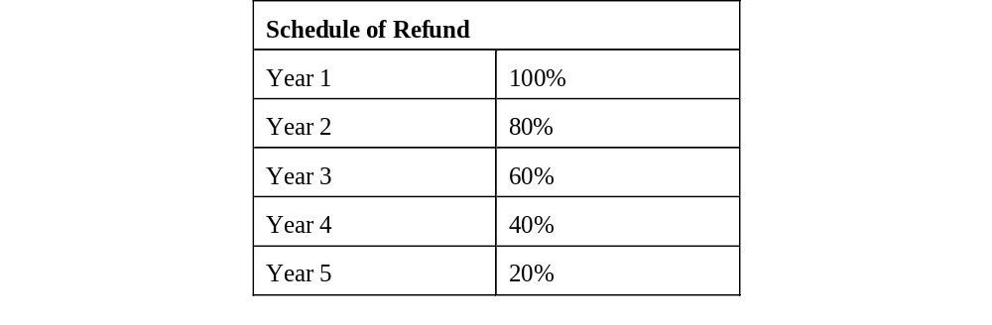
- Copyright and Patent Indemnity. Consultant shall defend, indemnify and shall hold harmless (including reasonable attorneys' fees) the State, NYSDOT, NYMTC, and any employee or agent thereof (each of the foregoing being hereinafter referred to as the "Indemnified Party") against all liability to third parties (other than liability solely the fault of the Indemnified Party) arising from and attributable to a breach of warranty, or negligent or intentional act or omissions of Consultant, its subconsultants, subcontractors, or the respective employees or agents of the aforesaid, or the possession or use by NYSDOT/NYMTC, of the System, including (but not limited to) the violation of any third party's trade secrets, proprietary information, trademark, copyright, or patent rights in connection with such System. A party requesting such indemnification shall give Consultant prompt notice of such a claim. Consultant shall conduct the defense in any such third party action arising as described herein and NYSDOT/NYMTC shall fully cooperate with such defense. This indemnification is limited to the System including modifications thereto made by Consultant or with Consultant's knowledge and consent and does not cover third party claims arising from modifications not authorized by or performed with the knowledge of Consultant or the use of the System in a combination or manner not specified by the Consultant.

  - Insurance. The Consultant shall procure, at its own sole cost and expense, and shall maintain in force at all times during the term of this contract including any extensions or renewals until Contract Final Acceptance, the policies of insurance covering all operations under the contract whether performed by it or its subconsultants as herein below set forth, written by companies authorized by the New York State Insurance Department to issue insurance in the State of New York and that have an A.M. Best Company rating of (A -) or better or approved by the Department. The Department may, at its sole discretion, permit the placement of policies with a non-authorized carrier or carriers upon request by the Consultant accompanied by the documentation required by 11 NYCRR §27.0 et seq.; provided that nothing herein shall be construed to require the Department to accept insurance placed with a non-authorized carrier under any circumstances. The Consultant shall deliver to the Department evidence of such policies as the Department deems necessary to verify that the required insurance is in effect. If policies are changed or canceled, the Consultant shall inform the State immediately. The State will determine whether to issue an order to the Consultant to stop work.

- Conditions Applicable to Insurance. All policies of insurance required by this agreement must meet the following requirements:

- Coverage Types and Policy Limits. The types of coverage and policy limits required from the Consultant are specified in Paragraph B, Insurance Requirements, below. General liability insurance shall apply separately on a per-job or per-project basis.

- Policy Forms. Except as may be otherwise specifically provided herein or agreed in writing by the Department, policies must be written on an occurrence basis. In the event that occurrence-based coverage is not commercially available, claims-made policy forms will be considered provided that, at minimum, it includes provisions that allow for (a) reporting circumstances or incidents that may give rise to future claims and (b) an extended reporting period of not less than three (3) years with respect to events that occurred but were not reported during the term of the policy. Insurance policies that remove or restrict blanket contractual liability located in the “insured contract” definition (as stated in Section V, Number 9, Item f in the ISO CGL policy) or that remove or modify the “insured contract” exception to the employers liability exclusion so as to limit coverage for claims that arise out of contract work, or that do not cover the additional insured for claims involving injury to employees of the named insured or subcontractors, are not acceptable. Policy forms must be provided to the Department upon request.

- Certificates of Insurance/Notices. Consultant shall provide a Certificate or Certificates of Insurance, in a form satisfactory to the Commissioner, before commencing any work under this contract. Certificates or transmittal correspondence shall reference NYSDOT Contract Number C000797. Consultant is strongly encouraged to transmit certificates and other materials concerning insurance coverage, referencing the Contract Number C000797 and the name of the Consultant in the Subject Line, by email to: Insur.consult.contr@dot.ny.gov. Certificates may be mailed to the:

New York State Department of Transportation
Contract Management Bureau
50 Wolf Road, Sixth Floor
Albany, NY 12232

Unless otherwise agreed, policies shall be written so as to require that the policy will not be (i) canceled, (ii) materially changed or (iii) permitted to expire or lapse for any reason except upon ten (10) days’ prior written notice to the Department by Certified Mail, Return Receipt Requested at the address stated above. In addition, if required by the Department, the Consultant shall deliver to the Department within ten (10) work days of such request a copy of any or all policies of insurance not previously provided, certified by the insurance carrier as true and complete. Certificates of Insurance shall:

- Be in a form satisfactory to the Department. The ACORD 25 Certificate must be accompanied by an ACORD 855 “New York Construction Addendum” completed to indicate information about the liability insurance.
- Be signed and dated by an authorized representative of the insurance carrier or producer.
- Disclose any deductible, self-insured retention, aggregate limit.
- Refer to this Contract by number on the face of the certificate.

If at any time during the term of this contract, it shall come to the attention of the Department that required insurance is not in effect or that adequate proof of insurance has not been provided, the Department may, at its option:

- Direct the Consultant to suspend work and not re-enter the premises with no additional payment or extension of time due on account thereof, or
- May withhold further contract payments in accordance with Paragraph 7 No Payment Due to Consultant’s Non-Compliance of the contract agreement, or
- Treat such failure as a breach or default of the contract.

- Additional Insureds. All insurance policies required by these specifications, except workers’ compensation and professional liability shall be endorsed to provide coverage to “The State of New York/New York State Department of Transportation, any municipality in which the work is being performed, any public benefit corporation, railroad, or public utility whose property or facilities are affected by the work, and their agents or employees” with respect to any claim arising from the Consultant’s Work under this contract or as a result of the Consultant’s activities. The endorsement shall be effected by endorsement of the applicable policy using ISO form CG 20 10 11 85, CG 20 37 07 04, CG 20 33 07 98 when used in combination with CG 20 37 07 04, or CG 20 33 10 01 or a form(s) that provides equivalent coverage.

- Primary Coverage. The liability and protective liability insurance policies shall provide primary and non-contributory coverage to the Department for any claim arising from the Consultant’s Work under this contract, or as a result of the Consultant’s activities.

- Waiver of Subrogation. As to every type and form of insurance coverage required from the Consultant, there shall be no right of subrogation against the State of New York/New York State Department of Transportation, its agents or employees. To the extent that any of Consultant’s policies of insurance prohibit such a waiver of subrogation, Consultant shall secure the necessary permission to make this waiver.

- Policy Renewal/Expiration. At least ten (10) calendar days prior to the expiration of any policy required by this contract, evidence of renewal or replacement policies of insurance with terms no less favorable to the Department than the expiring policies shall be delivered to the Department in the manner required for service of notice in Paragraph A.3. Certificates of Insurance/Notices above.

- Self-Insured Retention/Deductibles. Consultants utilizing self-insurance programs are required to provide a description of the program for Department approval. Collateralized deductible and self-insured retention programs administered by a third party may be approved. Except as may be specifically provided in the Contract Documents of a particular project, the Consultant or third-party-administered insurance deductible shall be limited to the amount of the bid deposit or $100,000, whichever is less. Security is not required if it is otherwise provided to an administrator for an approved risk management program. The Department will not accept a self-insured retention program without security being posted to assure payment of both the self-insured retention limit and the cost of adjusting claims. The Consultant shall be solely responsible for all claim expense and loss payments within any permitted deductible or self-insured retention. If the Consultant’s deductible in a self-administered program exceeds the amount of the bid deposit, the Consultant shall furnish an irrevocable Letter of Credit as collateral to guarantee its obligations. Such Letter of Credit or other collateral as may be approved by Department must be issued by a guarantor or surety with an AM Best Company rating of (A -) or better. If, at any time during the term of this agreement, the Department, in its sole discretion, determines that the Consultant is not paying its deductible, it may require the Consultant to collateralize all or any part of the deductible or self-insured retention on any or all policies of insurance or, upon failure to promptly do so, the same may be withheld from payments due the Consultant.

- Waiver of Indemnities. The Consultant waives any right of action it and/or its insurance carrier might have against the Department (including its employees, officers, commissioners, or agents) for any loss that is covered by a policy of insurance that is required by this contract. The Consultant waives any right of action it and/or its insurance carrier might have against the Department (including its employees, officers, commissioners, or agents) for any loss, whether or not such loss is insured.

- Subconsultant’s Liability Insurance. In the event that any portion of the work described in this contract is performed by an approved subconsultant, the insurance requirements of this Article shall be incorporated into the subcontract agreement. Subconsultant insurance requirements shall include the requirements for Workers’ Compensation, Commercial General Liability, and, if applicable, Commercial Auto and/or Professional Liability. Excess or umbrella insurance is not required for subconsultants. Consultant shall require that Certificates of Insurance, meeting the requirements of the Department are provided to the Department documenting the insurance coverage for each and every subconsultant employed by them to do work under this contract.

- Insurance Requirements. The types of insurance and minimum policy limits shall be as follows:

- NYS Workers’ Compensation and NYS Disability Insurance. As required by State Finance Law Section 142, the Consultant shall maintain in force workers’ compensation insurance upon forms required by or acceptable to the Workers Compensation Board for all of Consultant’s employees. Consultant shall also maintain disability insurance as required by the Disability Benefits Law of the State of New York.

- Commercial General Liability Insurance. The Consultant shall maintain an occurrence form commercial general liability policy or policies insuring against liability arising from premises (including loss of use thereof), personal injury or death, advertising injury, liability insured under an insured contract (including the tort liability of another assumed in a business contract) occurring on or in any way related to the premises or occasioned by reason of the operations of Consultant. Such coverage shall be written on an ISO occurrence form (ISO Form CG 00 01 12 07 or a policy form providing equivalent coverage) in an amount of not less than $1,000,000.00 per occurrence and not less than $2,000,000.00 aggregate. Unless otherwise provided, the policy or policies of insurance providing the liability coverage shall include:

- Coverage for contractual liability assumed by the Consultant insured under an insured contract (including the tort liability of another assumed in a business contract).
- All insurance policies required by these specifications except workers’ compensation and professional liability shall be endorsed to provide coverage to “the State of New York/New York State Department of Transportation, any municipality in which the work is being performed, any public benefit corporation, railroad, or public utility whose property or facilities are affected by the work, or any consultant inspecting engineer or inspector working for or on the project, and their agents or employees” using ISO form CG 20 10 11 85, CG 20 37 07 04, CG 20 33 07 98 when used in combination with CG 20 37 07 04, or CG 20 33 10 01 or a policy form or forms providing equivalent coverage.
- Products-Completed Operations Coverage, as provided in the General Liability Policy, or in certain instances through ISO form CG 26 11 09 99 or suitable equivalent.
- Where contract work will be performed by unregistered off-road equipment, Consultant shall provide documentation of a blanket Pollution Liability policy, or an endorsement to cover short-term pollution events, ISO form CG 04 33 10 01 or equivalent.
- Coverage for claims for bodily injury asserted by an employee of an additional insured and any Employer Liability Exclusion which may otherwise operate to exclude such coverage shall be voided in this respect.
- Explosion, Collapse and Underground Hazards coverage (“XCU”) (for contracts that call for the performance of excavating, underground work, and/or the use of blasting equipment).

- Commercial Automobile Insurance. Shall include liability and required coverage for New York. In the event that automobiles are used in connection with Consultant’s business or operations with the Department, the Consultant shall maintain a commercial or other automobile policy or policies insuring against liability for bodily injury, death, or damage to property and other mandatory coverages, relating to the use, operation, loading or unloading of any of Consultant’s automobiles (including owned, hired and non-owned vehicles) on and around the project. This may be ISO form CA 00 01 10 01, CA 00 01 01 87 or a policy form providing equivalent coverage along with mandatory New York endorsements. Coverage shall be in an amount of not less than $1,000,000 each accident.

- Umbrella or Excess Liability Insurance. The Consultant shall maintain an occurrence form umbrella liability policy or policies insuring against liability arising from premises (including loss of use thereof), operations, independent Consultants, products-completed operations, personal injury and advertising injury, and liability insured under an insured contract (including the tort liability of another assumed in a business contract) occurring on or in any way related to the premises or occasioned by reason of the operations of Consultant or arising from automobile liability as described above. Such coverage shall be written on an ISO occurrence form CU 00 01 12 07 or a policy form providing equivalent coverage. In the event that umbrella coverage is unavailable, equivalent excess coverage may be substituted. The minimum required limits for the umbrella/excess coverage shall be sufficient to provide a total of not less than $5,000,000 per occurrence/aggregate.

- Consultant’s Risks. The Consultant shall be responsible for obtaining any insurance it deems necessary to cover its own risks, including without limitation: (a) business interruption, such as gross earnings, extra expense, or similar coverage, (b) personal property, and/or (c) automobile physical damage and/or theft. In no event shall the Department be liable for any damage to, or loss of, personal property, or damage to, or loss of, an automobile that is covered by a policy of insurance that is required by this agreement, even if such loss is caused by the negligence of the Department.

  - Intellectual Property Rights to Licensed Software. Intellectual property rights to Software other than that governed by Article 12 hereof, are as follows:

- Third-Party Software. Third-party Software (if any) utilized under this project will be provided to NYSDOT/NYMTC with, as applicable, such other license terms as negotiated between the Consultant as negotiated between the Consultant and the Third-Party and as approved by NYSDOT/NYMTC. The Consultant shall use it best efforts to minimize the costs to the State of all Third-party Software under this Agreement.

- Consultant-Owned Software. This Software is provided by Consultant to NYSDOT/NYMTC, in accordance with the following terms:

- Consultant grants a royalty-free, perpetual, transferable, nonexclusive and irrevocable license for all Intellectual Property related to the Licensed Consultant-owned Software for authorized users of the NYSDOT/NYMTC.

- Such Software licenses shall include in their meaning: (i) any Maintenance Releases, enhancements or New Version of such Software developed by Consultant or its subconsultants or subcontractors during the term of this Agreement (within the Scope of Services or otherwise provided by Consultant or its subconsultants or subcontractors to the NYMC UPWP Web Application Project related thereto; (ii) and all materials, documentation and technical information provided to NYSDOT/NYMTC in written form and for use in connection with such Software; and (iii) If at any time after the acceptance date, Consultant shall develop any changes in the Licensed Software which change the basic program functions of the Software or add one or more new ones, the right to obtain such program changes at the lesser of (x) Consultant's standard prices for comparable applications then in effect for installing such changes; or (y) the difference between the then current price of such Software including such changes and the applicable fees and charges for the Licensed Software reflected herein.

- Consultant warrants that it has full power and authority to grant the rights granted by this subsection to NYSDOT/NYMTC with respect to such Software without the consent of any other person; and that neither the performance of services by Consultant nor the license to and use by NYSDOT/NYMTC of the Software, Software Modification and Software documentation (including the copying and modifying thereof, exclusive of modifications not made by Consultant) will in any way constitute an infringement or violation of any copyright, trade secret, trademark, patent, invention, proprietary information, non-disclosure, contract or any other rights of any third party.

- Consultant warrants that such Software, Software Modification, its license as described herein, and the performance by Consultant of services, to be in compliance with all applicable laws, rules and regulations.

  - Intellectual Property Developed Under This Agreement. Rights to intellectual property developed under this Agreement shall be allocated and owned in accordance with the following:

- Federal Law. The applicable provisions of Federal Law and regulation provide for the non-Federal parties of an agreement to retain all intellectual property rights developed under this Agreement, subject further to the provisions defining, identifying, allocating or restricting such rights otherwise set forth herein.

- Identification of Intellectual Property. Consultant is responsible for identifying and segregating in advance intellectual property which was or will be developed by Consultant or its subcontractors or subconsultants under this Agreement solely with non-Federal funding.

- Trade Secrets. The parties shall not publicly disclose information they obtain as a result of this Agreement which is marked and identified as proprietary or confidential, and which consists of information such as trade secrets or commercial or financial information that is privileged or confidential within the meaning of Section 552(b)(4) of Title 5, U.S.C.

- FHWA License. Under the FHWA Grant Agreement, FHWA has reserved a royalty-free, perpetual, transferable, nonexclusive and irrevocable license to reproduce, publish, modify or otherwise use in any media which exists currently or in the future and to authorize others to use any such copyrightable work produced under this Agreement with Federal funds, for Federal Government purposes.

- Patents. Rights to inventions made under this Agreement shall be determined in accordance with 37 C.F.R. Part 401. The standard patent rights clause at 37 C.F.R. Section 401.14, as modified below, is hereby incorporated by reference:

- The terms "to be performed by a small business firm or domestic nonprofit organization" shall be deleted from paragraph (g)(1) of the clause;
- Paragraphs (g)(2) and (g)(3) of the clause shall be deleted; and
- Paragraph (1) of the clause, entitled "Communications" shall read as follows: "(1) Communications. All notifications required by this clause shall be submitted to the FHWA Division Office."

- Ownership. The State shall own, outright, any NYMTC UPWP Web Application and associated documentation that are specific to the Project Scope and Deliverables developed under this Agreement.

- Backups. Consultant shall make at least weekly backups free from passwords, encryption or malicious or time triggered code, of all NYMTC UPWP Web Application content including, but not limited to speech files, vocabulary, text and manuals, HTML pages/code and data. One copy of all such backups shall be stored on an off-site, secure, recoverable location. Such backups shall be in a format readily recoverable and restorable to full-functionality such that no more than the last weeks’ worth of development work and information shall be lost. Consultant shall provide copies of backup material should NYSDOT/NYMTC request such. Consultant shall provide verification of such backups in compliance with the above terms, to NYSDOT/NYMTC upon request. NYMTC shall be responsible for backups of all software and data stored on NYMTC-owned or NYMTC-controlled equipment.

  - Provision of Source Code. Consultant shall place a copy of the source codes of the Consultant-Owned Software and any proprietary or custom developed software (for the NYMTC UPWP Web Application Project) and any Open-Source Software, and any supporting documentation and project manuals -- or subconsultant- or subcontractor-Owned Software onto NYMTC servers, in a mutually-agreed location, as a condition of milestone/deliverable Acceptance by NYMTC.

  - Training, Support and Maintenance. Consultant shall offer training in the use and implementation of the NYMTC UPWP Web Application to NYSDOT, NYMTC and selected employees who will be using the System in accordance with the Scope of Work (Schedule A) and incorporated herein as between the parties to this agreement. Upon the commencement of Phase 2, Consultant shall submit a training plan to NYSDOT/NYMTC’s Project Manager for approval. Said training plan shall include Consultant's proposal for providing end-user and technical training, determinations regarding the needs of the target audience, develop lesson plans and prepare visual aids. The NYSDOT/NYMTC will identify candidates for training courses and the Consultant shall arrange schedules and locations, which shall be at or proximate to the Project. Consultant shall also evaluate feedback on training sessions to enhance future sessions.

- Scope and Duration of Consultant Maintenance of Proprietary, Developed, and/or Third Party Software. Following initial installation and implementation of the proprietary, developed, or Third-Party Software involved in the project underlying this Agreement, Consultant shall provide ongoing maintenance during the term of this Agreement for such software and systems, which shall cover the software and systems provided by Consultant, be of the scope and duration, include the types of maintenance, and be provided in accordance with the requirements, set forth in Schedule A and Exhibit 4, Support and Maintenance Services Add-on.

- Terms and Conditions of Maintenance Agreement. The maintenance to be provided by Consultant under Article 14.1 shall include, but not be limited to, providing new releases or updates if issued, and/or patches or bypasses, to address any known material problem, i.e. any substantial deviation of unmodified software or systems from their then applicable specifications. In accordance with the provisions of this agreement and Schedule A and Exhibit 4 of this Agreement, providing NYSDOT/NYMTC with access to the current version of such software and systems, Consultant’s obligation to provide ongoing maintenance shall be limited to the then current version of such software and/or systems, and the immediately preceding version of same for a period of twelve (12) months after it is first superseded. Subject to such different or additional terms and conditions as may be set forth Schedule A and Exhibit 4, Consultant shall at minimum provide NYSDOT/NYMTC with the same level of maintenance for Consultant’s proprietary, developed, and/or licensed software that Consultant provides to other institutional clients and customers.

- Scope and Duration of Consultant Support for NYSDOT/NYMTC Usage of Proprietary, Developed and/or Licensed Third Party Software. The Consultant shall provide technical support during NYSDOT/NYMTC’s installation and implementation of the Developed or Consultant-Owned Software and Systems as set forth in Exhibit 4. Following the initial installation and implementation of the proprietary, developed, or licensed third-party software and related systems involved in the project underlying this Agreement, Consultant shall provide ongoing technical support during the term of this Agreement for NYSDOT usage of such software and systems, which shall cover the software and systems, be of the scope and duration, include the types of support, and be conducted in accordance with the requirements, set forth in Schedule A and Exhibit 4.

  - System Acceptance Tests.

- Implementation. Within five (5) business days of Contract approval by NYS, the Consultant shall meet with NYSDOT/NYMTC to negotiate any changes required to the NYMTC UPWP Web Application Project Plan as described in the Consultant’s proposal. Completion of each phase of the project shall be contingent upon satisfactory turnover of all deliverables by the Consultant and upon review and approval of those deliverables by NYSDOT/NYMTC.

- System Acceptance. In accordance with the NYMTC UPWP Web Application Project Plan, the Consultant shall advise NYSDOT/NYMTC in writing that the NYMTC UPWP Web Application (the System) is ready to be tested in accordance with the procedures outlined in Task 2.9 of Schedule A (Scope of Services). Prior to conduct of any acceptance testing the Consultant shall, at no additional expense to NYSDOT/NYMTC, provide training to NYSDOT/NYMTC staff as described in Task 2.10 of Schedule A (Scope of Services).

If and when the acceptance test results establish that the System is performing properly, NYSDOT/NYMTC shall notify Consultant in writing of its acceptance. Upon NYSDOT/NYMTC acceptance of the System, NYSDOT/NYMTC shall sign the Final Acceptance Certificate and the earlier of the date specified in the Final Acceptance Certificate or the date of execution of the Final Acceptance Certificate shall be the date on which the term of the Warranty Period shall begin (hereinafter, the Final Acceptance Date).

If the System repeatedly fails to perform properly in accordance with the Acceptance Test procedure outlined in Task 2.9 of Schedule A (Scope of Services), NYSDOT/NYMTC may determine that such failure constitutes a material default under this Agreement for the purposes of the default and termination provisions of this Agreement, or may afford the Consultant with additional opportunity to cure the default.

- Correction Costs. The Consultant's correction of the product deficiency shall be at no additional cost to NYSDOT/NYMTC unless the Acceptance Test failure(s) are the results of Disputed Work within the meaning of Section 4.6 of this Agreement (in which case the remedy within such section applies). The Consultant shall, however, bear sole responsibility for the costs of correction of product deficiencies revealed by such testing, including all previously unanticipated and unscheduled time and effort required for the development of corrective measures.

  - Consultant Warranties.

- Warranty Provisions. Beginning from the effective date of this agreement, Consultant warrants that, for the lesser of (i) two years from the effective date of this Agreement, or (ii) for a period of one year after the Final Acceptance Date, the NYMTC UPWP Web Application and Licensed Software shall be free from significant programming and operational errors which shall prevent it from operating in conformity with the standards set forth in this Agreement.

- If NYSDOT/NYMTC notifies Consultant that any Software, System or Service fails to conform to the requirements of this agreement during the Warranty period, Consultant shall remedy such failure at no additional cost to NYSDOT/NYMTC.

- NYSDOT/NYMTC agrees to provide Consultant with access (via remote desktop or virtual private network) to NYMTC owned, leased or third-party servers sufficient to be able to carry out necessary Warranty repairs or modifications.

- NYSDOT/NYMTC agrees that Consultant’s Warranty obligations do not apply if NYSDOT, NYMTC, nor third parties representing or working on behalf of NYSDOT or NYMTC make any changes to the Software, System, or Service without approval in writing by Consultant.

- NYSDOT/NYMTC agrees that Consultant’s Warranty does not apply to problems caused by failures, outages, or improper installation or maintenance of hardware or other (non-project) software; or by failures or bandwidth delays in network connectivity that are the responsibility of NYMTC, NYMTC’s hosting contractor, or any other third party.

- NYSDOT/NYMTC agrees that Consultant’s Warranty does not apply to problems caused by upgrades or other changes by NYMTC, or any other third party to the hardware, software, and configuration of the project hosting environment, unless the consultant team is notified a minimum of 30 days in advance of any such planned changes and given the opportunity to coordinate such upgrades.

- Exclusive Warranty for Third-Party Commercial-Off-The-Shelf Software. Notwithstanding the foregoing, Consultant's warranties do not apply to Third-Party Commercial-Off-The-Shelf Software that is not used as an integral component of the System. Such Third-Party Commercial-Off-The-Shelf Software manufacturer and any other third-party warranties shall, to the extent permissible, be passed through to NYSDOT/NYMTC.

- Correction of Defects. If at any time during the Warranty Period Consultant or NYSDOT/NYMTC discovers one or more defects or errors in the Software and Systems or any other respect in which such Software and Systems fail to conform to the provision of any warranty contained in the Agreement, Consultant shall, entirely at its own expense, correct such defect, error or non-conformity by, among other things, supplying NYSDOT/NYMTC with such corrective codes and making such additions, modifications or adjustments to the Software and Systems or hardware as may be necessary to keep all Software, Systems and hardware in operating order in conformity with the warranties herein, in accordance with the timeframes set forth in this Agreement.

- Warranty Disclaimer. Consultant disclaims any and all other promises, representations or warranties not expressly provided for elsewhere in this Agreement and its attachments, schedules and exhibits to the maximum extent allowable by law, with respect to the software and systems, either express or implied, including, but not limited to the implied warranties of merchantability and fitness for a specific purpose, and any warranties that the operation of the software will be uninterrupted or error free.

  - Suspension and Termination; Bankruptcy.

- Suspension or Termination for Convenience of NYSDOT. NYSDOT may without cause and for its convenience upon not less than seven (7) days written notice to Consultant suspend Consultant's performance under this Agreement or terminate this Agreement.

- Contracts between Consultant and its subconsultants or subcontractors shall provide for their suspension or termination without cause and for the convenience of Consultant upon not less than 7 day notice by Consultant to its subconsultants or subcontractors, and for closeout compensation in such event for work in progress and materials on order prior to termination, work performed, materials delivered, but not lost profit on the balance of contract work. NYSDOT may without cause and for its convenience upon not less than seven (7) days written notice to Consultant require Consultant to suspend or terminate any or all of its contracts pursuant to such provisions.

- If a termination is brought about for the convenience of the State and not as a result of unsatisfactory performance on the part of the Consultant, final payment shall be made based on the percentage of work satisfactorily completed by the Consultant, as determined by the State, times the Lump Sum amount.

- Suspension or Termination for Cause. NYSDOT may for cause and, unless in NYSDOT's judgment the public interest requires earlier action, upon not less than seven (7) days written notice to Consultant suspend Consultant's performance under this Agreement or terminate this Agreement if Consultant breaches or is in default of any obligation hereunder, which default is incapable of cure or which, being capable of cure, has not been cured within twenty (20) days after receipt of notice of such default from NYSDOT or within such additional cure period as NYSDOT may authorize. Consultant shall also be deemed in default if: (i) it fails to make reasonable progress as defined by NYSDOT on the Project in accordance with this Agreement; or (ii) the NYMTC UPWP Web Application does not perform in accordance with the requirements of this Agreement, notwithstanding Consultant’s remedial or maintenance efforts; or, (iii) other material violation of this Agreement that significantly endangers substantial performance of the Project.

- In the event of the termination of this Agreement for failure of Consultant to provide a specified, project deliverable, or in the performance of the NYMTC UPWP Web Application Software or Services during the Warranty Period as stated in Article 16.1 above, NYSDOT may: (i) recover from Consultant reasonable costs, fees and expenses incurred by NYSDOT to remedy such failure, including for elements which are rendered substantially useless as a result of such failure up to the amount paid to Consultant for the specified, project deliverable that has so failed; and, (ii) if such failure is integral to the entire NYMTC UPWP Web Application , all money paid for the NYMTC UPWP Web Application as well as associated services.

- In the event of the failure of a Project element, or component, or in the performance of the NYMTC UPWP Web Application Software, Systems or Services during the Warranty Period as stated in Article 16.1 above, NYSDOT may suspend Consultant's performance in whole or part without terminating this Agreement and contractually or otherwise remedy the failure at costs to be charged to Consultant or offset against Consultant's compensation under this Agreement. In the event of such suspension or other remedy, NYSDOT may: (i) recover from Consultant reasonable costs, fees and expenses incurred by NYSDOT to remedy such failure, including for elements which are rendered substantially useless as a result of such failure up to the amount paid to Consultant for the specified, project deliverable that has so failed; and, (ii) if such failure is integral to the entire NYMTC UPWP Web Application software and Systems, all money paid for the NYMTC UPWP Web Application Software and Systems as well as associated services.

- If a termination is brought about for the convenience of the State and not as a result of unsatisfactory performance on the part of the Consultant, final payment shall be made based on the percentage of work satisfactorily completed by the Consultant, as determined by the State.

- The New York State Department of Transportation reserves the right to terminate this contract in the event it is found that the certification filed by the Consultant in accordance with the requirements contained in State Finance Laws Sections 139j & 139k was intentionally false or intentionally incomplete. Upon such finding, the New York State Department of Transportation may exercise its termination right by providing written notification to the Consultant in accordance with the written notification terms of the contract.

- Delivery of Documentation. In the event of suspension or termination pursuant to this section Consultant shall secure for and deliver to the NYSDOT/NYMTC all documentation relating to the contracts terminated thereby, including, but not limited to, any designs, plans or specifications, contract and subcontract documents, tapes or discs.

- Impact on Project Schedule. In the event such suspension or termination affects project duration, the impact will be reflected in the project schedule.

- Suspension or Termination Payments. In general, suspension of performance or termination of any financial assistance under this Agreement will not invalidate the State's obligation to reimburse Consultant for costs and expenses properly incurred by Consultant and concurred in by the State before the suspension or termination date, to the extent those obligations cannot be canceled. However, if the State determines that Consultant has willfully misused State or Federal assistance funds by the gross negligence or willful failure to: make adequate progress; make reasonable use of the Project property, facilities, or equipment; or, adhere to the terms of this Agreement, the State reserves the right to require Consultant to refund the entire amount of State funding received by Consultant under this Agreement.

- Bankruptcy. Should a petition for bankruptcy be filed by Consultant pursuant to Title 11 USC or its successor statute:

- Consultant shall comply with all requirements as set forth in 11 USC Section 365 or any successor statute regarding the assumption, assignment or rejection of this Agreement. Consultant shall either cure all defaults, compensate actual losses, give adequate assurance of future performance and fulfill all obligations pursuant to 11 USC Section 365(b)(1) or other applicable law and assume the obligation; or shall reject this Agreement as provided by Bankruptcy Law. If this Agreement is rejected, possession of or rights to contract property, including subcontracts required for the performance of the Project (which is in the public interest), equipment and deliverables shall be immediately returned to or transferred and assigned to the State. No sale or assignment of this Agreement shall be permitted without the consent of the State or without compliance with the assumption and assignment provisions under Bankruptcy Law pursuant to 11 USC Section 365 or its successor statute.

- The Debtor may not assume or assign this Agreement if it has been terminated pursuant to the terms hereof prior to the filing for a petition for relief in bankruptcy.

- New York Court of Claims Jurisdiction – No Waiver. Notwithstanding the above, any claim, proceeding chose in action or judicial relief sought by consultant against the State, its agents’ servants or employees, shall be the exclusive jurisdiction of the New York Court of Claims, as more fully described in the New York Court of Claims Act. In no event shall the State’s appearance in U.S. Bankruptcy Court in relation to this contract be considered a waiver of this provision nor dispositive, in any way, of any questions of law, any questions of fact or matters in equity related to this Agreement.

- Consultant Warranties Surviving Suspension, Termination or Bankruptcy. Following a suspension or termination of this Agreement, and/or a Chapter 11 reorganization bankruptcy of Consultant, Consultant’s obligations to have provided properly-performing software and/or systems as required under this Agreement, and the warranties provided by Consultant to NYSDOT under this Agreement, shall continue in effect for the remainder of the term of this Agreement, without regard to such suspension or termination, and to the fullest extent allowed by federal bankruptcy statutes and case law. Consultant shall not avoid responsibility for failure to provide properly-performing software and/or systems as required under this Agreement by asserting that the suspension or termination of this Agreement, or Consultant’s Chapter 11 bankruptcy, has voided the obligations of Consultant’s contractual warranties under this Agreement.

- Limitation of Liability/Exclusion of Damages. Except for Licensee’s breach of confidentiality obligations hereunder, in no event shall either party be liable to the other for any incidental, indirect, special, consequential or punitive damages, related to the software that is not expressly provided for elsewhere in this Agreement and its attachments, schedules and exhibits, including without limitation lost profits, costs of delay, any failure of delivery, business interruption, costs of lost or damaged data or documentation, or liabilities to third parties arising from the software’s use, even if the party from which such damages are sought has been advised of the possibility of such damages. Notwithstanding the foregoing, Consultant remains liable, without monetary limitation, for direct damages for personal injury, death or damage to real property or tangible personal property or intellectual property attributable to the negligence or other tort of contractor, its officers, employees or agents.

  - Title to Equipment. Title shall vest in NYSDOT/NYMTC to all Equipment purchased or provided for the NYMTC UPWP Web Application Project by Consultant or its subconsultants or subcontractors. Consultant shall execute, acknowledge, deliver and perform, or cause to be executed, acknowledged, delivered or performed, all such bills of sale, assignments, conveyances or other documents or acts as NYSDOT/NYMTC may reasonably request in order to assure proper vesting in and confirming to NYSDOT, NYMTC, its successor and assigns, of title to and possession of such Equipment upon completion of the term of the Agreement or earlier termination thereof. In the event Consultant or its subconsultants or subcontractors lease Equipment for the NYMTC UPWP Web Application Project, Consultant or its subconsultants or subcontractors shall assure that the agreement for such Equipment provides for a lease transfer option to NYSDOT/NYMTC. For the purposes of this subsection, Equipment shall be deemed to include, but not be limited to, computers, computer hardware, monitors, consoles, cameras, video and other surveillance equipment, telephones, and furniture.

  - Independent Consultants or Contractors.

- Purpose. The purpose of this Agreement is to promote economic and technical cooperation and efficiencies among the Government, the State, Consultant and private entities, in pursuing mutually advantageous goals. The relationship of the parties to the Agreement is that of independent Consultants or Contractors and not joint venturers, partners, or agents.

- Officer or Employee of State. Consultant agrees that it will neither hold itself out as nor claim to be an officer or employee of the State, and that it will not, by reason hereof, make any claim, demand, or application to or for any right or privilege applicable to an officer or employee of the State including but not limited to worker's compensation coverage, unemployment insurance benefits, social security coverage, or retirement membership or credit.

  - Taxes. The following paragraph 60 of General Specifications by the New York State Office of General Services applies:

- Tax Provisions. Purchases made by the State of New York are not subject to State or Local taxes or Federal Excise taxes. To satisfy the requirements of the New York State sales tax, either the purchase order issued by an agency or institution of New York State for supplies or equipment, or the voucher forwarded to authorize payment for such supplies and equipment will be sufficient evidence that the sale by a contractor or Consultant was made to the State of New York, an exempt organization under section 1116(a)(1) of the Tax Law. Exemption certificates for Federal excise taxes will be furnished upon request by the Office of General Services, Standards and Purchase. No person, firm or corporation is, however, exempt from paying New York State Truck Mileage and Unemployment Insurance or the Federal Social Security Taxes.

The address of the Office of General Services, Standard and Purchases is:

Tower Building
38th Floor
Empire State Plaza
Albany, New York 12242

In lieu of the NYSDOT furnishing an exemption certificate for excise taxes, Consultant is advised that the New York Registration number 14740026K covers tax free transactions under the Internal Revenue Code.

  - Entire Agreement. This Agreement, together with its Schedules and Exhibits hereto, constitute the entire agreement between the parties with respect to the subject matter covered, and all prior representations or agreements have been merged into this document and superseded by it.

  - Amendments. Amendments to this Agreement and amended or Supplemental Schedules or Supplemental Exhibits may be made only in writing signed by both parties and specifically referred to as an amendment to this Agreement or Supplemental Schedule or Supplemental Exhibit.

  - Required Clauses. Attached hereto and made part of this Agreement, as fully set forth herein via Appendix A, Appendix A-1, Appendix B, Appendix C and Appendix D are Standard Clauses for all New York State contracts.

  - Executory Clause. It is understood by and between the parties hereto that this Agreement shall be deemed executory only to the extent of the moneys available to the State and no liability on account thereof shall be incurred by the State beyond moneys available for the purposes hereof.

  - Effective Date. This Agreement takes effect on Month Day, 2021.

  - Successors and Assigns. All the covenants and obligations of the parties hereunder shall bind their successors and assigns whether or not expressly assumed by such successors and assigns.

  - Interpretation. All Article headings utilized in this Agreement are for convenience only and shall not affect the construction hereof. All Appendices attached hereto are integral parts of this Agreement and the provisions set forth therein shall bind the parties hereto to the same extent as if such provision had been set forth in their entirety in the main body of this Agreement. Nothing expressed or implied herein shall give or be construed to give any person, firm or corporation other than the State or Consultant, any legal or equitable right, remedy or claim under or in respect of this Agreement. Neither this Agreement nor any of the terms hereof may be terminated, amended, supplemented, waived or modified orally. Any supplement or amendment to this Agreement shall be in writing.

  - Severability. If any part of this Agreement is determined to be invalid, illegal or unenforceable, such determination shall not affect the validity, legality or enforceability of any other part of this Agreement and the remaining parts of this Agreement shall be enforced as if such invalid, illegal or unenforceable part were not contained herein.

  - Counterparts. This Agreement may be executed in any number of counterparts, each of which shall be an original.

  - Assignment or Transfer of Agreement

- Consent Required. As required by the State Finance Law Section 138, Consultant shall not assign, transfer, convey, sublet or otherwise dispose of this Agreement or of its right, title or interest therein, or its power to execute such Agreement, to any other person, company or corporation, without the previous consent in writing of NYSDOT.

- Violation. If this restriction be violated, NYSDOT may revoke and annul the Agreement and, in that event, the State shall be relieved from any and all liability and obligations thereunder to the person, company or corporation to whom the Consultant shall assign, transfer, convey, sublet or otherwise dispose of the Agreement, and such transferee shall forfeit and lose all moneys therefore assigned under said Agreement.

  - Certification Required by 49CFR, Part 29. The signatory to this Agreement, being duly sworn, certifies that its company and any person associated therewith in the capacity of owner, partner, director, officer, or major stockholder (five percent or more ownership):

- is not currently under suspension, debarment, voluntary exclusion, or determination of ineligibility by any federal agency;
- has not been suspended, debarred, voluntarily excluded or determined ineligible by any federal agency within the past three years;
- does not have a proposed debarment pending; and
- has not been indicted, convicted, or had a civil judgment rendered against it by a court of competent jurisdiction in any matter involving fraud or official misconduct within the past three years.

  - Certification for Federal-Aid Contracts. The prospective participant certifies, by signing this Agreement to the best of his or her knowledge and belief, that:

- No Federal appropriated funds have been paid or will be paid, by or on behalf of the undersigned, to any person for influencing or attempting to influence an officer or employee of any Federal agency, a Member of Congress, an officer or employee of Congress, or an employee of a Member of Congress in connection with the awarding of any Federal contract, the making of any Federal grant, the making of any Federal loan, the entering into of any cooperative agreement, and extension, continuation, renewal, amendment, or modification of any Federal contract, grant, loan, or cooperative agreement.

- If any funds other than Federal appropriate funds have been paid or will be paid to any person for influencing or attempting to influence an officer or employee of any Federal agency, a Member of Congress, an officer or employee of Congress, or an employee of a Member of Congress in connection with this Federal contract, grant, loan or cooperative agreement, the undersigned shall complete and submit Standard Form-LLL, "Disclosure Form to Report Lobbying," in accordance with its instructions.

This certification is a material representation of fact upon which reliance was placed when this transaction was made or entered into. Submission of this certification is a prerequisite for making or entering this transaction imposed by Section 1352, Title 31, U.S. Code. Any person who fails to file the required certification shall be subject to a civil penalty of not less than $10,000 and not more than $100,000 for each such failure.

The prospective participant also agrees by submitting his or her bid or proposal that he or she shall require that the language of this certification be included in all lower tier subcontracts, which exceed $100,000 and that all such sub-recipients shall certify and disclose accordingly.

  - Application of Federal, State and Local Laws and Regulations. To achieve compliance with changing Federal requirements, Consultant agrees to include in all its subcontracts and shall require its sub-consultants or subcontractors to further contractually provide specific notice that Federal and State requirements may change and the changed requirements will apply to the Project as required.

  - Sub-Awards to Debarred Parties. Consultant acknowledges that it must not make any award or permit award of any contract or subcontract at any tier for work covered by this Agreement, to any party which is debarred or suspended or otherwise excluded from participation in Federal assistance programs under E.O. 12549, "Debarment and Suspension."

This certification is a material representation of fact upon which reliance was placed when this transaction was made or entered into. Submission of this certification is a prerequisite for making or entering into this transaction imposed by Section 1352, Title 31, U.S. Code. Any person who fails to file the required certification shall be subject to civil penalty of not less than $10,000 and not more than $100,000 for each such failure.

The Consultant also shall require that the language of this certification be included in all subcontract and lower tier subcontracts, which exceed $100,000 and that all such sub-recipients shall certify and disclose accordingly.

  - Governing Law. The parties hereto agree that this Agreement shall be governed by the Laws of the State of New York.

  - Security and Confidentiality of Information. Information received as part of this contract shall be considered Confidential Information. The Consultant warrants that it will take the appropriate steps as to its personnel, agents, officers and any Subcontractors/Sub-consultants regarding the obligations arising under this clause to insure such confidentiality. The Consultant shall have written policies and/or business procedures in place which will protect Confidential Information from unauthorized disclosure, use, access, loss, alteration or destruction. The Consultant may disclose to other parties, as authorized by the NYSDOT/NYMTC Project Manager, or as described in the scope of services, only the information necessary to perform services under this contract. However, the Consultant shall in no circumstance, communicate with the public or news media without prior authorization from the States designee. Neither shall the Consultant disclose information deemed confidential by the State nor shall the Consultant disclose any other information obtained or developed in the performance of services under this agreement without the written authorization of the State. This obligation shall survive termination of this Contract.

Consultant shall comply with the provisions of the New York State Information Security Breach and Notification Act, including General Business Law Section 889-aa and State Technology Law Section 208 as enacted by such Act or subsequently amended. In the event of an information security breach resulting in the unauthorized disclosure of personal information, Consultant shall be liable for the costs associated with such breach if caused by Consultant’s negligent or willful acts or omissions, or the negligent or willful acts or omissions of the Consultant’s agents, officers, employees or Sub-consultant.

- Non-Disclosure or Confidentiality Agreements. The Consultant shall agree to execute and be bound by any non-disclosure or confidentiality agreements that NYSDOT, NYMTC, or any other agency, consortia, corporation or other entity which requires such non-disclosure or confidentiality agreement to be executed before data, software, code or other information shall be provided to the NYMTC UPWP Web Application. The Consultant’s acceptance and execution of such agreements shall not be unreasonably withheld.

  - Vendor Responsibility. The NYS Department of Transportation has undertaken an affirmative review of the proposed consultant’s responsibility in accordance with the applicable standards outlined in Comptroller’s ‘Guide to Financial Operations’, and based upon such review, reasonable assurance that the proposed Consultant is responsible has been determined.

- The Consultant shall at all times during the Contract term remain responsible. The Consultant agrees, if requested by the Commissioner of Transportation or his or her designee, to present evidence of its continuing legal authority to do business in New York State, integrity, experience, ability, prior performance, and organizational and financial capacity.

- The Commissioner of Transportation or his or her designee, in his or her sole discretion, reserves the right to suspend any or all activities under this Contract, at any time, when he or she discovers information that calls into question the responsibility of the Consultant. In the event of such suspension, the Consultant will be given written notice outlining the particulars of such suspension. Upon issuance of such notice, the Consultant must comply with the terms of the suspension order. Contract activity may resume at such time as the Commissioner of Transportation or his or her designee issues a written notice authorizing a resumption of performance under the Contract.

- Upon written notice to the Consultant and a reasonable opportunity to be heard with appropriate NYSDOT officials or staff, the Contract may be terminated by the Commissioner of Transportation or his or her designee at the Consultant’s expense where the Consultant is determined by the Commissioner of Transportation or his or her designee to be non-responsible. In such event, the Commissioner of Transportation or his or her designee may complete the contractual requirements in any manner he or she may deem advisable and pursue available legal or equitable remedies for breach.

  - Compliance with Consultant Disclosure Laws. The Consultant shall timely, accurately and properly comply with the reporting requirements of State Finance Law Subdivision 17 of Section 8 and Subdivision 14 of Section 163 as amended by the Chapter 10 of the Laws of 2006, by submitting the New York State Office of the Comptroller’s “Form A - State Consultant Services – Contractor’s Planned Employment From Contract Start Date Through the End of the Contract Term” and “Form B - State Consultant Services – Contractor’s Annual Employment Report” (available through the NYSDOT’s website under Consultant Contract Reporting Requirements at: https://www.dot.ny.gov/main/business-center/consultants/forms-publications-and-instructions).

Annual employment reports should be submitted to the following addresses. It is recommended, however, that consultants check the agency websites annually to confirm the addresses.

By mail:

NYS Office of the State Comptroller
Bureau of Contracts
110 State Street, 11th Floor
Albany, N. Y. 12236
Attn: Consultant Reporting

NYS Department of Civil Service
Alfred E. Smith Building
Albany, N. Y. 12239
Attn: Chapter 10

NYS Department of Transportation: Reports that are submitted to the NYS Department of Transportation must be submitted electronically, preferably as a Word, Excel or pdf file via email to: consultantdisclosure@dot.ny.gov.

  - Reserved.

  - Notices.

- All notices permitted or required under this agreement hereunder shall be in writing and shall be transmitted either:

- via certified or registered United States mail, return receipt requested;
- by facsimile transmission;
- by personal delivery;
- by expedited delivery service; or
- by e-mail.

Such notices shall be addressed as follows or to such different addresses as the parties may from time-to-time designate:

For the New York State Department of Transportation:

Contact Person’s Name: Matt Bromirski, Contract #C037696
Title: Deputy Assistant Commissioner, Director, Contracts
Address: NYSDOT Contract Management Bur., 50 Wolf Rd., 6th Fl, Albany, NY 12232
Telephone Number: 518-457-2600
Facsimile Number: 518-457-2875
E-Mail Address: Matt.Bromirski@dot.ny.gov

And to:

The New York Metropolitan Transportation Council
25 Beaver Street, Suite 201
New York, NY 10004
ATTN: Mr. Seitu Allen, Admin. Group, Contract #C000797
E-Mail Address: I@dot.ny.gov

For the Consultant: ________________________

Contact Person’s Name: ________________
Title: _______________
Address: ______________________
Telephone Number: ___________
Facsimile Number: ___________
E-Mail Address: ___________

- Any such notice shall be deemed to have been given either at the time of personal delivery or, in the case of expedited delivery service or certified or registered United States mail, as of the date of first attempted delivery at the address and in the manner provided herein, or in the case of facsimile transmission or email, upon receipt.

- The parties may, from time to time, specify any new or different address in the United States as their address for purpose of receiving notice under this Agreement by giving fifteen (15) days written notice to the other party sent in accordance herewith. The parties agree to mutually designate individuals as their respective representatives for the purposes of receiving notices under this Agreement. Additional individuals may be designated in writing by the parties for purposes of implementation and administration/billing, resolving issues and problems and/or for dispute resolution.

  - Responsibility of the Consultant.

- The CONSULTANT shall be responsible for the professional quality, technical accuracy, and the coordination of all services furnished by the CONSULTANT under this contract. The CONSULTANT shall, without additional compensation, correct or revise any errors or deficiencies in its services. However, the STATE may in certain circumstances, provide compensation for such work.

- Neither the STATE'S review, approval or acceptance of, nor payment for, the services required under this contract shall be construed to operate as a waiver of any rights under this contract or of any cause of action arising out of the performance of this contract, and the CONSULTANT shall be and remain liable to the STATE in accordance with applicable law for all damages to the STATE caused by the CONSULTANT'S negligent performance or breach of contract of any of the services furnished under this contract.

- The rights and remedies of the STATE provided for under this contract are in addition to any other rights and remedies provided by law.

- If the CONSULTANT is comprised of more than one legal entity or any group of partners or joint venturers associated for the purposes of undertaking this agreement, each such entity acknowledges and hereby affirmatively represents and agrees that each has the power to bind the CONSULTANT and each of the others hereunder; and as such, each acts both as principal and agent of the CONSULTANT and of each of the others hereunder. Each further acknowledges and agrees that all such entities, partners or joint venturers associated for the purposes of undertaking this agreement shall be jointly and severally liable to third parties, including but not limited to the STATE, for the acts or omissions of the CONSULTANT or any other entity, partner or joint venturer hereunder.

- If the CONSULTANT is comprised of more than one legal entity or any group of partners or joint venturers associated for the purposes of undertaking this agreement, each such entity acknowledges and hereby affirmatively represents and agrees that the respective rights, duties and liabilities of each hereunder shall be governed by the laws of the State of New York, including but not limited to the New York Partnership Law.

  - TITLE VI Assurance. During the performance of this contract, the consultant or contractor, for itself, its assignees and successors in interest (hereinafter referred to as the "contractor") agrees as follows:

- Compliance with Regulations. The contractor shall comply with the Regulation relative to nondiscrimination in Federally-assisted programs of the Department of Transportation of the United States, Title 49, Code of Federal Regulations, Part 21, and the Federal Highway Administration (hereinafter “FHWA”) Title 23, Code of Federal Regulations, Part 200 as they may be amended from time to time, (hereinafter referred to as the Regulations), which are herein incorporated by reference and made a part of this contract.

- Nondiscrimination. The Contractor, with regard to the work performed by it during the contract, shall not discriminate on the grounds of race, color, or national origin, sex, age, and disability/handicap in the selection and retention of subcontractors, including procurements of materials and leases of equipment. The contractor shall not participate either directly or indirectly in the discrimination prohibited by 49 CFR, section 21.5 of the Regulations, including employment practices when the contract covers a program set forth in Appendix B of the Regulations.

- Solicitations for Subcontractors, Including Procurements of Materials and Equipment. In all solicitations either by competitive bidding or negotiation made by the contractor for work to be performed under a subcontract, including procurements of materials or leases of equipment, each potential subcontactor or supplier shall be notified by the contractor of the contractor's obligations under this contract and the Regulations relative to nondiscrimination on the grounds of race, color, or national origin, sex, age, and disability/handicap.

- Information and Reports. The contractor shall provide all information and reports required by the Regulations or directives issued pursuant thereto, and shall permit access to its books, records, accounts, other sources of information, and its facilities as may be determined by NYSDOT or the FHWA to be pertinent to ascertain compliance with such Regulations, orders and instructions. Where any information required of a contractor is in the exclusive possession of another who fails or refuses to furnish this information the contractor shall so certify to NYSDOT’s Office of Civil Rights or FHWA, as appropriate, and shall set forth what efforts it has made to obtain the information.

- Sanctions for Noncompliance. In the event of the contractor's noncompliance with the nondiscrimination provisions of this contract, NYSDOT shall impose such contract sanctions as it or the FHWA may determine to be appropriate, including, but not limited to:

- withholding of payments to the contractor under the contract until the contractor complies, and/or
- cancellation, termination or suspension of the contract, in whole or in part.

- Incorporation of Provisions. The contractor shall include the provisions of paragraphs 42.1 through 42.6 in every subcontract, including procurements of materials and leases of equipment, unless exempt by the Regulations, or directives issued pursuant thereto.

The contractor shall take such action with respect to any subcontract or procurement as NYSDOT or the FHWA may direct as a means of enforcing such provisions including sanctions for non-compliance: Provided, however, that, in the event a contractor becomes involved in, or is threatened with, litigation with a subcontractor or supplier as a result of such direction, the contractor may request NYSDOT to enter into such litigation to protect the interests of NYSDOT, and, in addition, the contractor may request the United States to enter into such litigation to protect the interests of the United States.

  - Reserved

  - Subcontractors/Subconsultants. All subcontractors and subconsultants performing work on this project shall be bound by the same required contract provisions as the prime consultant. All agreements between the prime consultant and a subcontractor or subconsultant shall include all standard required contract provisions, and such agreements shall be subject to review by the State.

  - Covenant Against Contingent Fees. The CONSULTANT warrants that they have not employed or retained any company or person, other than a bona fide employee working for the CONSULTANT, to solicit or secure this AGREEMENT, and that they have not paid or agreed to pay any company or person, other than a bona fide employee, any fee, commission, percentage, brokerage fee, gift, or any other consideration, contingent upon or resulting from the award or making of this AGREEMENT. For breach or violation of this warranty, the STATE shall have the right to annul this AGREEMENT without liability, or, in its discretion, to deduct from the AGREEMENT price or consideration, or otherwise recover, the full amount of such fee, commission, percentage, brokerage fee, gift, or contingent fee.

  - Code of Ethics. The CONSULTANT specifically agrees that this AGREEMENT may be canceled or terminated if any work under this AGREEMENT is in conflict with the provisions of Section 74 of the New York State Public Officer's Law, as amended, establishing a Code of Ethics for State officers and employees. The CONSULTANT shall not engage, on a full or part-time or other basis any professional or technical personnel who are or have been at any time during the period of this AGREEMENT in the employ of the Federal Highway Administration or the highway organizations of any public employer, except regularly retired employees, without the consent of the public employer of such person.

  - Death or Disability of the Consultant. In case of the death or disability of one or more but not all the persons herein referred to as CONSULTANT, the rights and duties of the CONSULTANT shall devolve upon the survivors of them, who shall be obligated to perform the services required under this AGREEMENT, and the STATE shall make all payments due to them.

In case of the death or disability of all the persons herein referred to as CONSULTANT, all data and records pertaining to the PROJECT shall be delivered within (60) days to the STATE or their duly authorized representative. In case of the failure of the CONSULTANT'S successors or personal representatives to make such delivery on demand, then in that event the representatives of the CONSULTANT shall be liable to the STATE for any damages it may sustain by reason thereof. Upon the delivery of all such data to the STATE, the STATE will pay to the representatives of the CONSULTANT all amounts due the CONSULTANT, including retained percentages to the date of the death of the last survivor.

  - Disposition of Data. At the time of completion of the work, the CONSULTANT shall make available to the STATE all documents and data pertaining to the work or to the PROJECT which materials at all times shall be the property of the STATE. It is agreed that the CONSULTANT may maintain copies of all documents and data. Or in the event that this Agreement is terminated for any reason, then, within ten (10) days after such termination, the CONSULTANT shall make available to the STATE the aforementioned data and material. All technical data in regard to the PROJECT existing in the office of the STATE or existing in the offices of the CONSULTANT shall be made available to the other party to this Agreement without expense to such other party.

  - Ensuring Pay Equity by State Consultants/Contractors. In accordance with Executive Order 162, issued on January 9, 2017, the consultant shall provide detailed workforce utilization reports of the CONSULTANT and each subconsultant – or subcontractor – that include, in addition to equal employment opportunity information, the job title and salary of each employee directly performing work on a STATE contract.

If the CONSULTANT cannot identify the individuals working directly on a State contract, then the CONSULTANT and each subconsultant shall provide such information of each employee in the CONSULTANT’S entire workforce. Such information shall be reported to the Department at quarterly intervals.

The reporting period shall be on a quarterly basis (January 1 through March 31, April 1 through June 30, July 1 through September 30 and October 1 through December 31). The reporting requirement shall begin on the effective date of the contract and continue for the duration of the contract term. Reports shall be submitted within 15 calendar days from the end of each reporting period. This provision is in effect for the quarterly reporting period ending December 31, 2017, or the quarterly reporting period that is immediately subsequent to the effective date of the contract, whichever date is later.

Detailed workforce utilization reports, as required above, shall be submitted in such form and in such
manner as shall be required by the Department and as in accordance with NYSDOT Consultant Instruction 17-02.

The Consultant shall include this provision in every subcontract so that such provisions shall be binding upon each subconsultant, if the subcontract is in excess of $25,000.

  - Conflict of Interest. The CONSULTANT has provided a form (Vendor Assurance of No Conflict of Interest or Detrimental Effect), signed by an authorized executive or legal representative attesting that the CONSULTANT’s performance of the services does not and will not create a conflict of interest with, nor position the CONSULTANT to breach any other contract currently in force with the State of New York, that the CONSULTANT will not act in any manner that is detrimental to any STATE project on which the CONSULTANT is rendering services.

The CONSULTANT hereby reaffirms the attestations made in its proposal and covenants and represents that there is and shall be no actual or potential conflict of interest that could prevent the CONSULTANT's satisfactory or ethical performance of duties required to be performed pursuant to the terms of this AGREEMENT. The CONTRACTOR shall have a duty to notify the STATE immediately of any actual or potential conflicts of interest.

In conjunction with any subcontract under this AGREEMENT, the CONSULTANT shall obtain and deliver to the STATE, prior to entering into a subcontract, a Vendor Assurance of No Conflict of Interest or Detrimental Effect form, signed by an authorized executive or legal representative of the subconsultant/subcontractor. The CONSULTANT shall also require in any subcontracting agreement that the subconsultant/subcontractor, in conjunction with any further subcontracting agreement, obtain and deliver to the STATE a signed and completed Vendor Assurance of No Conflict of Interest or Detrimental Effect form for each of its subconsultants/subcontractors prior to entering into a subcontract.

The STATE and the CONSULTANT recognize that conflicts may occur in the future because the CONSULTANT may have existing, or establish new, relationships. The STATE will review the nature of any relationships and reserves the right to terminate this AGREEMENT for any reason, or for cause, if, in the judgment of the STATE, a real or potential conflict of interest cannot be cured.

  - Ethics Requirements. The Consultant and its Subconsultants/Subcontractors shall not engage any person who is, or has been at any time, in the employ of the State to perform services in violation of the provisions of the New York Public Officers Law, other laws applicable to the service of State employees, and the rules, regulations, opinions, guidelines or policies promulgated or issued by the New York State Joint Commission on Public Ethics, or its predecessors (collectively, the “Ethics Requirements'). The Consultant certifies that all of its employees and those of its Subconsultants/Subcontractors who are former employees of the State and who are assigned to perform services under this Contract shall be assigned in accordance with all Ethics Requirements. During the Term, no person who is employed by the Consultant or its Subconsultants/Subcontractors and who is disqualified from providing services under this Contract pursuant to any Ethics Requirements may share in any net revenues of the Consultant or its Subconsultants/Subcontractors derived from this Contract. The Consultant shall identify and provide the State with notice of those employees of the Consultant and its Subconsultants/Subcontractors who are former employees of the State that will be assigned to perform services under this Contract, and make sure that such employees comply with all applicable laws and prohibitions. The State may request that the Consultant provide it with whatever information the State deems appropriate about each such person’s engagement, work cooperatively with the State to solicit advice from the New York State Joint Commission on Public Ethics, and, if deemed appropriate by the State, instruct any such person to seek the opinion of the New York State Joint Commission on Public Ethics. The State shall have the right to withdraw or withhold approval of any Subconsultant/Subcontractor if utilizing such Subconsultant/Subcontractor for any work performed hereunder would be in conflict with any of the Ethics Requirements. The State shall have the right to terminate this Contract at any time if any work performed hereunder is in conflict with any of the Ethics Requirements.

  - Subcontracting. The Consultant agrees not to subcontract any of its services, unless as indicated in its proposal, without the prior written approval of the State. Approval shall not be unreasonably withheld upon receipt of written request to subcontract.

The CONSULTANT may arrange for a portion(s) of its responsibilities under this AGREEMENT to be subcontracted to qualified, responsible subconsultants/subcontractors, subject to approval of the STATE. If the CONSULTANT determines to subcontract a portion of the services, the subconsultants/subcontractors must be clearly identified and the nature and extent of its involvement in and/or proposed performance under this AGREEMENT must be fully explained by the CONSULTANT to the STATE. As part of this explanation, the subconsultant/subcontractor must submit to the STATE a completed Vendor Assurance of No Conflict of Interest or Detrimental Effect form, as required by the CONSULTANT prior to execution of this AGREEMENT.

The CONSULTANT retains ultimate responsibility for all services performed under the AGREEMENT.

All subcontracts shall be in writing and shall contain provisions, which are functionally identical to, and consistent with, the provisions of this AGREEMENT including, but not limited to, the body of this AGREEMENT, Appendix A – Standard Clauses for New York State Contracts and the advertisement for proposals. Unless waived in writing by the STATE, all subcontracts between the CONSULTANT and subconsultants/subcontractors shall expressly name the STATE, through the Department of Transportation, as the sole intended third party beneficiary of such subcontract. The STATE reserves the right to review and approve or reject any subcontract, as well as any amendment to said subcontract(s), and this right shall not make the STATE a party to any subcontract or create any right, claim, or interest in the subconsultant/subcontractor or proposed subconsultant/subcontractor against the STATE.

The STATE reserves the right, at any time during the term of the AGREEMENT, to verify that the written subcontract between the CONSULTANT and subconsultants/subcontractors is in compliance with all of the provisions of this Section and any subcontract provisions contained in this AGREEMENT.

The CONSULTANT shall give the STATE immediate notice in writing of the initiation of any legal action or suit which relates in any way to a subcontract with a subconsultant/subcontractor or which may affect the performance of the CONSULTANT’s duties under the AGREEMENT. Any subcontract shall not relieve the CONSULTANT in any way of any responsibility, duty and/or obligation of the AGREEMENT.

If at any time during performance under this AGREEMENT total compensation to a subconsultant/subcontractor exceeds or is expected to exceed $100,000, that subconsultant/subcontractor shall be required to submit and certify a Vendor Responsibility Questionnaire.

  - Non-Infringement/Compliance with Laws. The selected Consultant warrants that in performing the services called for by this Agreement, that the Consultant shall not violate any applicable law, rule, or regulation, any Contracts with third parties, or any intellectual rights of any third party, including, but not limited to, and United States patent, trademark, copyright, or trade secret.

  - Assignment. The Prime Consultant shall not have the right to assign this Agreement or to assign or delegate any of its duties or obligations under this Agreement to any other party (whether by operation of law or otherwise), except to a successor in business, without the prior written consent of NYSDOT. Such consent will not be reasonably withheld. In the event that the Prime Consultant provides NYSDOT with written notice and NYSDOT does not respond within thirty (30) days, then NYSDOT’s consent to such assignment shall be deemed to have been granted. Any purported assignment in violation of this section shall be null and void. Further, the Consultant may not assign the right to receive money due under the Agreement without the prior written consent of NYSDOT.

The Prime Consultant shall not delegate any duties or obligations under this Agreement to a Subcontractor or Subconsultant other than a Subcontractor or Subconsultant named in the accepted Proposal unless NYSDOT has given written consent to the delegation.

  - Ownership. Perpetual licenses for software is NYSDOT’s preferred solution (provided that the cost of such lies within the State’s best interest). Should perpetual licenses not be granted, NYSDOT shall retain rights to all licenses (without fees, maintenance and support) and the use of the Software shall be granted, without restrictions, for a period of at least five (5) years after expiration of the Agreement. NYSDOT shall retain ownership of, and have unrestricted access to, all engineering data and other files stored in the document management system. Upon expiration of the Agreement, all externally stored data shall be transferred to NYSDOT, otherwise unrestricted access to it shall be granted at no cost for perpetuity. No encryption or other restrictive controls shall be imposed upon the data that limits its use or accessibility unless otherwise authorized. The vendor has no rights to stored or transferred data and shall not access or share data with others unless otherwise explicitly authorized by NYSDOT in writing. Any resources, settings, tools, configurations, customizations, etc., developed by the vendor, including by Subcontractors or Subconsultants and On-site Consultants, in specific support of NYSDOT operations shall become the property of the Prime Consultant yet a free forever usable copy shall be provided and remain available to NYSDOT at no cost for perpetuity.

IN WITNESS WHEREOF, this Contract No. C000797 has been executed by the STATE, acting by and through the Commissioner of Transportation, and the CONSULTANT, by signature below, has duly executed this Agreement effective the day and year first above written.

In addition to the acceptance of this Agreement, the Department also certifies that original copies of this signature page will be attached to all other exact copies of this Agreement.

RECOMMENDED BY THE PEOPLE OF THE STATE OF NEW YORK

______________________________________ ____ ______________________________________
New York Metropolitan Transportation Council Date

___________________________________ By: _________________________________
NYSDOT Contract Management Date Department of Transportation Date

Consultant Certifications: I certify that all the information with respect to the “Vendor Responsibility Questionnaire” submitted by (FIRM NAME) on the _____ day of __________________________, 20______ pursuant to the requirements set forth in OSC’s ‘Guidelines to Financial Operations’ is complete true and accurate. I additionally certify nothing has occurred since the date of that submission that would result in requiring a change or alteration to any of the answers provided on the “Vendor Responsibility Questionnaire” submitted that date.

In addition to the acceptance of this agreement, I certify that all information provided to the STATE with respect to the requirements contained in State Finance Laws Sections 139j & 139k is complete, true and accurate.

By _____________________________________ Date: ___________________________
Firm

NYMTC UPWP WEB APPLICATION PROJECT

APPROVALS

Attorney General Thomas P. DiNapoli
State Comptroller

By ______________________________

Date _____________________________

Acknowledgement for Contract #C000797

For contracts signed in New York State

State of New York )

County of ) ss.:

On the______ day of __________ in the year 20__, before me the undersigned, personally appeared __________________, personally known to me or proved to me on the basis of satisfactory evidence to be the individual(s) whose name(s) is (are) subscribed to the within instrument and acknowledged to me that he/she/they executed the same in his/her/their capacity(ies), and that by his/her/their signature(s) on the instrument, the individual(s), or the person upon behalf of which the individual(s) acted, executed the instrument.

__________________________________
Notary Public

My Commission Expires: _________________________

For contracts signed outside New York State

State of )

County of ) ss.:

On the ______ day of ___________ in the year 20___ before me, the undersigned, personally appeared __________________ , personally known to me or proved to me on the basis of satisfactory evidence to be the individual(s) whose name(s) is (are) subscribed to the within instrument and acknowledged to me that he/she/they executed the same in his/her/their capacity(ies), that by his/her/their signature(s) on the instrument, the individual(s), or the person upon behalf of which the individual(s) acted, executed the instrument, and that such individual made such appearance before the undersigned in ________________________________________ (insert the city or other political subdivision and the state or country or other place the acknowledgement was taken).

______________________________
Notary Public

_____________________________
(Signature and office of individual taking acknowledgement.)

My Commission Expires: _____________________________

APPENDIX A

STANDARD CLAUSES FOR NEW YORK STATE CONTRACTS

The parties to the attached contract, license, lease, amendment or other agreement of any kind (hereinafter, "the contract" or "this contract") agree to be bound by the following clauses which are hereby made a part of the contract (the word "Contractor" herein refers to any party other than the State, whether a contractor, licenser, licensee, lessor, lessee or any other party):

1. EXECUTORY CLAUSE. In accordance with Section 41 of the State Finance Law, the State shall have no liability under this contract to the Contractor or to anyone else beyond funds appropriated and available for this contract.

2. NON-ASSIGNMENT CLAUSE. In accordance with Section 138 of the State Finance Law, this contract may not be assigned by the Contractor or its right, title or interest therein assigned, transferred, conveyed, sublet or otherwise disposed of without the State’s previous written consent, and attempts to do so are null and void. Notwithstanding the foregoing, such prior written consent of an assignment of a contract let pursuant to Article XI of the State Finance Law may be waived at the discretion of the contracting agency and with the concurrence of the State Comptroller where the original contract was subject to the State Comptroller’s approval, where the assignment is due to a reorganization, merger or consolidation of the Contractor’s business entity or enterprise. The State retains its right to approve an assignment and to require that any Contractor demonstrate its responsibility to do business with the State. The Contractor may, however, assign its right to receive payments without the State’s prior written consent unless this contract concerns Certificates of Participation pursuant to Article 5-A of the State Finance Law.

3. COMPTROLLER'S APPROVAL. In accordance with Section 112 of the State Finance Law (or, if this contract is with the State University or City University of New York, Section 355 or Section 6218 of the Education Law), if this contract exceeds $50,000 (or the minimum thresholds agreed to by the Office of the State Comptroller for certain S.U.N.Y. and C.U.N.Y. contracts), or if this is an amendment for any amount to a contract which, as so amended, exceeds said statutory amount, or if, by this contract, the State agrees to give something other than money when the value or reasonably estimated value of such consideration exceeds $10,000, it shall not be valid, effective or binding upon the State until it has been approved by the State Comptroller and filed in his office. Comptroller's approval of contracts let by the Office of General Services is required when such contracts exceed $85,000 (State Finance Law Section 163.6-a). However, such pre-approval shall not be required for any contract established as a centralized contract through the Office of General Services or for a purchase order or other transaction issued under such centralized contract.

4. WORKERS' COMPENSATION BENEFITS. In accordance with Section 142 of the State Finance Law, this contract shall be void and of no force and effect unless the Contractor shall provide and maintain coverage during the life of this contract for the benefit of such employees as are required to be covered by the provisions of the Workers' Compensation Law.

5. NON-DISCRIMINATION REQUIREMENTS. To the extent required by Article 15 of the Executive Law (also known as the Human Rights Law) and all other State and Federal statutory and constitutional non-discrimination provisions, the Contractor will not discriminate against any employee or applicant for employment because of race, creed, color, sex (including gender identity or expression), national origin, sexual orientation, military status, age, disability, predisposing genetic characteristics, marital status or domestic violence victim status. Furthermore, in accordance with Section 220-e of the Labor Law, if this is a contract for the construction, alteration or repair of any public building or public work or for the manufacture, sale or distribution of materials, equipment or supplies, and to the extent that this contract shall be performed within the State of New York, Contractor agrees that neither it nor its subcontractors shall, by reason of race, creed, color, disability, sex, or national origin: (a) discriminate in hiring against any New York State citizen who is qualified and available to perform the work; or (b) discriminate against or intimidate any employee hired for the performance of work under this contract. If this is a building service contract as defined in Section 230 of the Labor Law, then, in accordance with Section 239 thereof, Contractor agrees that neither it nor its subcontractors shall by reason of race, creed, color, national origin, age, sex or disability: (a) discriminate in hiring against any New York State citizen who is qualified and available to perform the work; or (b) discriminate against or intimidate any employee hired for the performance of work under this contract. Contractor is subject to fines of $50.00 per person per day for any violation of Section 220-e or Section 239 as well as possible termination of this contract and forfeiture of all moneys due hereunder for a second or subsequent violation.

6. WAGE AND HOURS PROVISIONS. If this is a public work contract covered by Article 8 of the Labor Law or a building service contract covered by Article 9 thereof, neither Contractor's employees nor the employees of its subcontractors may be required or permitted to work more than the number of hours or days stated in said statutes, except as otherwise provided in the Labor Law and as set forth in prevailing wage and supplement schedules issued by the State Labor Department. Furthermore, Contractor and its subcontractors must pay at least the prevailing wage rate and pay or provide the prevailing supplements, including the premium rates for overtime pay, as determined by the State Labor Department in accordance with the Labor Law. Additionally, effective April 28, 2008, if this is a public work contract covered by Article 8 of the Labor Law, the Contractor understands and agrees that the filing of payrolls in a manner consistent with Subdivision 3-a of Section 220 of the Labor Law shall be a condition precedent to payment by the State of any State approved sums due and owing for work done upon the project.

7. NON-COLLUSIVE BIDDING CERTIFICATION. In accordance with Section 139-d of the State Finance Law, if this contract was awarded based upon the submission of bids, Contractor affirms, under penalty of perjury, that its bid was arrived at independently and without collusion aimed at restricting competition. Contractor further affirms that, at the time Contractor submitted its bid, an authorized and responsible person executed and delivered to the State a non-collusive bidding certification on Contractor's behalf.

8. INTERNATIONAL BOYCOTT PROHIBITION. In accordance with Section 220-f of the Labor Law and Section 139-h of the State Finance Law, if this contract exceeds $5,000, the Contractor agrees, as a material condition of the contract, that neither the Contractor nor any substantially owned or affiliated person, firm, partnership or corporation has participated, is participating, or shall participate in an international boycott in violation of the federal Export Administration Act of 1979 (50 USC App. Sections 2401 et seq.) or regulations thereunder. If such Contractor, or any of the aforesaid affiliates of Contractor, is convicted or is otherwise found to have violated said laws or regulations upon the final determination of the United States Commerce Department or any other appropriate agency of the United States subsequent to the contract's execution, such contract, amendment or modification thereto shall be rendered forfeit and void. The Contractor shall so notify the State Comptroller within five (5) business days of such conviction, determination or disposition of appeal (2NYCRR 105.4).

9. SET-OFF RIGHTS. The State shall have all of its common law, equitable and statutory rights of set-off. These rights shall include, but not be limited to, the State's option to withhold for the purposes of set-off any moneys due to the Contractor under this contract up to any amounts due and owing to the State with regard to this contract, any other contract with any State department or agency, including any contract for a term commencing prior to the term of this contract, plus any amounts due and owing to the State for any other reason including, without limitation, tax delinquencies, fee delinquencies or monetary penalties relative thereto. The State shall exercise its set-off rights in accordance with normal State practices including, in cases of set-off pursuant to an audit, the finalization of such audit by the State agency, its representatives, or the State Comptroller.

10. RECORDS. The Contractor shall establish and maintain complete and accurate books, records, documents, accounts and other evidence directly pertinent to performance under this contract (hereinafter, collectively, "the Records"). The Records must be kept for the balance of the calendar year in which they were made and for six (6) additional years thereafter. The State Comptroller, the Attorney General and any other person or entity authorized to conduct an examination, as well as the agency or agencies involved in this contract, shall have access to the Records during normal business hours at an office of the Contractor within the State of New York or, if no such office is available, at a mutually agreeable and reasonable venue within the State, for the term specified above for the purposes of inspection, auditing and copying. The State shall take reasonable steps to protect from public disclosure any of the Records which are exempt from disclosure under Section 87 of the Public Officers Law (the "Statute") provided that: (i) the Contractor shall timely inform an appropriate State official, in writing, that said records should not be disclosed; and (ii) said records shall be sufficiently identified; and (iii) designation of said records as exempt under the Statute is reasonable. Nothing contained herein shall diminish, or in any way adversely affect, the State's right to discovery in any pending or future litigation.

11. IDENTIFYING INFORMATION AND PRIVACY NOTIFICATION. (a) Identification Number(s). Every invoice or New York State Claim for Payment submitted to a New York State agency by a payee, for payment for the sale of goods or services or for transactions (e.g., leases, easements, licenses, etc.) related to real or personal property must include the payee's identification number. The number is any or all of the following: (i) the payee’s Federal employer identification number, (ii) the payee’s Federal social security number, and/or (iii) the payee’s Vendor Identification Number assigned by the Statewide Financial System. Failure to include such number or numbers may delay payment. Where the payee does not have such number or numbers, the payee, on its invoice or Claim for Payment, must give the reason or reasons why the payee does not have such number or numbers.

(b) Privacy Notification. (1) The authority to request the above personal information from a seller of goods or services or a lessor of real or personal property, and the authority to maintain such information, is found in Section 5 of the State Tax Law. Disclosure of this information by the seller or lessor to the State is mandatory. The principal purpose for which the information is collected is to enable the State to identify individuals, businesses and others who have been delinquent in filing tax returns or may have understated their tax liabilities and to generally identify persons affected by the taxes administered by the Commissioner of Taxation and Finance. The information will be used for tax administration purposes and for any other purpose authorized by law. (2) The personal information is requested by the purchasing unit of the agency contracting to purchase the goods or services or lease the real or personal property covered by this contract or lease. The information is maintained in the Statewide Financial System by the Vendor Management Unit within the Bureau of State Expenditures, Office of the State Comptroller, 110 State Street, Albany, New York 12236.

12. EQUAL EMPLOYMENT OPPORTUNITIES FOR MINORITIES AND WOMEN. In accordance with Section 312 of the Executive Law and 5 NYCRR 143, if this contract is: (i) a written agreement or purchase order instrument, providing for a total expenditure in excess of $25,000.00, whereby a contracting agency is committed to expend or does expend funds in return for labor, services, supplies, equipment, materials or any combination of the foregoing, to be performed for, or rendered or furnished to the contracting agency; or (ii) a written agreement in excess of $100,000.00 whereby a contracting agency is committed to expend or does expend funds for the acquisition, construction, demolition, replacement, major repair or renovation of real property and improvements thereon; or (iii) a written agreement in excess of $100,000.00 whereby the owner of a State assisted housing project is committed to expend or does expend funds for the acquisition, construction, demolition, replacement, major repair or renovation of real property and improvements thereon for such project, then the following shall apply and by signing this agreement the Contractor certifies and affirms that it is Contractor’s equal employment opportunity policy that:

(a) The Contractor will not discriminate against employees or applicants for employment because of race, creed, color, national origin, sex, age, disability or marital status, shall make and document its conscientious and active efforts to employ and utilize minority group members and women in its work force on State contracts and will undertake or continue existing programs of affirmative action to ensure that minority group members and women are afforded equal employment opportunities without discrimination. Affirmative action shall mean recruitment, employment, job assignment, promotion, upgradings, demotion, transfer, layoff, or termination and rates of pay or other forms of compensation;

(b) at the request of the contracting agency, the Contractor shall request each employment agency, labor union, or authorized representative of workers with which it has a collective bargaining or other agreement or understanding, to furnish a written statement that such employment agency, labor union or representative will not discriminate on the basis of race, creed, color, national origin, sex, age, disability or marital status and that such union or representative will affirmatively cooperate in the implementation of the Contractor's obligations herein; and

(c) the Contractor shall state, in all solicitations or advertisements for employees, that, in the performance of the State contract, all qualified applicants will be afforded equal employment opportunities without discrimination because of race, creed, color, national origin, sex, age, disability or marital status.

Contractor will include the provisions of "a", "b", and "c" above, in every subcontract over $25,000.00 for the construction, demolition, replacement, major repair, renovation, planning or design of real property and improvements thereon (the "Work") except where the Work is for the beneficial use of the Contractor. Section 312 does not apply to: (i) work, goods or services unrelated to this contract; or (ii) employment outside New York State. The State shall consider compliance by a contractor or subcontractor with the requirements of any federal law concerning equal employment opportunity which effectuates the purpose of this section. The contracting agency shall determine whether the imposition of the requirements of the provisions hereof duplicate or conflict with any such federal law and if such duplication or conflict exists, the contracting agency shall waive the applicability of Section 312 to the extent of such duplication or conflict. Contractor will comply with all duly promulgated and lawful rules and regulations of the Department of Economic Development’s Division of Minority and Women's Business Development pertaining hereto.

13. CONFLICTING TERMS. In the event of a conflict between the terms of the contract (including any and all attachments thereto and amendments thereof) and the terms of this Appendix A, the terms of this Appendix A shall control.

14. GOVERNING LAW. This contract shall be governed by the laws of the State of New York except where the Federal supremacy clause requires otherwise.

15. LATE PAYMENT. Timeliness of payment and any interest to be paid to Contractor for late payment shall be governed by Article 11-A of the State Finance Law to the extent required by law.

16. NO ARBITRATION. Disputes involving this contract, including the breach or alleged breach thereof, may not be submitted to binding arbitration (except where statutorily authorized), but must, instead, be heard in a court of competent jurisdiction of the State of New York.

17. SERVICE OF PROCESS. In addition to the methods of service allowed by the State Civil Practice Law & Rules ("CPLR"), Contractor hereby consents to service of process upon it by registered or certified mail, return receipt requested. Service hereunder shall be complete upon Contractor's actual receipt of process or upon the State's receipt of the return thereof by the United States Postal Service as refused or undeliverable. Contractor must promptly notify the State, in writing, of each and every change of address to which service of process can be made. Service by the State to the last known address shall be sufficient. Contractor will have thirty (30) calendar days after service hereunder is complete in which to respond.

18. PROHIBITION ON PURCHASE OF TROPICAL HARDWOODS. The Contractor certifies and warrants that all wood products to be used under this contract award will be in accordance with, but not limited to, the specifications and provisions of Section 165 of the State Finance Law, (Use of Tropical Hardwoods) which prohibits purchase and use of tropical hardwoods, unless specifically exempted, by the State or any governmental agency or political subdivision or public benefit corporation. Qualification for an exemption under this law will be the responsibility of the contractor to establish to meet with the approval of the State.

In addition, when any portion of this contract involving the use of woods, whether supply or installation, is to be performed by any subcontractor, the prime Contractor will indicate and certify in the submitted bid proposal that the subcontractor has been informed and is in compliance with specifications and provisions regarding use of tropical hardwoods as detailed in Section 165 State Finance Law. Any such use must meet with the approval of the State; otherwise, the bid may not be considered responsive. Under bidder certifications, proof of qualification for exemption will be the responsibility of the Contractor to meet with the approval of the State.

19. MACBRIDE FAIR EMPLOYMENT PRINCIPLES. In accordance with the MacBride Fair Employment Principles (Chapter 807 of the Laws of 1992), the Contractor hereby stipulates that the Contractor either (a) has no business operations in Northern Ireland, or (b) shall take lawful steps in good faith to conduct any business operations in Northern Ireland in accordance with the MacBride Fair Employment Principles (as described in Section 165 of the New York State Finance Law), and shall permit independent monitoring of compliance with such principles.

20. OMNIBUS PROCUREMENT ACT OF 1992. It is the policy of New York State to maximize opportunities for the participation of New York State business enterprises, including minority and women-owned business enterprises as bidders, subcontractors and suppliers on its procurement contracts.

Information on the availability of New York State subcontractors and suppliers is available from:
NYS Department of Economic Development
Division for Small Business
Albany, New York 12245
Telephone: 518-292-5100
Fax: 518-292-5884
email: opa@esd.ny.gov

A directory of certified minority and women-owned business enterprises is available from:
NYS Department of Economic Development
Division of Minority and Women's Business Development
633 Third Avenue
New York, NY 10017
212-803-2414
email: mwbecertification@esd.ny.gov
https://ny.newnycontracts.com/FrontEnd/VendorSearchPublic.asp

The Omnibus Procurement Act of 1992 requires that by signing this bid proposal or contract, as applicable, Contractors certify that whenever the total bid amount is greater than $1 million:

(a) The Contractor has made reasonable efforts to encourage the participation of New York State Business Enterprises as suppliers and subcontractors, including certified minority and women-owned business enterprises, on this project, and has retained the documentation of these efforts to be provided upon request to the State;

(b) The Contractor has complied with the Federal Equal Opportunity Act of 1972 (P.L. 92-261), as amended;

(c) The Contractor agrees to make reasonable efforts to provide notification to New York State residents of employment opportunities on this project through listing any such positions with the Job Service Division of the New York State Department of Labor, or providing such notification in such manner as is consistent with existing collective bargaining contracts or agreements. The Contractor agrees to document these efforts and to provide said documentation to the State upon request; and

(d) The Contractor acknowledges notice that the State may seek to obtain offset credits from foreign countries as a result of this contract and agrees to cooperate with the State in these efforts.

21. RECIPROCITY AND SANCTIONS PROVISIONS. Bidders are hereby notified that if their principal place of business is located in a country, nation, province, state or political subdivision that penalizes New York State vendors, and if the goods or services they offer will be substantially produced or performed outside New York State, the Omnibus Procurement Act 1994 and 2000 amendments (Chapter 684 and Chapter 383, respectively) require that they be denied contracts which they would otherwise obtain. NOTE: As of May 15, 2002, the list of discriminatory jurisdictions subject to this provision includes the states of South Carolina, Alaska, West Virginia, Wyoming, Louisiana and Hawaii. Contact NYS Department of Economic Development for a current list of jurisdictions subject to this provision.

22. COMPLIANCE WITH NEW YORK STATE INFORMATION SECURITY BREACH AND NOTIFICATION ACT. Contractor shall comply with the provisions of the New York State Information Security Breach and Notification Act (General Business Law Section 899-aa; State Technology Law Section 208).

23. COMPLIANCE WITH CONSULTANT DISCLOSURE LAW. If this is a contract for consulting services, defined for purposes of this requirement to include analysis, evaluation, research, training, data processing, computer programming, engineering, environmental, health, and mental health services, accounting, auditing, paralegal, legal or similar services, then, in accordance with Section 163 (4-g) of the State Finance Law (as amended by Chapter 10 of the Laws of 2006), the Contractor shall timely, accurately and properly comply with the requirement to submit an annual employment report for the contract to the agency that awarded the contract, the Department of Civil Service and the State Comptroller.

24. PROCUREMENT LOBBYING. To the extent this agreement is a "procurement contract" as defined by State Finance Law Sections 139-j and 139-k, by signing this agreement the contractor certifies and affirms that all disclosures made in accordance with State Finance Law Sections 139-j and 139-k are complete, true and accurate. In the event such certification is found to be intentionally false or intentionally incomplete, the State may terminate the agreement by providing written notification to the Contractor in accordance with the terms of the agreement.

25. CERTIFICATION OF REGISTRATION TO COLLECT SALES AND COMPENSATING USE TAX BY CERTAIN STATE CONTRACTORS, AFFILIATES AND SUBCONTRACTORS. To the extent this agreement is a contract as defined by Tax Law Section 5-a, if the contractor fails to make the certification required by Tax Law Section 5-a or if during the term of the contract, the Department of Taxation and Finance or the covered agency, as defined by Tax Law 5-a, discovers that the certification, made under penalty of perjury, is false, then such failure to file or false certification shall be a material breach of this contract and this contract may be terminated, by providing written notification to the Contractor in accordance with the terms of the agreement, if the covered agency determines that such action is in the best interest of the State.

26. IRAN DIVESTMENT ACT. By entering into this Agreement, Contractor certifies in accordance with State Finance Law Section 165-a that it is not on the “Entities Determined to be Non-Responsive Bidders/Offerers pursuant to the New York State Iran Divestment Act of 2012” (“Prohibited Entities List”) posted at: http://www.ogs.ny.gov/about/regs/docs/ListofEntities.pdf

Contractor further certifies that it will not utilize on this Contract any subcontractor that is identified on the Prohibited Entities List. Contractor agrees that should it seek to renew or extend this Contract, it must provide the same certification at the time the Contract is renewed or extended. Contractor also agrees that any proposed Assignee of this Contract will be required to certify that it is not on the Prohibited Entities List before the contract assignment will be approved by the State.

During the term of the Contract, should the state agency receive information that a person (as defined in State Finance Law Section 165-a) is in violation of the above-referenced certifications, the state agency will review such information and offer the person an opportunity to respond. If the person fails to demonstrate that it has ceased its engagement in the investment activity which is in violation of the Act within 90 days after the determination of such violation, then the state agency shall take such action as may be appropriate and provided for by law, rule, or contract, including, but not limited to, imposing sanctions, seeking compliance, recovering damages, or declaring the Contractor in default.

The state agency reserves the right to reject any bid, request for assignment, renewal or extension for an entity that appears on the Prohibited Entities List prior to the award, assignment, renewal or extension of a contract, and to pursue a responsibility review with respect to any entity that is awarded a contract and appears on the Prohibited Entities list after contract award.

Updated January 2014

APPENDIX A-1

SUPPLEMENTAL TITLE VI PROVISIONS (CIVIL RIGHTS ACT)

During the performance of this contract, the contractor, for itself, its assignees and successors in interest (hereinafter referred to as the "contractor") agrees as follows:
- Compliance with Regulations: The contractor shall comply with the Regulation relative to nondiscrimination in Federally-assisted programs of the Department of Transportation of the United States, Title 49, Code of Federal Regulations, Part 21, and the Federal Highway Administration (hereinafter “FHWA”) Title 23, Code of Federal Regulations, Part 200 as they may be amended from time to time, (hereinafter referred to as the Regulations), which are herein incorporated by reference and made a part of this contract.

- Nondiscrimination: The Contractor, with regard to the work performed by it during the contract, shall not discriminate on the grounds of race, color, or national origin, sex, age, and disability/handicap in the selection and retention of subcontractors, including procurements of materials and leases of equipment. The contractor shall not participate either directly or indirectly in the discrimination prohibited by 49 CFR, section 21.5 of the Regulations, including employment practices when the contract covers a program set forth in Appendix B of the Regulations.

- Solicitations for Subcontractors, Including Procurements of Materials and Equipment: In all solicitations either by competitive bidding or negotiation made by the contractor for work to be performed under a subcontract, including procurements of materials or leases of equipment, each potential subcontactor or supplier shall be notified by the contractor of the contractor's obligations under this contract and the Regulations relative to nondiscrimination on the grounds of race, color, or national origin, sex, age, and disability/handicap.

- Information and Reports: The contractor shall provide all information and reports required by the Regulations or directives issued pursuant thereto, and shall permit access to its books, records, accounts, other sources of information, and its facilities as may be determined by NYSDOT or the FHWA to be pertinent to ascertain compliance with such Regulations, orders and instructions. Where any information required of a contractor is in the exclusive possession of another who fails or refuses to furnish this information the contractor shall so certify to NYSDOT’s Office of Civil Rights or FHWA, as appropriate, and shall set forth what efforts it has made to obtain the information.

- Sanctions for Noncompliance: In the event of the contractor's noncompliance with the nondiscrimination provisions of this contract, NYSDOT shall impose such contract sanctions as it or the FHWA may determine to be appropriate, including, but not limited to:
  - withholding of payments to the contractor under the contract until the contractor complies, and/or
  - cancellation, termination or suspension of the contract, in whole or in part.

- Incorporation of Provisions: The contractor shall include the provisions of paragraphs (1) through (6) in every subcontract, including procurements of materials and leases of equipment, unless exempt by the Regulations, or directives issued pursuant thereto.

The contractor shall take such action with respect to any subcontractor procurement as NYSDOT or the FHWA may direct as a means of enforcing such provisions including sanctions for non-compliance: Provided, however, that, in the event a contractor becomes involved in, or is threatened with, litigation with a subcontractor or supplier as a result of such direction, the contractor may request NYSDOT to enter into such litigation to protect the interests of NYSDOT, and, in addition, the contractor may request the United States to enter into such litigation to protect the interests of the United States.

APPENDIX B

Requirements for Federally-Aided Transportation Projects

There is a substantial body of requirements attached to the use of Federal highway or transportation aid. These requirements create or overlay processes, procedures, documentation requirements, authorizations, approvals and certifications that may be substantially greater or different from those that are not funded with Federal-aid and proceed under applicable State and local laws, customs and practices. Under Title 23 of the United States Code, the New York State Department of Transportation (NYSDOT) is responsible for the administration of transportation projects in New York State to which NYSDOT provides Federal highway or transportation-related aid. Through this Agreement, which provides or is associated with such funding, NYSDOT delegates various elements of project and funding administration as described elsewhere in this Agreement. In undertaking a Federally aided project, the Municipality/Sponsor, Authority or Project Manager designated under this Agreement with Federal-aid funding or project administration agrees to proceed in compliance with all the applicable Federal-aid requirements.
NYSDOT, in cooperation with FHWA, has assembled the body of Federal-aid requirements, procedures and practices in its Procedures for Locally Administered Federal-Aid Projects Manual (available through NYSDOT’s web site at: http://www.dot.ny.gov/plafap). In addition, the Municipality/Sponsor, Authority or Project Manager designated under this Agreement for Federal-aid funding or project administration that enters into Federally aided project construction contracts is required to physically incorporate into all its Federally aided construction contracts and subcontracts there under the provisions that are contained in Form FHWA-1273 (available from NYSDOT or electronically at: http://www.fhwa.dot.gov/programadmin/contracts/1273.htm).
In addition to the referenced requirements, the attention of Municipality/Sponsor hereunder is directed to the following requirements and information:
NON-DISCRIMINATION/EEO/DBE REQUIREMENTS
The Municipality/Sponsor and its contractors agree to comply with Executive Order 11246, entitled "Equal Employment Opportunity" and United States Department of Transportation (USDOT) regulations (49 CFR Parts 21, 23, 25, 26 and 27) and the following:
1. NON-DISCRIMINATION. No person shall, on the ground of race, color, creed, national origin, sex, age or handicap, be excluded from participation in, or denied the benefits of, or be subject to, discrimination under the Project funded through this Agreement.
2. EQUAL EMPLOYMENT OPPORTUNITY. In connection with the execution of this Agreement, the Municipality/Sponsors contractors or subcontractors shall not discriminate against any employee or applicant for employment because of race, religion, age, color, sex or national origin. Such contractors shall take affirmative actions to ensure that applicants are employed, and that employees are treated during their employment, without regard to their race, religion, color, sex, national origin or age. Such actions shall include, but not be limited to, the following: employment, upgrading, demotion or transfer; recruitment or recruitment advertising; layoff or termination; rates of pay or other forms of compensation; and selection for training, including apprenticeship.
3. DISADVANTAGED BUSINESS ENTERPRISES. In connection with the performance of this Agreement, the Municipality/Sponsor shall cause its contractors to cooperate with the State in meeting its commitments and goals with regard to the utilization of Disadvantaged Business Enterprises (DBEs) and will use its best efforts to ensure that DBEs will have opportunity to compete for subcontract work under this Agreement. Also, in this connection the Municipality or Municipality/Sponsor shall cause its contractors to undertake such actions as may be necessary to comply with 49 CFR Part 26.
As a sub-recipient under 49 CFR Part 26.13, the Municipality/Sponsor hereby makes the following assurance.
The Municipality/Sponsor shall not discriminate on the basis of race, color, national origin, or sex in the award and performance of any United States Department of Transportation (USDOT)-assisted contract or in the administration of its Disadvantaged Business Enterprise (DBE) program or the requirements of 49 CFR Part 26. The Municipality/Sponsor shall take all necessary and reasonable steps under 49 CFR Part 26 to ensure nondiscrimination in the award and administration of the United States Department of Transportation-assisted contracts. The New York State Department of Transportation’s DBE program, as required by 49 CFR Part 26 and as approved by the United States Department of Transportation, is incorporated by reference in this agreement. Implementation of this program is a legal obligation and failure to carry out its terms shall be treated as a violation of this agreement. Upon notification to the recipient of its failure to carry out its approved program, the USDOT may impose sanctions as provided for under part 26 and may, in appropriate cases, refer the matter for enforcement under 18 U.S.C. 1001 and/or the Program Fraud Civil Remedies Act of 1986 (31 U.S.C. 3801 et seq.).
FEDERAL SINGLE AUDIT REQUIREMENTS
Non Federal entities that expend $750,000 or more in a year in Federal awards from all sources are required to comply with the Federal Single Audit Act provisions contained in U.S. Office of Management and Budget (OMB) Circular No. A 133, Audits of States, Local Governments, and Non Profit Organizations. Non Federal entities that expend Federal awards from a single source may provide a program specific audit, as defined in the Circular. Non Federal entities that expend less than the amount above in a year in Federal awards from all sources are exempt from Federal audit requirements for that year, except as noted in Sec. 215 (a) of OMB Circular A-133 Subpart B--Audits, records must be available for review or audit by appropriate officials of the cognizant Federal agency the New York State Department of Transportation, the New York State Comptroller’s Office and the U.S. Governmental Accountability Office (GAO).
Non Federal entities are required to submit a copy of all audits, as described above, within 30 days of issuance of audit report, but no later than 9 months after the end of the entity’s fiscal year, to the New York State Department of Transportation, Contract Audit Bureau, 50 Wolf Road, Albany, NY 12232. Unless a time extension has been granted by the cognizant Federal Agency and has been filed with the New York State Department of Transportation’s Contract Audit Bureau, failure to comply with the requirements of OMB Circular A-133 may result in suspension or termination of Federal award payments.
THE CATALOG OF FEDERAL DOMESTIC ASSISTANCE
The Catalog of Federal Domestic Assistance (CFDA ), is an on-line database of all Federally-aided programs available to State and local governments (including the District of Columbia); Federally recognized Indian tribal governments; Territories (and possessions) of the United States; domestic public, quasi-public, and private profit and nonprofit organizations and institutions; specialized groups; and individuals.
THE CFDA IDENTIFICATION NUMBER
OMB Circular A 133 requires all Federal aid recipients to identify and account for awards and expenditures by CFDA Number. The Municipality/Sponsor is required to identify in its accounts all Federal awards received and expended, and the Federal programs under which they were received. Federal program and award identification shall include, as applicable, the CFDA title and number, award number and year, name of the Federal agency, and name of the pass through entity.
The most commonly used CFDA number for the Federal Aid Highway Planning and Construction program is 20.205.
Additional CFDA numbers for other transportation and non-transportation related programs are:
20.215 Highway Training and Education
20.219 Recreational Trails Program
20.XXX Highway Planning and Construction - Highways for LIFE;
20.XXX Surface Transportation Research and Development;
20.500 Federal Transit-Capital Investment Grants
20.505 Federal Transit-Metropolitan Planning Grants
20.507 Federal Transit-Formula Grants
20.509 Formula Grants for Other Than Urbanized Areas
20.600 State and Community Highway Safety
23.003 Appalachian Development Highway System
23.008 Appalachian Local Access Roads
PROMPT PAYMENT MECHANISMS
In accordance with 49 CFR 26.29, and NY State Finance Law 139-f or NY General Municipal Law 106-b(2) as applicable:
(a) You must establish, as part of your DBE program, a contract clause to require prime contractors to pay subcontractors for satisfactory performance of their contracts no later than 7 calendar days from receipt of each payment you make to the prime contractor.
(b) You must ensure prompt and full payment of retainage from the prime contractor to the subcontractor within 7 calendar days after the subcontractor's work is satisfactorily completed. You must use one of the following methods to comply with this requirement:
(1) You may decline to hold retainage from prime contractors and prohibit prime contractors from holding retainage from subcontractors.
(2) You may decline to hold retainage from prime contractors and require a contract clause obligating prime contractors to make prompt and full payment of any retainage kept by prime contractor to the subcontractor within 7 calendar days after the subcontractor's work is satisfactorily completed.
(3) You may hold retainage from prime contractors and provide for prompt and regular incremental acceptances of portions of the prime contract, pay retainage to prime contractors based on these acceptances, and require a contract clause obligating the prime contractor to pay all retainage owed to the subcontractor for satisfactory completion of the accepted work within 7 calendar days after your payment to the prime contractor.
(c) For purposes of this section, a subcontractor's work is satisfactorily completed when all the tasks called for in the subcontract have been accomplished and documented as required by the recipient. When a recipient has made an incremental acceptance of a portion of a prime contract, the work of a subcontractor covered by that acceptance is deemed to be satisfactorily completed.
(d) Your DBE program must provide appropriate means to enforce the requirements of this section. These means may include appropriate penalties for failure to comply, the terms and conditions of which you set. Your program may also provide that any delay or postponement of payment among the parties may take place only for good cause, with your prior written approval.
(e) You may also establish, as part of your DBE program, any of the following additional mechanisms to ensure prompt payment:
(1) A contract clause that requires prime contractors to include in their subcontracts language providing that prime contractors and subcontractors will use appropriate alternative dispute resolution mechanisms to resolve payment disputes. You may specify the nature of such mechanisms.
(2) A contract clause providing that the prime contractor will not be reimbursed for work performed by subcontractors unless and until the prime contractor ensures that the subcontractors are promptly paid for the work they have performed.
(3) Other mechanisms, consistent with this part and applicable state and local law, to ensure that DBEs and other contractors are fully and promptly paid.
CARGO PREFERENCE ACT REQUIREMENTS – U.S. FLAG VESSELS
In accordance with 46 CFR 381, the contractor agrees:
(a) To utilize privately owned United States-flag commercial vessels to ship at least 50 percent of the gross tonnage (computed separately for dry bulk carriers, dry cargo liners, and tankers) involved, whenever shipping any equipment, material, or commodities pursuant to this contract, to the extent such vessels are available at fair and reasonable rates for United States-flag commercial vessels.
(b) To furnish within 20 days following the date of loading for shipments originating within the United States or within 30 working days following the date of loading for shipments originating outside the United States, a legible copy of a rated, 'on-board' commercial ocean bill-of-lading in English for each shipment of cargo described in paragraph (b) (1) of this section to both the Contracting Officer (through the prime contractor in the case of subcontractor bills-of-lading) and to the Division of National Cargo, Office of Market Development, Maritime Administration, Washington, DC 20590.
(c) To insert the substance of the provisions of this clause in all subcontracts issued pursuant to this contract.

Updated June 2016
APPENDIX C

SPECIAL EQUAL EMPLOYMENT OPPORTUNITY PROVISIONS

Specific Equal Employment Opportunity Responsibilities

1. GENERAL (a) Equal employment opportunity requirements not to discriminate and to take affirmative action to assure equal employment opportunity, as required by Federal Executive Order 11246, Federal Executive Order 11375, and NYS Executive Order 45, are set forth in required Contract Provisions (Form PR-1273 or 1316, as appropriate) and those Special Provisions which are imposed pursuant to Section 140 of Title 23, U.S.C., as established by Section 22 of the Federal-Aid Highway Act of 1968. Non-discrimination and affirmative action are also required by the State Labor Law, Section 220-e, as amended, and the Regulations of the NYS Department of Transportation relative to federally-assisted programs (Title 49, Code of Federal Regulations, Part 21 and Section 21.5), including employment practices when the agreement covers a program set forth in Appendix B of the Regulations. The requirements set forth in these Special Provisions shall constitute the specific affirmative action requirements for projects activities under this contract.

(b) The CONSULTANT will work with the STATE and the Federal Government in carrying out equal employment opportunity obligations and in their review of their activities under this contract.

(c) The CONSULTANT and all their sub-consultants and/or sub-contractors holding sub-contracts of $10,000 or more will comply with the following minimum specific requirements of equal employment opportunity: (The equal employment opportunity requirements of Executive Order 11246, as set forth in Volume 6, Chapter 4, Section 1, Subsection 1 of the Federal-Aid Highway Program Manual, are applicable to contractors and sub-contractors.) The CONSULTANT will include these requirements in every sub-contract with such modification of language as is necessary to make them binding on the sub-contractor.

2. EQUAL EMPLOYMENT OPPORTUNITY POLICY The CONSULTANT, their sub-consultant and/or sub-contractor or any person acting on behalf of the CONSULTANT or sub-consultant and/or sub-contractor will accept as their operating policy the following statement which is designed to further the provision of equal employment opportunity to all persons without regard to their race, color, religion, sex, national origin, age, disability or marital status, and to promote the full realization of equal employment opportunity through a positive continuing program. "It is the policy of this Company to assure that applicants are employed, and that employees are treated during employment, or during consideration for employment, without regard to their race, religion, sex, or color, national origin, age, disability or marital status. Such non-discriminatory action shall include, but not be limited to: employment, job assignment, upgrading, demotion, or transfer; recruitment or recruitment advertising; layoff or termination; rates of pay or other forms of compensation; and selection for training, including apprenticeship, pre-apprenticeship, and/or on-the-job training."

3. EQUAL EMPLOYMENT OPPORTUNITY OFFICER The CONSULTANT will designate and make known to the New York State Department of Transportation contracting officers an Equal Employment Opportunity Officer and a Minority Business Enterprise officer (hereinafter referred to as the EEO Officer and M.B.E. Officer) who will have the responsibility for and must be capable of effectively administering and promoting an active equal employment opportunity program and who must be assigned adequate authority and responsibility to do so.

4. DISSEMINATION OF POLICY (a) All members of the CONSULTANT's staff who are authorized to hire, supervise, promote, and discharge employees, or who recommend such action, or who are substantially involved in such action, will be made fully cognizant of, and will implement, the CONSULTANT's equal employment opportunity policy and contractual responsibilities to provide equal employment opportunity in each grade and classification of employment. To insure that the above agreement will be met, the following actions will be taken as a minimum:
(1) Periodic meetings of supervisory and personnel office employees will be conducted before the start of work and then not less than once every six months, at which time the CONSULTANT's equal employment opportunity policy and its implementation will be reviewed and explained. The meetings will be conducted by the EEO Officer or other knowledgeable company official.
(2) All new supervisory (first level of supervision and above) or personnel office employees will be given a thorough indoctrination by the EEO Officer or other knowledgeable company official covering all major aspects of the CONSULTANT's equal employment opportunity obligations within thirty days following their reporting for duty with the CONSULTANT.
(3) All personnel who are engaged in direct recruitment for the project will be instructed in the CONSULTANT's procedures for locating and hiring minority group employees by the EEO Officer or appropriate company official. (Minority group referred to herein shall mean Black, Hispanic, Asian/Pacific Islander, American Indian/Alaskan.)

(b) In order to make the CONSULTANT's equal employment opportunity policy known to all employees, prospective employees and potential sources or employees, i.e., schools, employment agencies, labor unions (where appropriate), college placement officers, etc., the CONSULTANT will take the following actions:
(1) Notices and posters setting forth the CONSULTANT'S equal employment opportunity policy will be placed in areas readily accessible to employees, applicants for employment and potential employees.

(2) The CONSULTANT's equal employment opportunity policy and the procedures to implement such policy will be brought to the attention of employees by means of meetings, employee handbooks, or other appropriate means.

(c) In all solicitations either by competitive bidding or negotiation made by the CONSULTANT for work to be performed under a sub-contract, including procurements of materials or equipment, each potential sub-contractor or supplier shall be notified by the CONSULTANT of the CONSULTANT's obligations under this agreement and the Regulations relative to non-discrimination.

5. RECRUITMENT (a) When advertising for employees, the CONSULTANT will include in all advertisements for employees the notation: "An Equal Opportunity Employer." All such advertisements will be published in newspapers or other publications having a large circulation among minority groups in the area from which the project work force would normally be derived. These advertisements shall state that all qualified applicants will be afforded equal employment opportunity without regard to race, religion, sex, color, national origin, age, disability or marital status.

(b) The CONSULTANT will, unless precluded by a valid bargaining agreement, conduct systematic and direct recruitment through public and private employee referral sources likely to yield qualified minority group applicants, including, but not limited to, State employment agencies, schools, colleges and minority group organizations. To meet this requirement, the CONSULTANT's EEO Officer will identify sources of potential minority group employees, and establish with such identified sources procedures whereby minority group applicants may be referred to the CONSULTANT for employment consideration. In the event the CONSULTANT has a valid bargaining agreement providing for exclusive hiring hall referrals, the CONSULTANT is expected to observe the provisions of that agreement to the extent that the system permits the CONSULTANT's compliance with equal employment opportunity contract provisions. (The U.S. Department of Labor has held that where implementation of such agreements have the effect of discriminating against minorities or women, or obligates the CONSULTANT to do the same, such implementation violates Executive Order 11246.

(c) The CONSULTANT will encourage present employees to refer minority group applicants for employment by posting appropriate notices or bulletins in areas accessible to all such employees. In addition, information and procedures with regard to referring minority group applicants will be discussed with employees.

6. PERSONNEL ACTIONS Wages, working conditions, and employee benefits shall be established and administered, and personnel actions of every type, including hiring, upgrading, promotion, transfer, demotion, layoff, and termination, shall be taken without regard to race, color, religion, sex, national origin, age, disability or marital status. The following procedures shall be followed:

(a) The CONSULTANT will conduct periodic inspections of project sites to insure that working conditions and employee facilities do not indicate discriminatory treatment of project site personnel.

(b) The CONSULTANT will periodically evaluate the spread of wages paid within each classification to determine any evidence of discriminatory practices.

(c) The CONSULTANT will periodically review selected personnel actions in depth to determine whether there is evidence of discrimination. Where evidence is found, the CONSULTANT will promptly take corrective action. If the review indicated that the discrimination may extend beyond the actions reviewed, such corrective action shall include all affected persons.

(d) The CONSULTANT will promptly investigate all complaints of alleged discrimination made in connection with obligations under this agreement, will attempt to resolve such complaints, and will take appropriate corrective action within 15 days. All subsequent corrective actions or decisions will also be documented and forwarded to the NYS Department of Transportation Compliance Officer within 7 days after such action has taken place. If the investigation indicates that the discrimination may affect persons other than the complainant, such corrective action shall include such other persons. Upon completion of each investigation, the CONSULTANT will inform every complainant of the results and all of their avenues of appeal should the complaint be denied.

7. TRAINING AND PROMOTION (a) The CONSULTANT will assist in locating, qualifying and increasing the skills of minority group and women employees, and applicants for employment.

(b) Consistent with the CONSULTANT's work force requirements and as permissible under the Federal and State regulations, the CONSULTANT shall make full use of training programs; i.e., apprenticeship and on-the-job training programs for the geographical area of contract performance. In the event the Training Special Provision is provided under this contract, this subparagraph is superseded thereby.

c) The CONSULTANT will advise employees and applicants for employment of available training programs and entrance requirements for each.

(d) The CONSULTANT will periodically review the training and promotion potential of minority group and women employees and will encourage eligible employees to apply for such training and promotion.

8. UNIONS If the CONSULTANT relies in whole or in part upon unions as a source of employees, the CONSULTANT will use their best effort to obtain the cooperation of such unions to increase opportunities for minority groups and women within the unions, and, to effect referrals by such unions of minority and female employees. The CONSULTANT will send to each labor union or representative of workers with which he has or is bound by a collective bargaining or other agreement or understanding, a notice to be provided by the State Division of Human Rights, advising such labor union or representative of the CONSULTANT's compliance and with the non-discrimination clauses. Actions by the CONSULTANT, either directly or through a CONSULTANT's association acting as agent, will include the procedures set forth below:

(a) The CONSULTANT will use their best efforts to develop, in cooperation with the unions, joint training programs aimed toward qualifying more minority group members and women for membership in the unions and increasing the skills of minority group employees and women so that they may qualify for higher paying employment.

(b) The CONSULTANT will use their best efforts to incorporate an equal employment opportunity clause into each union agreement to the end that such union will be contractually bound to refer applicants without regard to their race, color, religion, sex, national origin, age, disability or marital status.

(c) The CONSULTANT is to obtain information as to the referral practices and policies of the labor union except that to the extent such information is within the exclusive possession of the labor union, and such labor union refuses to furnish such information to the CONSULTANT. The CONSULTANT shall so certify to the STATE and shall set forth what efforts have been made to obtain such information. Further, if the CONSULTANT was directed to do so by the contracting agency as part of the bid or negotiations of this contract, the CONSULTANT shall request such labor union or representative to furnish him with a written statement that such labor union or representative accepts the non-discrimination clauses and will affirmatively cooperate, within the limits of its legal and contractual authority, in the implementation of the policy and provisions of these non-discrimination clauses or that it consents and agrees that recruitment, employment and the terms and conditions of employment under this contract shall be in accordance with the purposes and provisions of these non-discrimination clauses. If such labor union or representative fails or refuses to comply with such a request that it furnish such a statement, the CONSULTANT shall promptly notify the State Division of Human Rights and set forth what efforts have been made to obtain such information.

(d) In the event the union is unable to provide the CONSULTANT with a reasonable flow of minority and women referrals within the time limit set forth in the collective bargaining agreement, the CONSULTANT will, through independent recruitment efforts, fill the employment vacancies without regard to race, color, religion, sex, national origin, age, disability or marital status, making full efforts to obtain qualified and/or qualifiable minority group persons and women. (The U.S. Department of Labor has held that it shall be no excuse that the union with which the CONSULTANT has a collective bargaining agreement providing for exclusive referral failed to refer minority employees.) In the event the union referral practice prevents the CONSULTANT from meeting the obligations pursuant to Executive Order 11246, as amended, and these special provisions, such CONSULTANT shall immediately notify the New York State Department of Transportation.

9. AFFIRMATIVE ACTION IN SUBCONTRACTING (a) The CONSULTANT will not discriminate on the grounds of race, religion, sex, color, national origin, age, disability or marital status in the selection of subcontractors, including procurements and leases of equipment.

(b) If the CONSULTANT determines to use a subcontractor as part of this agreement, affirmative action shall be taken to increase the participation of minority business firms in that work. As part of that affirmative action, the CONSULTANT will identify and contact minority business firms and solicit proposals for the work to be subcontracted. The STATE will provide a list of names of minority business firms to the CONSULTANT. Another source that should be contacted for a list of minority business firms is the Governor's Office of Minority & Women's Business Development (GOMWBD).

(c) The CONSULTANT will document the affirmative action steps taken to comply with paragraph 9b. Such documentation will be provided at the time or submittal of a formal proposal to the State's Contracts Bureau.

(d) By execution of this agreement, the CONSULTANT certifies that the affirmative action steps in 9a, 9b & 9c above were taken when soliciting proposals for the work in this agreement indicated to be subcontracted and that these steps will be taken should any work be subcontracted in the future.

(e) The CONSULTANT will insure binding subcontractor and vendor compliance with their EEO obligations. The CONSULTANT will take such actions in enforcing such provisions of such subcontract or purchase order as the contracting agency may direct, including sanctions or remedies for non-compliance. If the CONSULTANT becomes involved in or is threatened with litigation with a subcontractor or a vendor as a result of such direction by the contracting agency, the CONSULTANT shall promptly so notify the Attorney General, requesting him to intervene and protect the interest of the State of New York.

10. RECORDS AND REPORTS (a) The CONSULTANT will keep such records as are necessary to determine compliance with the CONSULTANT's equal employment opportunity obligations. The records kept by the CONSULTANT will be designed to indicate:

(1) The number of minority and non-minority group members and women employed in each work classification on the project, where required by the NYS D.O.T Compliance Officer.
(2) The progress and efforts being made in cooperation with unions to increase employment opportunities for minorities and women (applicable only to CONSULTANTS who rely in whole or in part on unions as a source of their work force).
(3) The progress and efforts being made in locating, hiring, training, qualifying, and upgrading minority and female employees.
(4) The progress and efforts being made in securing the services of minority group subcontractors or subcontractors with meaningful minority and female representation among their employees.
(5) Compliance with all other requirements in these provisions such as meetings, instructions, employment efforts, etc.

(b) The CONSULTANT will comply with Sections 291-299 of the Executive Law and Civil Rights Law and will provide all information and reports required by the Regulations, or orders and instructions issued pursuant thereto, and will permit access to its books, records, accounts other sources of information, and its facilities as may be determined by State or Federal officials to be pertinent to ascertain compliance with such Regulations, orders and instructions. All such records must be retained for a period of three years following completion of the contract work and shall be available at reasonable times and places for inspection by authorized representatives of the State and the Federal Highway Administration.

(c) Failure to comply with these Special EEO Provisions may be considered unsatisfactory performance and may subject the agreement to termination under the termination article of this agreement. Non-compliance may result in the CONSULTANT's being declared ineligible for future agreements made by or on behalf of the STATE or a public authority or agency of the STATE, until he satisfies the State Commissioner of Human Rights that he has established and is carrying out a program in conformity with the provisions of these non-discrimination clauses. Such finding shall be made by the State Commissioner of Human Rights after conciliation efforts by the State Division of Human Rights have failed to achieve compliance with these non-discrimination clauses and after a verified complaint has been filed with the State Division of Human Rights, notice thereof has been given to the CONSULTANT and an opportunity has been afforded them to be heard publicly before the State Commissioner of Human Rights or official designee. Such sanctions may be imposed and remedies invoked independently of or in addition to sanctions and remedies otherwise provided for by law. These may include, but are not limited to:

(1) withholding of payments to the CONSULTANT under the agreement until the CONSULTANT complies, and/or
(2) cancellation, termination or suspensions of the agreement in whole or in part.

11. TRAINING SPECIAL PROVISIONS This Training Special Provision supersedes paragraph 7.b above and is in implementation of 23 CFR Subpart A, Section 230.111 & Executive Order 11246.

As part of the CONSULTANT's equal employment opportunity affirmative action program training shall be provided as follows:

The CONSULTANT shall provide on-the-job training aimed at developing full competence in the job classification involved.

The number of months of training to be provided under these special provisions is previously stated in this Agreement.

In the event that the CONSULTANT subcontracts a portion of the contract work, it shall be determined how many, if any, of the trainees are to be trained by the subcontractor, provided however, that the CONSULTANT shall retain the primary responsibility for meeting the training requirements imposed by this special provision. The CONSULTANT shall also insure that this training special provision is made applicable to such subcontract.

The number of trainees shall be distributed among the work classifications on the basis of the CONSULTANT's needs. Along with their proposal, the CONSULTANT shall submit to the New York State Department of Transportation for approval the proposed number of trainees to be trained in each selected classification, their estimated salaries and a training schedule. The salaries to be paid trainees shall not be less than 75 percent of the average hourly rate approved in the agreement for the classification to be trained. During the period from the beginning of the project to its completion, the trainee shall receive reasonable salary increases commensurate to the abilities and effort exerted by the trainee. The training schedule required should indicate the start of work and appropriate incremental salary steps in accord with the above.

Training and upgrading the proficiency of minorities and women is a primary objective of this Training Special Provision. Accordingly, the CONSULTANT shall make every effort to enroll minority trainees and women (e.g., by conducting systematic and direct recruitment through public and private sources likely to yield minority and women trainees) to the extent that such persons are available within a reasonable area of recruitment. The CONSULTANT will be responsible for demonstrating the steps that have been taken in pursuance thereof, prior to a determination as to whether the CONSULTANT is in compliance with this Training Special Provision. This training commitment is not intended, and shall not be used, to discriminate against any applicant for training, whether a member of a minority group or not.

No employee shall be employed as a trainee in any classification in which they have successfully completed a training program or in a classification in which they have been employed. The CONSULTANT should satisfy this requirement by including appropriate questions in the employee application or by other suitable means. Regardless of the method used, the CONSULTANT's records should document the findings in each case.

The minimum length and type of training for each classification will be as established in the training schedule developed by the CONSULTANT and approved by the State and Federal Highway Administration. The State and the Federal Highway Administration shall approve a program if it reasonably calculated to meet the equal employment opportunity obligations of the CONSULTANT and to assist in qualifying the average trainee toward proficiency in the classification concerned by the end of the training period. Approval of a training program shall be obtained from the State prior to commencing work on the classification covered by the program. Training is permissible in lower level management positions. Some offsite training is permissible as long as the training is an integral part of an approved training program and does not comprise a significant part of the overall training.

The CONSULTANT will be reimbursed for the cost of any and all training under the payment terms of this agreement. This can include offsite training cost as discussed above. All offsite training must be defined in the training schedule. All costs claimed or calculated for training must be directly related to the work defined in the scope of this agreement and/or added by supplemental agreement.

The CONSULTANT must demonstrate their best efforts and evidence good faith in hiring trainees for positions in the classification in which they have completed training.

The CONSULTANT shall furnish the trainee a copy of the program they will follow in the training. The CONSULTANT shall provide each trainee with a certification showing the type and length of training satisfactorily completed.

The CONSULTANT will provide for the maintenance of records and furnish periodic reports documenting their performance under this Training Special Provision.
Updated December 2012

APPENDIX D

INFORMATION TECHNOLOGY INFRASTRUCTURE REQUIREMENTS

    - PROTECTION OF DATA , INFRASTRUCTURE AND SOFTWARE
  - Consultant is responsible for providing physical and logical security for all Data, infrastructure (e.g. hardware, networking components, physical devices), and software related to the services the Consultant is providing under this Agreement.
  - All Data security provisions agreed to by the Consultant within this Agreement may not be diminished for the duration of this Agreement. No reduction in these conditions in any fashion may occur at any time without prior written agreement by the parties amending this Agreement.

- SECURITY POLICIES AND NOTIFICATIONS
  - State Security Policies and Procedures: The Consultant and its personnel shall review and implement all State security policies, procedures and directives currently existing or implemented during the term of this Agreement, including ITS Policy NYS-P03-002 Information Security Policy (or successor policy(ies)) .
  - Security Incidents: Consultant shall address any Security Incidents in the manner prescribed in ITS Policy NYS-P03-002 Information Security Policy (or successor policy(ies)), including the New York State Cyber Incident Reporting Procedures incorporated therein or in such successor policy(ies) .

- DATA BREACH - REQUIRED CONSULTANT ACTIONS
  - Unless otherwise provided by law, in the event of a Data Breach, the Consultant shall:
    - notify the NYSDOT Project Coordinator or their designated contact person(s), by telephone as soon as possible, but in no event more than four (4) hours from the time the Consultant has knowledge of a Data Breach;
    - consult with and receive authorization from the NYSDOT Project Coordinator as to the content of any notice to affected parties prior to notifying any affected parties to whom notice of the Data Breach is required, either by statute or by NYSDOT;
    - coordinate all communication regarding the Data Breach with the NYSDOT Project Coordinator
    - cooperate with the NYSDOT Project Coordinator in attempting (a) to determine the scope and cause of the breach; and (b) to prevent the future recurrence of such security breaches; and
    - take corrective action in the timeframe required by the NYSDOT Project Coordinator. If Consultant is unable complete the corrective action within the required timeframe, the NYSDOT Project Coordinator may contract with a third party to provide the required services until corrective actions and services resume in a manner acceptable to NYSDOT, or until NYSDOT has completed a new procurement for a replacement service system . The Consultant will be responsible for the cost of these services during this period.
  - Nothing herein shall in any way (a) impair the authority of the Office of the Attorney General (“OAG”) to bring an action against Consultant to enforce the provisions of the New York State Information Security Breach Notification Act (ISBNA) or (b) limit Consultant's liability for any violations of the ISBNA or any other applicable statutes, rules or regulations.

- DATA OWNERSHIP, ACCESS AND LOCATION
  - Data Ownership: NYSDOT shall own all right, title and interest in Data.
  - Access to Data:
    - NYSDOT shall have access to its Data at all times, through the term of the Agreement.
    - NYSDOT shall have the ability to import or export Data in piecemeal or in its entirety at NYSDOT’s discretion, without interference from the Consultant.
  - Consultant Access to Data: The Consultant shall not copy or transfer Data unless authorized by NYSDOT. In such an event the Data shall be copied and/or transferred in accordance with the provisions of this Section. Consultant shall not access any Data for any purpose other than fulfilling the service. Consultant is prohibited from Data Mining, cross tabulating, monitoring NYSDOT’s Data usage and/or access, or performing any other Data Analytics other than those required within the Contract. At no time shall any Data or processes (e.g. workflow , applications, etc.), which either are owned or used by NYSDOT be copied, disclosed , or retained by the Consultant or any party related to the Consultant. The Consultant is allowed to perform industry standard back-ups of Data. Documentation of back-up must be provided to NYSDOT upon request. Consultant must comply with any and all security requirements within the Contract.
  - Data Location and Related Restrictions: All Data shall remain within the Continental United States (CONUS). Any Data stored, or acted upon, must be located solely in Data Centers in CONUS. Services which directly or indirectly access Data may only be performed from locations within CONUS. All Data in transit must be handled in accordance with FIPS- 140-2 or TLS1, or TLS2 (or successor).
    - Support Services: All helpdesk, online, and support services which access any Data must be performed from within CONUS. At no time will any Follow the Sun support be allowed to access Data directly, or indirectly, from outside CONUS.

- CONSULTANT PORTABLE DEVICES
  - Consultant shall not place Data on any portable Device unless Device is located and remains within Consultant's CONUS Data Center.
  - The Data, and/or the storage medium containing the Data, shall be destroyed in accordance with applicable ITS destruction policies (ITS Policy S13-003 Sanitization/Secure Disposal and S14-003 Information Security Controls or successor) when the Consultant is no longer contractually required to store the Data.

- TRANSFERRING OF DATA
  - General: The Consultant will not transfer Data unless directed to do so in writing by NYSDOT.
  - Transfer of Data at end of the Agreement: At the end of the Agreement, Consultant may be required to transfer Data to a new Consultant. This transfer must be carried out as specified by NYSDOT in the Agreement. This transfer may include, but is not limited to, conversion of all Data into or from an industry standard format(s) including comma/delimited files, txt files, or Microsoft standard file formats.
  - Transfer of Data; Charges: Transfer of Data shall be done at no additional charge to NYSDOT, except for the cost detailed for Task 11 in Attachment 8.
  - Transfer of Data; Contract Breach or Termination: In the case of Contract breach or termination for cause of the Contract, all expenses for the transfer of Data shall be the responsibility of the Consultant.

- ENCRYPTION
  - All Data must be encrypted at all times unless specifically authorized by the NYSDOT Project Coordinator. At a minimum, encryption must be carried out at the most current NYS Encryption Standard (NYS-S14-007), (or successor policy(ies) with key access restricted to NYSDOT only, unless with the express written permission of NYSDOT.

- REQUESTS FOR DATA BY THIRD PARTIES
  - Unless prohibited by law, Consultant shall notify the NYSDOT Project Coordinator in writing within 24 hours of any request for Data (including requestor, nature of Data requested and timeframe of response) by a person or entity other than NYSDOT, and the Consultant shall secure Written acknowledgement of such notification from the NYSDOT Project Coordinator before responding to the request for Data.
  - Unless compelled by law, the Consultant shall not release Data without NYSDOT’s prior written approval.

- SECURITY PROCESSES
  - Consultant shall cooperate with all reasonable NYSDOT requests for a written description of Consultant's physical/virtual security and/or internal control processes. NYSDOT shall have the right to terminate this Agreement when such a request has been denied.

- UPGRADES, SYSTEM CHANGES AND MAINTENANCE/SUPPORT
  - The Consultant shall give a minimum of five (5) business days advance written notice to the designated NYSDOT Project Coordinator of any upgrades or system changes that will impact services as provided in this Agreement.

- EXPIRATION, TERMINATION OR SUSPENSION OF SERVICES
  - Return of Data: The Consultant shall return Data in a format agreed upon within the Contract or as agreed to with the NYSDOT Project Coordinator. The Consultant must certify all Data has been removed from its system and removed from backups within timeframes established in the Contract or as agreed to with the NYSDOT Project Coordinator.
  - Suspension of Services: During any period of suspension of service, NYSDOT shall have full access to all Data at no charge. The Consultant shall not take any action to erase and/or withhold any NYSDOT Data, except as directed by the NYSDOT Project Coordinator.
  - Expiration or Termination of Services: Upon expiration or termination of the Agreement, NYSDOT shall have full access to all Data for a period of 60 calendar days at no charge. During this period, the Consultant shall not take any action to erase and/or withhold any Data, except as directed by the NYSDOT Project Coordinator.

- SECURE DATA DISPOSA L
  - When requested by the NYSDOT Project Coordinator, the Consultant shall destroy Data in all of its forms, including all back­ ups. Data shall be permanently deleted and shall not be recoverable, according ITS Policy S13-003 Sanitization/Secure Disposal or successor and S14-003 Information Security Controls or successor. Certificates of Destruction, in a form acceptable to NYSDOT, shall be provided by the Consultant to the NYSDOT Project Coordinator.

- ACCESS TO SECURITY LOGS AND REPORTS
  - Upon request, the Consultant shall provide reports to NYSDOT in a format as specified in the Contract.

- CONSULTANT PERFORMANCE AUDIT
  - The Consultant shall allow NYSDOT to assess Consultant's performance by providing any materials requested in the Contract (e.g., page load times, response times, uptime, fail over time). NYSDOT may perform this Consultant performance audit with a third party at its discretion.
  - The Consultant shall perform an independent audit of their Data Centers, at least annually, at Consultant expense. The Consultant will provide a full version of the audit report upon request by NYSDOT. The Consultant shall identify any confidential, trade secret, or proprietary information in accordance with Freedom of Information Law (“FOIL”), Article 6 of the Public Officers Law.
  - The Office of the State Comptroller reserves its right conduct an audit of the Consultant.

- PERSONNEL
  - Background Checks: NYSDOT may require the Consultant to conduct background checks on certain Consultant staff at no charge to NYSDOT.
  - Separation of Duties: NYSDOT may require the separation of job duties, and limit staff knowledge of Data to that which is absolutely needed to perform job duties.

- BUSINESS CONTINUITY/DISASTER RECOVERY (BC/DR) OPERATIONS
  - The Consultant shall provide a business continuity and disaster recovery plan to the NYSDOT Project Coordinator within 30 days of receiving the Notice to Proceed.

- COMPLIANCE WITH FEDERAL , STATE AND LOCAL REGULATIONS
  - If required, Consultant will provide verification of compliance with specific Federal, State and local regulations, laws and IT standards that NYSDOT is required to comply with.

- AUTHENTICATION TOKENS
  - NYSDOT may require authentication tokens for all systems. For more details, please see NYS ITS Policy S14-006 Authentication Tokens Standard or successor.

- MODIFICATION TO CLOUD SERVICE DELIVERY TYPE AND DESCRIPTION WITHIN AN AUTHORIZED USER AGREEMENT
  - As Cloud services can be flexible and dynamic, delivery mechanisms may be subject to change. NYSDOT requires notification of any such changes to ensure security and business needs are met.
  - Any changes to the description, type of service(s), or SKU (e.g., PaaS to laaS) must be provided to NYSDOT.
  - In addition, notification must be provided to the NYSDOT Project Coordinator for review and acceptance, prior to implementation. Any changes to the Agreement will require NYSDOT to re-assess the risk mitigation methodologies and strategies and revise the Agreement as needed.

December 2015

Schedule A

Scope of Services

Contract # C000797
NYMTC UPWP Web Application Project

<FIRM NAME >

P L A C E H O L D E R

(NOTE: Scope of Service may be taken from the RFP’s Scope of Service Section III AS IS)

SCHEDULE B
COMPENSATION
(Fees, Labor Costs, Rates)

Contract #C000797
NYMTC UPWP Web Application Project

<FIRM NAME >

P L A C E H O L D E R

EXHIBIT A

 |  |  |  |  | OSC Use Only:
 |  |  |  |  | Reporting Code:
 |  |  |  |  | Category Code:
 |  |  |  |  | Date Contract Approved:
FORM A
State Consultant Services – Contractor's Planned Employment
From Contract Start Date Through The End Of The Contract Term
State Agency Name: NYSDOT |  |  |  |  |  | Agency Code: 3900283
Contractor Name: |  |  |  |  |  | Contract Number: C000797
Contract Start Date: / / |  |  |  | Contract End Date: / /
O*Net Employment Category & ONET Employment Category Name |  |  | Number of Employees |  | Number of hours to be worked |  | Amount Payable Under the Contract
Total this page |  |  | 0 |  | 0 |  | $ 0.00
 | Grand Total
Name of person who prepared this report:
Title: |  |  |  |  |  | Phone #:
Preparer's Signature:
Date Prepared: / /
(Use additional pages, if necessary) |  |  |  |  |  |  | Page of
Consultant Employment Disclosure Legislation Form B

Attachment 4. Consultant Employment Disclosure Legislation Forms

FORM B |  |  |  |  |  |  |  | OSC Use Only:
 |  |  |  |  |  |  |  | Reporting Code:
 |  |  |  |  |  |  |  | Category Code:
State Consultant Services
Contractor’s Annual Employment Report
Report Period: April 1, to March 31,
Contracting State Agency Name: NYSDOT Agency Code: 3900283
Contract Number: C000797
Contract Term: to / /
Contractor Name:
Contractor Address:
Description of Services Being Provided: NYMTC UPWP WEB APPLICATION PROJECT
Scope of Contract (Choose one that best fits):
Analysis Evaluation Research Training
Data Processing Computer Programming Other IT consulting
Engineering Architect Services Surveying Environmental Services
Health Services Mental Health Services
Accounting Auditing Paralegal Legal Other Consulting
O*Net Employment Category & ONET Employment Category Name |  |  | Number of Employees |  |  | Number of Hours Worked |  |  | Amount Payable Under the Contract
Total this page |  |  | 0 |  |  | 0 |  |  | $ 0.00
Grand Total
Name of person who prepared this report:
Preparer's Signature:___________________________________________________
Title: |  |  |  |  | Phone #:
Date Prepared: / /
Use additional pages if necessary) |  |  |  |  |  |  |  |  | Page of

Attachment 5. Part II Cost Proposal (On-Line)

The Cost Proposal Spreadsheet template form is to be downloaded from the NYSDOT project website, located at https://www.dot.ny.gov/doing-business/opportunities/consult-opportunities under Request for Proposal (RFP) C000797 ‘NYMTC UPWP Web Application Project. It will also be available from NYMTC’s website, https://www.nymtc.org/UTILITY-MENU/Doing-Business/Current-RFPs .

Attachment 6. Executive Order 177 Certification

INFORMATIONAL ONLY. DO NOT SUBMIT WITH YOUR PEROPOSAL. ONLY FOR THE SELECTED CONSULTANT.

The New York State Human Rights Law, Article 15 of the Executive Law, prohibits discrimination and harassment based on age, race, creed, color, national origin, sex, pregnancy or pregnancy-related conditions, sexual orientation, gender identity, disability, marital status, familial status, domestic violence victim status, prior arrest or conviction record, military status or predisposing genetic characteristics.

The Human Rights Law may also require reasonable accommodation for persons with disabilities and pregnancy-related conditions. A reasonable accommodation is an adjustment to a job or work environment that enables a person with a disability to perform the essential functions of a job in a reasonable manner. The Human Rights Law may also require reasonable accommodation in employment on the basis of Sabbath observance or religious practices.

Generally, the Human Rights Law applies to:

- all employers of four or more people, employment agencies, labor organizations and apprenticeship training programs in all instances of discrimination or harassment;
- employers with fewer than four employees in all cases involving sexual harassment; and,
- any employer of domestic workers in cases involving sexual harassment or harassment based on gender, race, religion or national origin.

In accordance with Executive Order No. 177, the Proposer/Bidder hereby certifies that it does not have institutional policies or practices that fail to address the harassment and discrimination of individuals on the basis of their age, race, creed, color, national origin, sex, sexual orientation, gender identity, disability, marital status, military status, or other protected status under the Human Rights Law.

Executive Order No. 177 and this certification do not affect institutional policies or practices that are protected by existing law, including but not limited to the First Amendment of the United States Constitution, Article 1, Section 3 of the New York State Constitution, and Section 296(11) of the New York State Human Rights Law.

Consultant: ______________________________________
By [signature]: ___________________________________
Name [print]: ____________________________________
Title: ___________________________________________
Date: ____________ __ , 20__

Attachment 7. DBE Participation Information

Please complete the following table for the prime firm and all subconsultants (consultant team composition): please identify each firm’s full legal name, checking if they are a certified DBE by utilizing the NYSUCP DBE Directory, and indicating each firm’s percentage of the total budget (or total contract cost) for the contract. Please keep in mind that only NYSUCP certified DBEs are eligible to count toward attainment of this federally-funded procurement with a DBE participation goal.

Further, participation by a certified DBE prime consultant counts towards attainment of the contract’s 10% DBE participation goal.

If the total budget for all proposed, certified participating DBEs is less than the 10% DBE Participation Goal set for contract #C000797, then the proposing prime firm is required to fill out and submit the DBE Participation Solicitation Log (Attachment 8), and the DBE Goal Attainment Explanation Letter. Further, prime consultants certified as a DBE are still required to either meet the Department’s DBE subconsultant participation goal via their meaningful participation, or are required to fill out and submit the DBE Subconsultant Participation Solicitation Log (Attachment 8) unless their outreach efforts results in proposed DBE subconsultant.

Exhibit __
DBE Participation Information: C000797
Firm Legal Name | NYSUCP Certified DBE |  | % of Total Budget
 | DBE | None
A. Prime Consultant
B. Sub-Consultants
Total |  |  | 100%

Attachment 8. DBE Subconsultant Participation Solicitation Log

(Good Faith Effort Documentation)

CONTRACT NO. __C000797____________ |  |  | DBE PARTICIPATION GOAL: 10% |  | PAGE NUMBER ___ OF ___
PRIME FIRM NAME/ADDRESS/ZIP CODE |  |  | CONTACT PERSON |  | TELEPHONE NUMBER (INCLUDE AREA CODE)  E-MAIL
SOLICITED COMPANY NAME AND  CONTACT PERSON | TELEPHONE  (WITH AREA CODE) | FEDERAL EMPLOYER ID # |  | WORK TYPES BEING SOLICITED | TYPES AND DATES OF CONTACTS | CONTACT RESULT(S)

INSTRUCTIONS FOR COMPLETING (Attachment 8 Continued)
DBE Subconsultant Participation Solicitation Log
(Good Faith Effort Documentation)

To be deemed responsive to this solicitation, Consultants whose proposed DBE participation does not meet the established Disadvantaged Business Enterprises (DBE) participation goal must document and report their efforts to solicit participation by certified DBE in this Non-Architecture/Non-Engineering contract. The DBE Participation Solicitation Log is used for this purpose.

PLEASE NOTE: Only participation by NYSUCP certified DBE prime consultants as well as NYSUCP certified DBE subconsultants may count toward goal attainment.

Guidance concerning Good Faith Efforts in meeting DBE participation goals in Federally-funded contracts is located at the end of this section.

The log is to be filled out and submitted with the proposing firm’s Cost and Contract Proposal. In order for a proposal to be determined as responsive when the DBE participation goal is not attained at all or only partially attained, then the proposer must complete all sections of this form and submit a DBE Participation Solicitation Log, along with a DBE Goal Attainment Explanation Letter, documenting the firm’s Good Faith Effort.

*** DBE CERTIFICATION IS A FEDERAL PROGRAM CERTIFICATION. ***
IT IS SEPARATE AND DISTINCT FROM THE NEW YORK STATE MBE & WBE PROGRAM. PLEASE
DO NOT CONFUSE THE TWO. FIRMS WITH QUESTIONS REGARDING THESE PROGRAMS ARE ENCOURAGED TO SUBMIT WRITTEN QUESTIONS

CONTRACT NO: Enter NY State DOT contract number (Example: C012345).

DBE PARTICIPATION GOAL: Enter applicable DBE participation goal percentage as stated in the proposal.

PAGE NO.: Enter 1 of 1; or 1 of 2 and 2 of 2; etc. Use additional forms as needed.

PRIME NAME/ADDRESS/ZIP CODE: Enter name of the Prime Consultant, its address and zip code.

CONTACT PERSON: Enter the name of the person your firm has designated as the authorized contact person for this solicitation.

CONTACT PERSON TELEPHONE AND E-MAIL: Enter area code, phone number and e-mail address for the person your firm has designated as the authorized contact person for this solicitation.

DBE CONSULTANTS SOLICITED:

SOLICITED COMPANY NAME AND CONTACT PERSON: Enter name of solicited firm and name of the individual associated with the firm to whom the solicitation inquiry was sent.

TELEPHONE (With Area Code): Enter TELEPHONE number of the solicited firm.

FEDERAL EMPLOYER ID #: Enter the Federal Employer Identification Number of the solicited firm.

WORK TYPE(S) BEING SOLICITED: Enter the work type(s) or Commercial Useful Function for which this firm has been solicited in connection with the Scope of Services for this contract. (NOTE: Work type codes are provided for every certified firm listed in the DBE Registry (see RFP cover letter).

TYPES AND DATES OF CONTACT: Enter dates on which your firm contacted the solicited firm, either by mail (date solicitation sent), telephone (including date and time of call) or other person-to-person contacts. Identify the type of contact by prefacing each date with ‘M” if a mail contact; “T” if a telephone call; and “D” if a direct meeting with the firm.

CONTACT RESULT(S): Enter the code(s) which indicates the result(s) of your solicitation.

*** USE ADDITIONAL PAGES AS NEEDED ***

A description of the codes to use is as follows:

CODE DESCRIPTION:

1 This firm is unavailable to participate in the contract for the reason(s) stated on the DBE Solicitation Response. (Attach explanation to the Log.)
2 This firm is no longer in business. (NOTE: If this action is checked, attach your explanation as to why the solicitation was sent to the firm and how evidence that it was no longer in business was obtained. Attach the returned envelope showing that it was undeliverable, for instance.
3 The soliciting Prime Consultant was unable to reach this firm after having a telephone conversation to follow-up on the DBE participation solicitation inquiry. (NOTE: Indicate In the Types and Dates of Contact column the dates and times at which follow-up was attempted.)
4 This firm did not respond to repeated telephone messages. (NOTE: Indicate in the Types and Dates of Contact column the dates and times at which messages were left).

(Attachment 8 Continued)
Guidance Concerning Good Faith Efforts
In Meeting DBE Participation Goals In Federally-Funded Contracts

The following is a list of types of actions that demonstrate good faith efforts in obtaining DBE participation for federally-funded contracts. This list is not exclusive or exhaustive. The bidder must show that it took all necessary and reasonable steps to achieve a DBE goal which, by their scope, intensity, and appropriateness to the objective, could reasonably be expected to obtain sufficient DBE participation, even if they were not fully successful.

- Soliciting through all reasonable and available means (e.g. attendance at pre-bid meetings, utilizing the NYSUCP DBE Directory – https://nysucp.newnycontracts.com/) the interest of all certified DBEs who have the capability to perform the work of the contract. The bidder must solicit this interest within sufficient time to allow the DBEs to respond to the solicitation. The bidder must determine with certainty if the DBEs are interested by taking appropriate steps to follow up initial solicitations.

- Selecting portions of the work to be performed by DBEs in order to increase the likelihood that the DBE goals will be achieved. This includes, where appropriate, breaking out contract work items into economically feasible units to facilitate DBE participation, even when the bidder might otherwise prefer to perform these work items with its own forces.

- Providing interested DBEs with adequate information about the plans, specifications, and requirements of the contract in a timely manner to assist them in responding to a solicitation.

- Negotiating in good faith with interested DBEs – it is the bidder’s responsibility to make a portion of the work available to DBE subcontractors and suppliers and to select those portions of the work or material needs consistent with the available DBE subcontractors and suppliers, so as to facilitate DBE participation. Evidence of such negotiation includes the names, addresses, and telephone numbers of DBEs that were considered; a description of the information provided regarding the plans and specifications for the work selected for subcontracting; and evidence as to why additional agreements could not be reached for DBEs to perform the work.

- A bidder using good business judgment should consider a number of factors in negotiating with subcontractors, including DBE subcontractors, and would take a firm’s price and capabilities as well as contract goals into consideration. However, the fact that there may be some additional costs involved in finding a DBEs is not in itself sufficient reason for failure to meet the contract DBE goal. Also, the ability or desire to perform the work of a contract with its own organization does not relieve the bidder of the responsibility to make good faith efforts.

- Do not reject DBEs as being unqualified without sound reasons based on a thorough investigation of their capabilities. The contractor’s standing within its industry, membership in specific groups, organizations, or associations and political or social affiliations (for example union versus non-union employee status) are not legitimate causes for the rejection or non-solicitation of bids in the contractor’s efforts to meet the project goal.

- Making efforts to assist interested DBEs in obtaining bonding, lines of credit, or insurance as required by the recipient or contractor.

Attachment 9. Non-Collusive Bidding Certification
Page 1 of 3
NON-COLLUSIVE BIDDING CERTIFICATION REQUIRED BY
SECTION 139-D OF THE STATE FINANCE LAW

SECTION 139-D, Statement of Non-Collusion in bids to the State:

BY SUBMISSION OF THIS BID, BIDDER AND EACH PERSON SIGNING ON BEHALF OF BIDDER CERTIFIES, AND IN THE CASE OF JOINT BID, EACH PARTYTHERETO CERTIFIES AS TO ITS OWN ORGANIZATION, UNDER PENALTY OF PERJURY, THAT TO THE BEST OF HIS/HER KNOWLEDGE AND BELIEF:

[1] The prices of this bid have been arrived at independently, without collusion, consultation, communication, or agreement, for the purposes of restricting competition, as to any matter relating to such prices with any other Bidder or with any competitor;

[2] Unless otherwise required by law, the prices which have been quoted in this bid have not been knowingly disclosed by the Bidder and will not knowingly be disclosed by the Bidder prior to opening, directly or indirectly, to any other Bidder or to any competitor; and

[3] No attempt has been made or will be made by the Bidder to induce any other person, partnership or corporation to submit or not to submit a bid for the purpose of restricting competition.

A BID SHALL NOT BE CONSIDERED FOR AWARD NOR SHALL ANYAWARD BE MADE WHERE [1], [2], [3] ABOVE HAVE NOT BEEN COMPLIED WITH; PROVIDED HOWEVER, THAT IF IN ANY CASE THE BIDDER(S) CANNOT MAKE THE FOREGOING CERTIFICATION, THE BIDDER SHALL SO STATE AND SHALL FURNISH BELOW A SIGNED STATEMENT WHICH SETS FORTH IN DETAIL THE REASONS THEREFORE:

[AFFIX ADDENDUM TO THIS PAGE IF SPACE IS REQUIRED FOR STATEMENT.]

Subscribed to under penalty of perjury under the laws of the State of New York, this _______ day of ___________, 20____ as the act and deed of said corporation of partnership.

Page 2 of 3

NON-COLLUSIVE BIDDING CERTIFICATION REQUIRED BY
SECTION 139-D OF THE STATE FINANCE LAW

IF BIDDER(S) (ARE) A PARTNERSHIP, COMPLETE THE FOLLOWING:

NAMES OF PARTNERS OR PRINCIPALS LEGAL RESIDENCE

____________________________________________ _____________________________

____________________________________________ _____________________________

____________________________________________ _____________________________

____________________________________________ _____________________________

IF BIDDER(S) (ARE) A CORPORATION, COMPLETE THE FOLLOWING:

NAME LEGAL RESIDENCE

___________________________________________ _____________________________
President:

___________________________________________ _____________________________
Secretary:

___________________________________________ _____________________________
Treasurer:

___________________________________________ _____________________________
President:

___________________________________________ _____________________________
Secretary:

___________________________________________ _____________________________
Treasurer:

Page 3 of 3

NON-COLLUSIVE BIDDING CERTIFICATION REQUIRED BY
SECTION 139-D OF THE STATE FINANCE LAW

Identifying Data

Potential Consultant: _____________________________________________________

Address: _______________________________________________________________
Street

_______________________________________________________________
City, Town, etc.

Telephone: _______________________ Title: __________________________

If applicable, Responsible Corporate Officer

Name: ___________________________ Title: __________________________

Signature: _________________________

Joint or combined bids by companies or firms must be certified on behalf of each participant.

_________________________________ _______________________________
Legal name of person, firm or corporation Legal name of person, firm or corporation

By: _____________________________ _______________________________
Name Name

_____________________________ _______________________________
Title Title

Address: _________________________ Address: ____________________________
Street Street

_________________________ ____________________________
City State City State

Attachment 10. Current UPWP Web App Screenshots

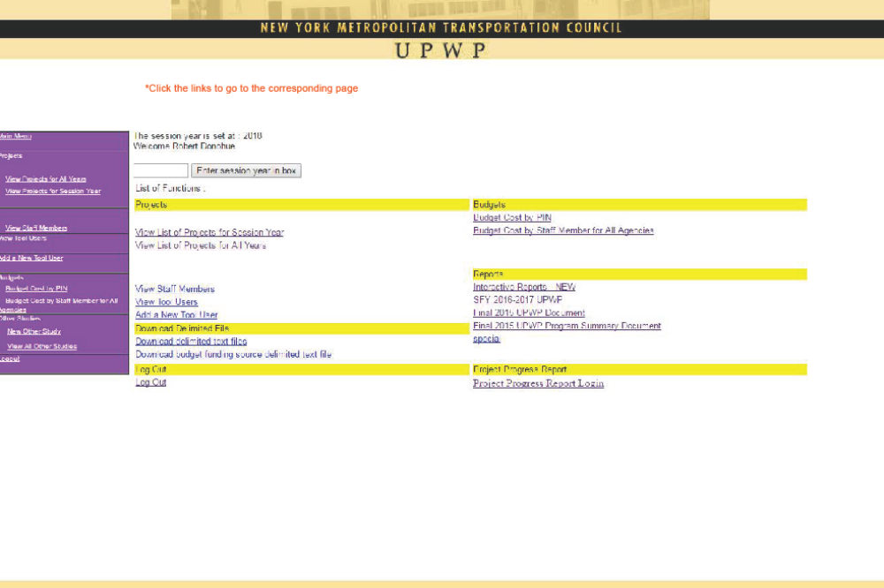

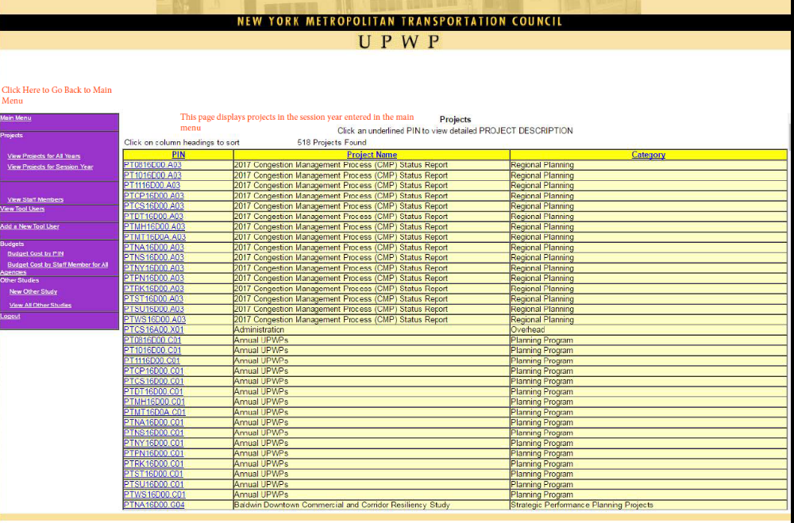

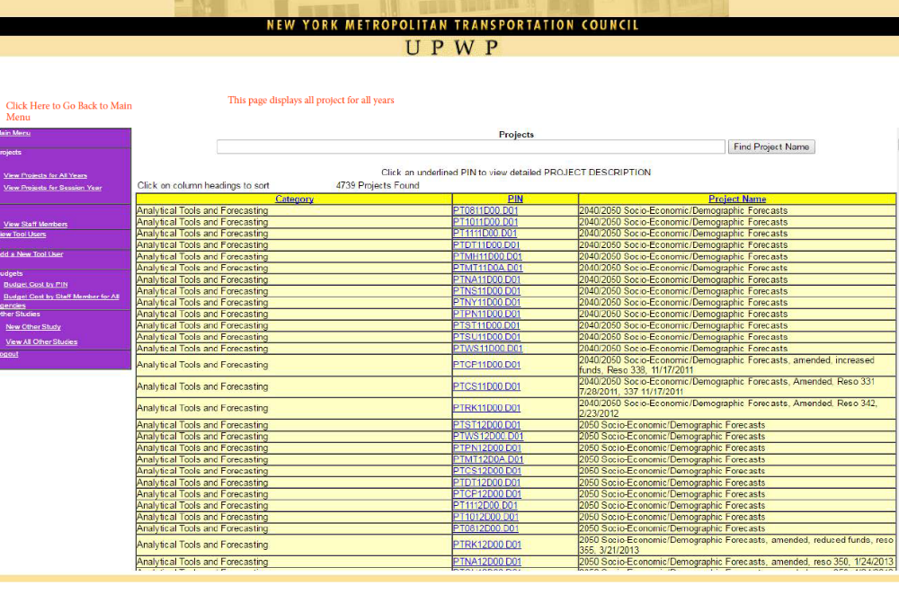

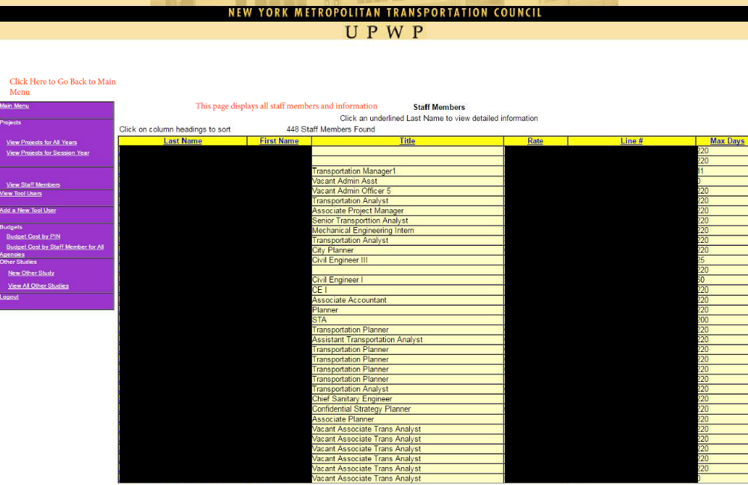
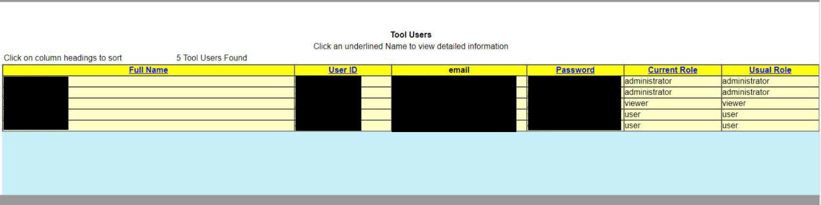

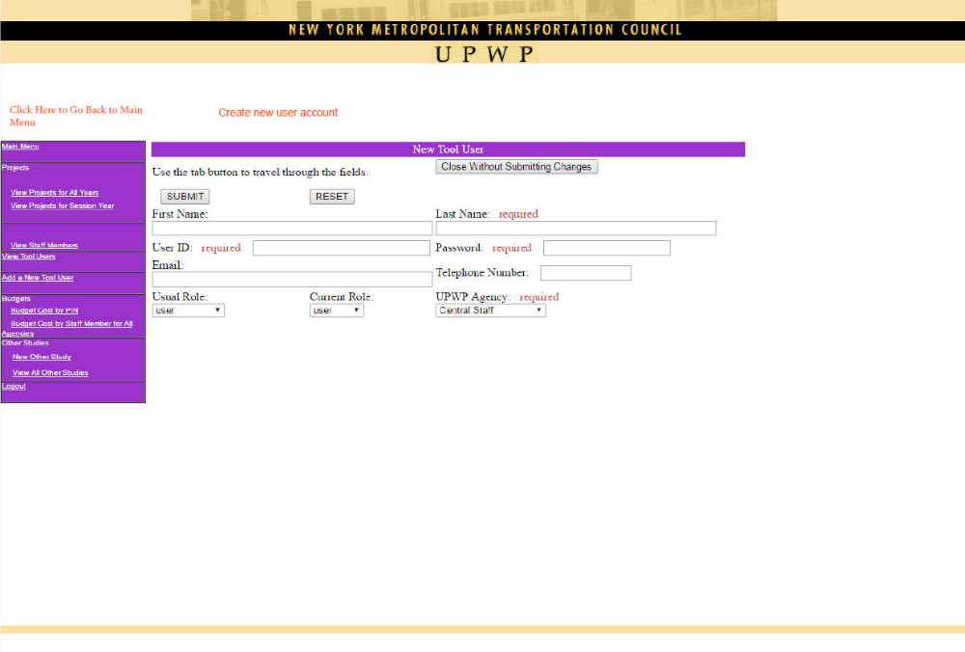

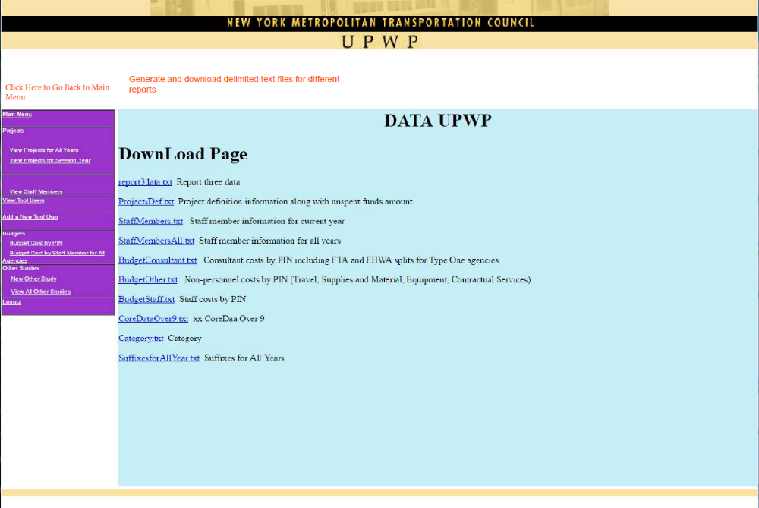

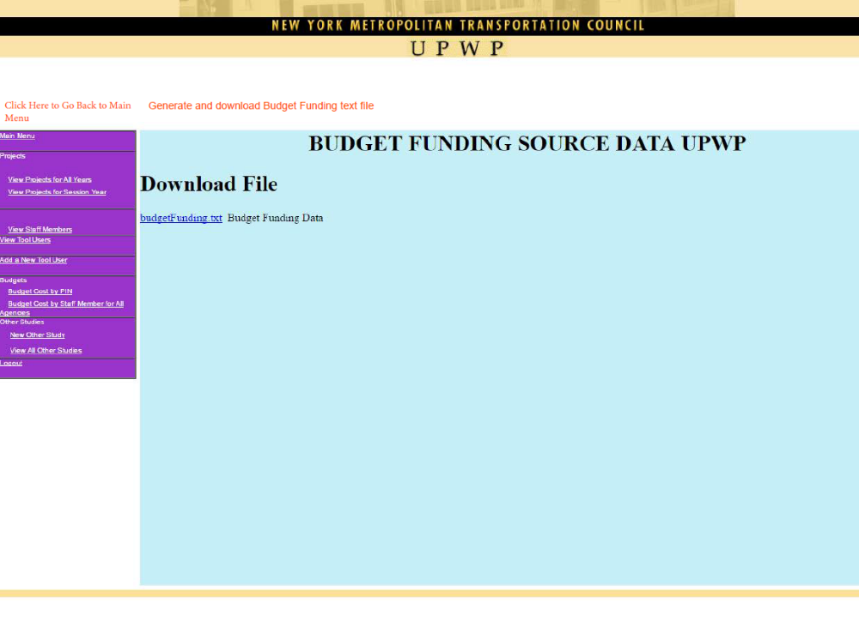

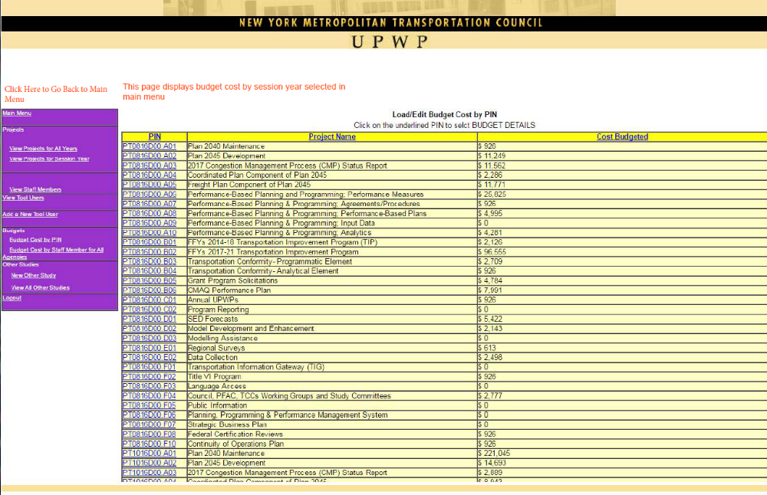

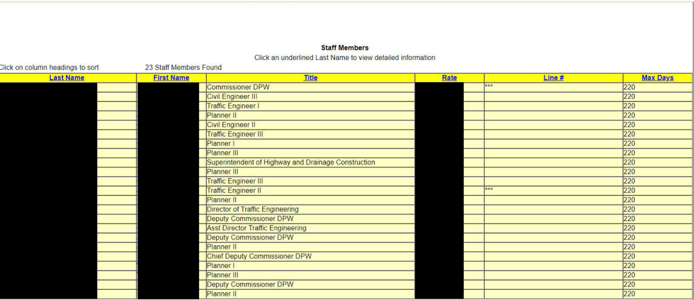

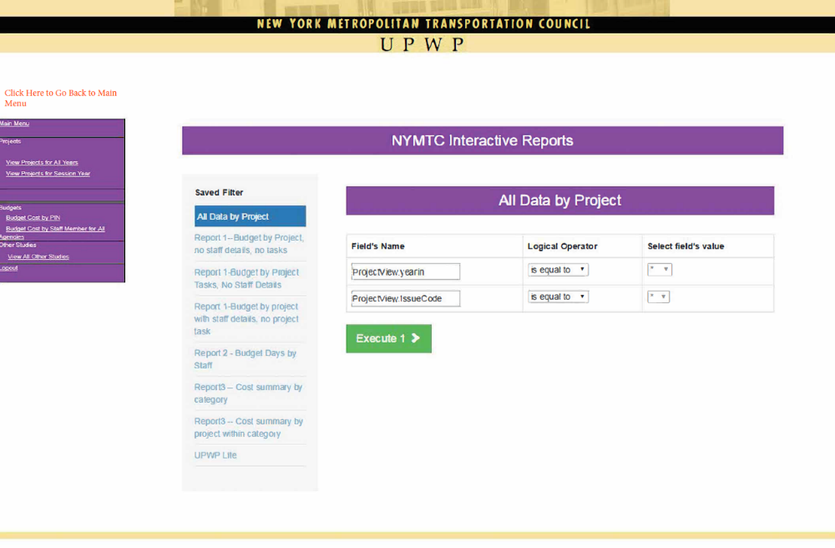

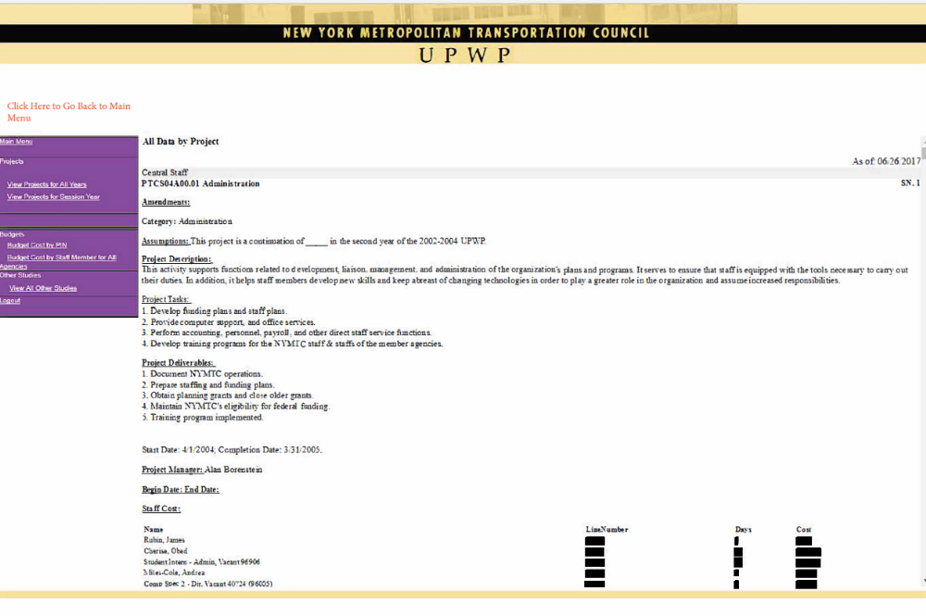

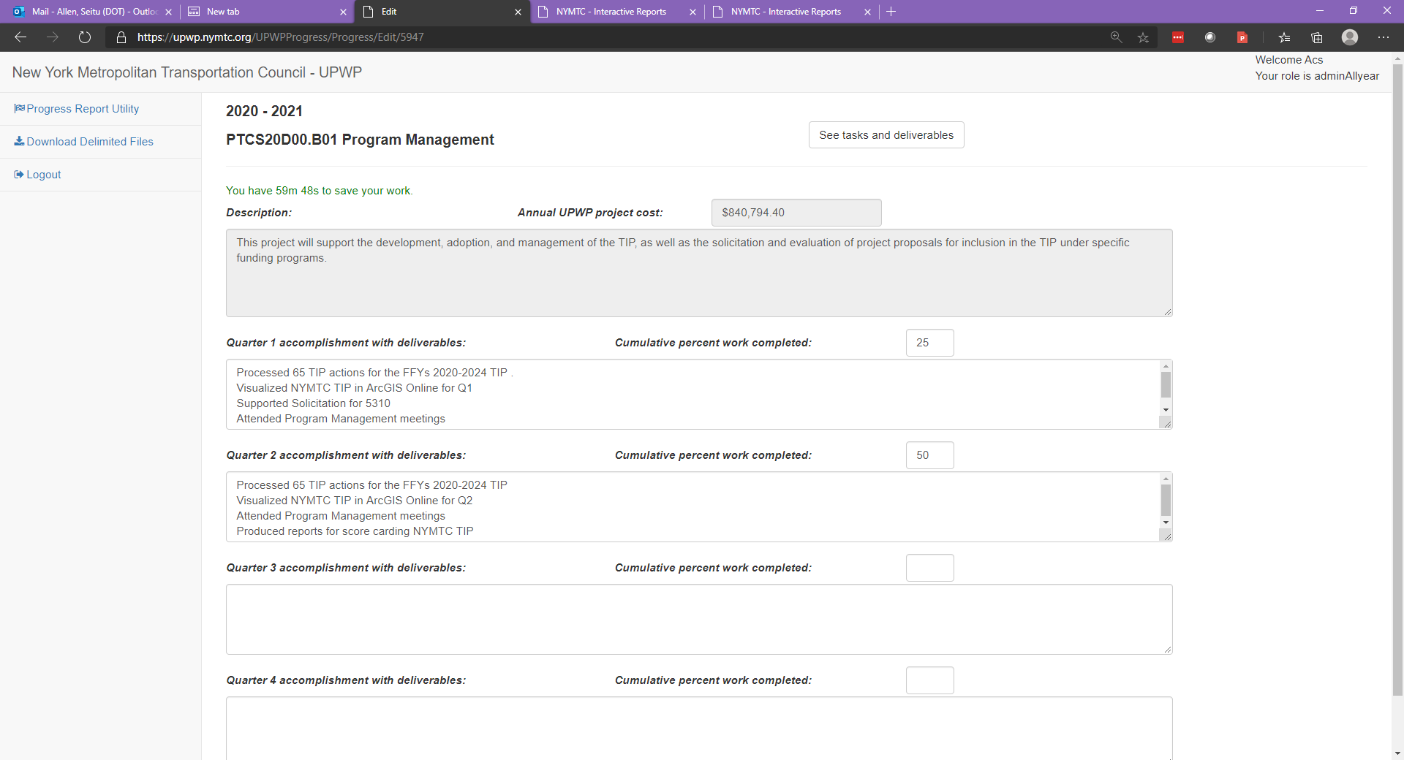

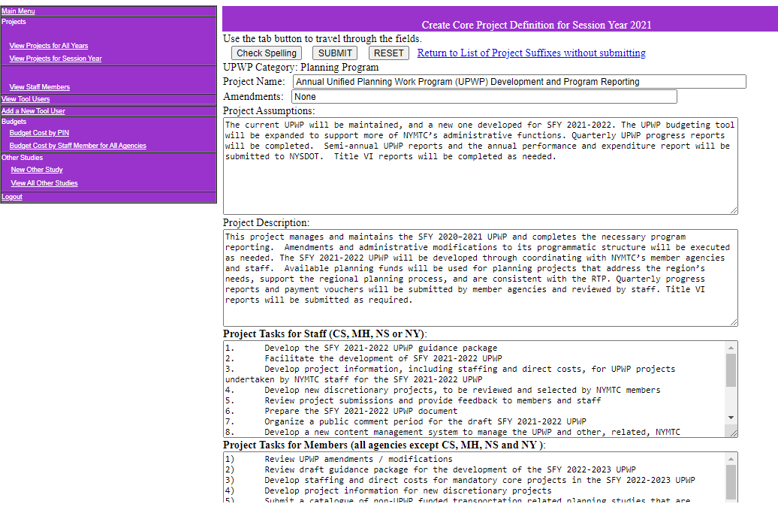

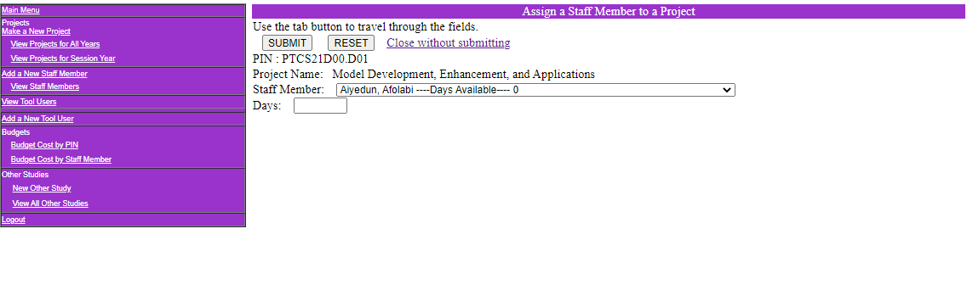
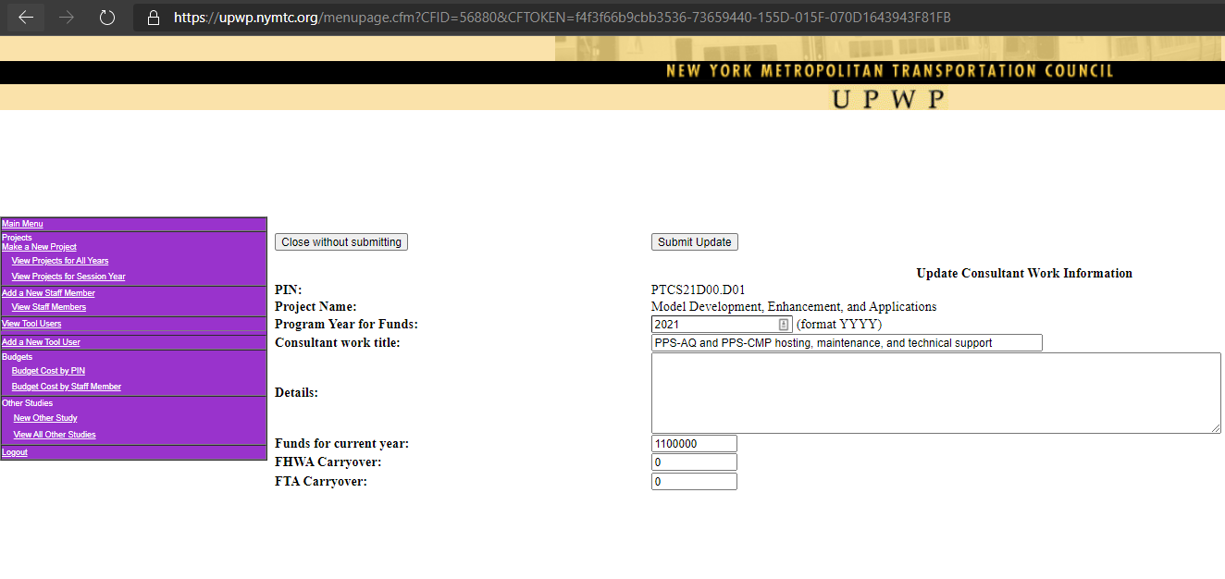

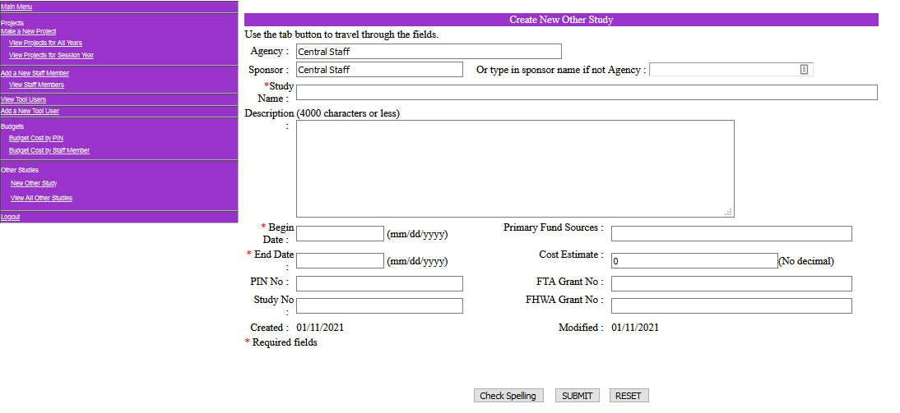

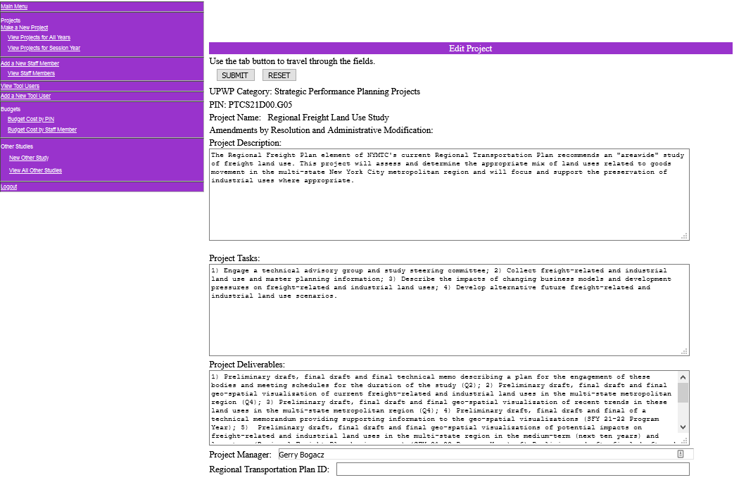
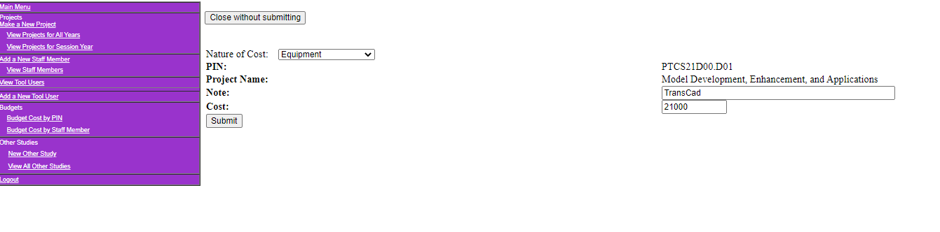

Attachment 11. Form OAR
ACKNOWLEDGMENT OF RECEIPT OF
RFP, MODIFICATIONS AND RESPONSES TO QUESTIONS

NAME OF PROPOSER:

We hereby acknowledge receipt of the NYMYC UPWP Web Application Project (Contract #C000797) Request for Proposals, dated January 29, 2021 and all subsequent RFP Modifications issued by NYSDOT/NYMTC, as listed below. Do not include any RFP Announcements.

Add additional lines below, if needed.
RFP MODIFICATION NUMBER: | DATE ISSUED BY DEPARTMENT:

SIGNED:
(Signature)
DATE:
NAME:
(Print name)
TITLE:

Attachment 12. Vendor Assurance of No Conflict of Interest or Detrimental Effect

C000797

The Firm offering to provide services pursuant to this RFP, as a contractor, joint venture contractor, subcontractor, or consultant, attests that its performance of the services outlined in this [RFP/Contract] does not and will not create a conflict of interest with nor position the Firm to breach any other contract currently in force with the State of New York.
Furthermore, the Firm attests that it will not act in any manner that is detrimental to any State project on which the Firm is rendering services. Specifically, the Firm attests that:
- The fulfillment of obligations by the Firm, as proposed in the response, does not violate any existing contracts or agreements between the Firm and the State;
- The fulfillment of obligations by the Firm, as proposed in the response, does not and will not create any conflict of interest, or perception thereof, with any current role or responsibility that the Firm has with regard to any existing contracts or agreements between the Firm and the State;
- The fulfillment of obligations by the Firm, as proposed in the response, does not and will not compromise the Firm’s ability to carry out its obligations under any existing contracts between the Firm and the State;
- The fulfillment of any other contractual obligations that the Firm has with the State will not affect or influence its ability to perform under any contract with the State resulting from this RFP;
- During the negotiation and execution of any contract resulting from this RFP, the Firm will not knowingly take any action or make any decision which creates a potential for conflict of interest or might cause a detrimental impact to the State as a whole including, but not limited to, any action or decision to divert resources from one State project to another;
- In fulfilling obligations under each of its State contracts, including any contract which results from this RFP, the Firm will act in accordance with the terms of each of its State contracts and will not knowingly take any action or make any decision which might cause a detrimental impact to the State as a whole including, but not limited to, any action or decision to divert resources from one State project to another;
- No former officer or employee of the State who is now employed by the Firm, nor any former officer or employee of the Firm who is now employed by the State, has played a role with regard to the administration of this contract procurement in a manner that may violate section 73(8)(a) of the State Ethics Law; and
- The Firm has not and shall not offer to any employee, member or director of the State any gift, whether in the form of money, service, loan, travel, entertainment,

hospitality, thing or promise, or in any other form, under circumstances in which it could reasonably be inferred that the gift was intended to influence said employee, member or director, or could reasonably be expected to influence said employee, member or director, in the performance of the official duty of said employee, member or director or was intended as a reward for any official action on the part of said employee, member or director.
- Firms responding to this RFP should note that the State recognizes that conflicts may occur in the future because a Firm may have existing or new relationships. The State will review the nature of any such new relationship and reserves the right to terminate the contract for cause if, in its judgment, a real or potential conflict of interest cannot be cured.
Name, Title: _________________________________________
Signature:______________________________ Date:_______________
Firm Name: ________________________________________________

This form must be signed by an authorized executive or legal representative.

Attachment 13. Firm Experience

The qualifications and prior experience of the proposing Consultants are of great importance to NYSDOT. Direct, prior experience regarding the delivery of the requested services is highly desirable. Comparable firm experience is allowed only if a direct relevancy is clear. Provide a list of projects currently in progress and those completed within the last three to five years which are relevant to this effort. Proposers must demonstrate that experience and expertise through past and current project attestations and reachable, verifiable references. NYSDOT reserves the right to request information from any source so named and to contact additional references (including appropriate references not specifically named by proposers) to completely verify all offered experience.

Organization Overview:

The organizational overview should consist of a succinct statement outlining corporate/business history including a general mission statement, the overall number of employees per position, and other general information about the firm. The Offeror must demonstrate that it possesses adequate staffing resources, financial resources and organization to perform the type, magnitude and quality of work specified herein this RFP, and demonstrate that the Offeror has been in continuous operation for at least the past five (5) years. In addition, the Proposer must provide a statement of previous experience that qualifies the Proposer to provide the Project Services. Proposer may include information not defined as required in this section but deemed necessary to fully understand the Proposer’s Company experience and Staff Qualifications.

Consultant’s Organizational Overview Response:

Company Experience:

Provide a description of the Proposer’s direct, relevant prior experience. Describe this experience and related services as well as describing the client in each case. The number of years the Proposer’s team has been providing relevant services. Information documenting the complexity (large project, multi-year, multi-site, multi-agency, etc.) of previous implementations. This should include, but not be limited to:
  - the type of client (government entity, private company, etc.)
  - the number of locations
  - the project duration
  - the number of Proposer FTE’s involved in the implementation
  - the number of client FTE’s involved in the implementation
  - and any other information relevant to describing the client organization in the context of this RFP

Consultant’s Company Experience Response:

Company References:

Submit relevant project and contact information for reachable references for up to two past relevant company projects. It is preferred that each cited project experience be of similar scale and scope to this RFP. All cited company references must be reachable (i.e., willing to provide a reference on behalf of the proposer to NYSDOT upon request). The references should be willing to provide information via an emailed reference response form and possibly follow that up with a conference call to speak further on the proposer's behalf.
Fill out the requested information using the provided form. Use one form for each company reference provided, for up to two past project references. Be sure to cover the proposed Prime Consultant and each proposed Subconsultant.

Consultant’s Company Reference Response (include as many completed responses as appropriate):

Reference Company Name:
Reference Main Line of Business:
Reference Contact Information
Primary Contact Person’s Name:
Title:
Affiliation/Company Employed By:
Phone:
Email:
Project Information
Project Name:
Project Start Date:
Project End Date:
Project Budget:
Number of Staff Involved:
Types of Staff Involved:

Degree to which offered key personnel were primarily responsible for project delivery:

Description of all services provided and how they were/are comparable to the size and scope of the services specified in this RFP:

An explanation of the size and complexity of the project, including how it compares in size to this project:

A list of all sub-consultants and the duties they performed (if applicable):

Project results and benefits delivered to the client

Comp any Experience with Subconsultants:

Information documenting the Proposer’s experience working with any proposed sub-contractors (e.g. nature of the relationship, number of engagements worked together, duration of engagements, percent split between firms, etc.).

Consultant’s Subconsultant Experience Response:

Attachment 14. Key Personnel Experience

- Complete a profile form for each proposed Contractor personnel.
- One form is provided below. Use additional pages as needed.

Staff Name and Title:
Professional Associations, Degrees, and Certifications:
Number of Years of Relevant Experience in the Proposed Project Role:
Description of Relevant Experience:

Consultant Key Personnel References:
- Provide two per proposed contractor staff person.
- Can cite more than one project – work needs to be relevant to the RFP.
- Use below form, one for each (fill in number blank – i.e., Staff Reference #1; Staff Reference #2, etc.)
- Form is expandable – be concise.
- Reference check evaluation criteria provided below

Staff reference Number: | #_____
Client Name (Reference Company):
Reference Main Line of Business:
Project Name:
Name & Title of Contact:
Email Address & Telephone Number:
Provide a Brief Description of Recent, Relevant Project for which they are Serving to Reference
Staff Reference Check Evaluation Criteria:
Describe the nature of the project and the work that this staff member performed for you.
How would you rate the staff member's experience and qualifications?
How well did the staff member respond to your needs?
How pleased are you with the work the staff member has performed/is performing for you?
Would you contract with this staff member again?

Attachment 15. New York State Holidays
Request for Proposals for Contract #C000797

N.Y.S OFFICIAL 2021 STATE HOLIDAYS
For Calendar Year 2021, the New York State Official Holidays are as follows:
Friday, January 1, 2021 | New Year's Day
Monday, January 18, 2021 | Dr. Martin Luther King, Jr. Day
Friday, February 12, 2021 | Lincoln's Birthday (Float)
Monday, February 15, 2021 | Washington's Birthday (Observed)
Monday, May 31, 2021 | Memorial Day
Saturday, June 19, 2021 | Juneteenth
Monday, July 5, 2021 | Independence Day (Observed)
Monday, September 6, 2021 | Labor Day
Monday, October 11, 2021 | Columbus Day
Tuesday, November 2, 2021 | Election Day
Thursday, November 11, 2021 | Veterans' Day
Thursday, November 25, 2021 | Thanksgiving Day
Saturday, December 25, 2021 | Christmas Day

Attachment 16. Sample Data Dictionary for Current UPWP Application

Attachment 16 generally describes the contents, format, and structure of the current UPWP Web Application for informational purposes.

Attachment 17. Sample Data from Current UPWP Application
Attachment 17 provides data extracts from the current UPWP web applications for informational purposes.

Attachment 18. Product Demonstration Scenario Data
Attachment 18 provides scenario data that may be used during the product demonstration. The data reflects two UPWP budget cycles for an MPO that has a central staff and two member agencies that receive pass-through federal transportation planning funding. The workbook presents annual MPO revenue, annual and multi-year projects, funding, staffing, and other resource allocations for those projects, invoicing, expenditures tracking, and progress reporting. This data provides a general overview of the data NYMTC collects throughout the year to develop and manage the UPWP, whether through the current UPWP application or through other means.

